Let’s celebrate Christmas together!

ACTIVITY A: Cloze Test
Photodentro gap filling
Let’s have a closer look at this activity together!
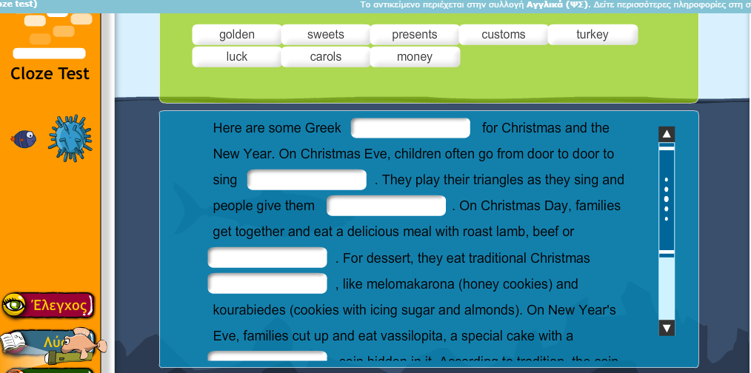

ACTIVITY B: Christmas customs
British Council
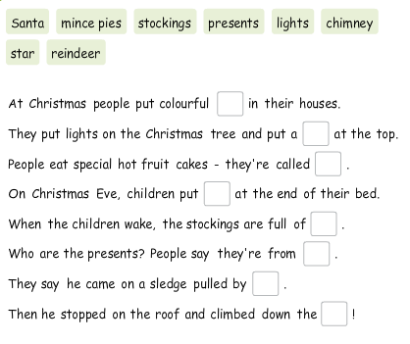
ACTIVITY C: Time to write about our Christmas customs!
You can share some Christmas photos of your decorations. No faces, please! We need them for our Christmas wishes padlet! You can also record your voice saying ‘Merry Christmas!’
Send them to e-class or to kdermitz@gmail.com
Send: στέλνω
Always: πάντα
Often: συχνά
Never: ποτέ
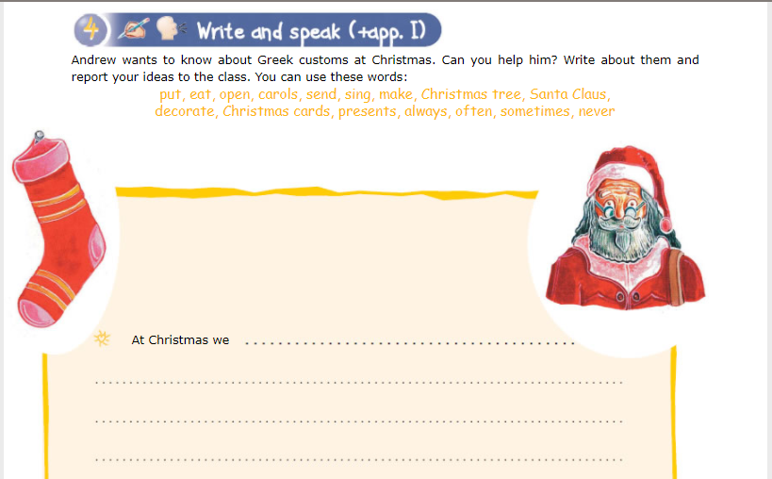

ACTIVITY D: Vocabulary games
Time for some fun. Are there any other words you would like to add?
Christmas quizlet games



Thank you! See you soon!

