Unit 5.2: British customs

Activity A: Listening and reading
Please go to your S.B. p. 62. Let’s now listen and read the Christmas text together! Next time you will read it to us.

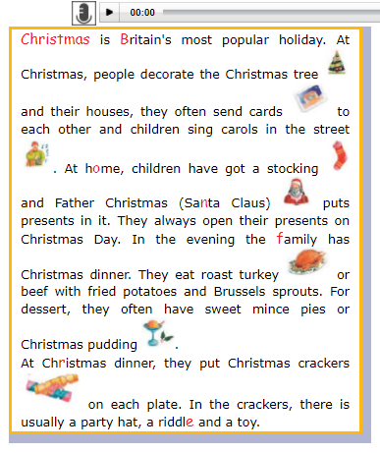
Activity B: Let’s learn the new words!
Write the new words in your vocabulary notebook, please! If you have problems with other unknown words (άγνωστες λέξεις), please ask me!

VOCABULARY
custom | έθιμο
popular | δημοφιλής-ές
holidays | διακοπές
decorate | διακοσμώ
send | στέλνω
carols | κάλαντα
often | συχνά
turkey | γαλοπούλα
stocking | 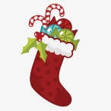
Father Christmas  Santa Claus | 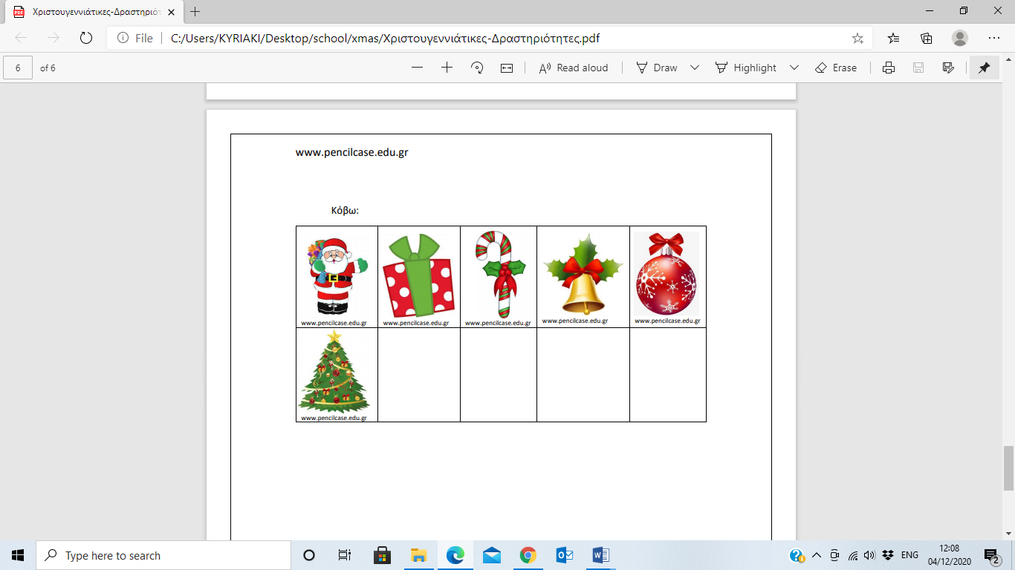
present
candy cane
Christmas tree
ball
bauble
bell
Christmas  crackers | 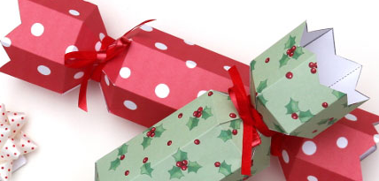

Activity B: Let’s play games!
crossword
fill in the gaps
hidden words

Activity C: Homework!
Learn the new words and try to do Act. 3 a) and b) S.B. p. 63.
We will check them together next time!

Thank you and see you soon! 

