Unit 5.2
British customs: Christmas!

Activity A: Vocabulary
Let’s learn and remember some Christmas vocabulary!
Christmas vocabulary
Και στον τοίχο της e-class

Activity B: Filling in the gaps.
Please go to S.B. p. 63b.
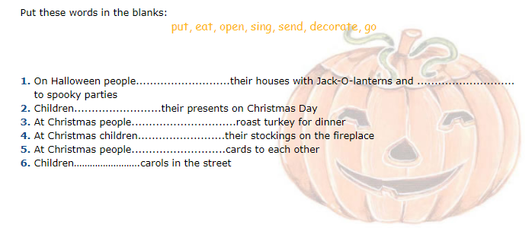

Answers
- decorate go
- open
- eat
- put
- send
- sing
Activity C: Let’s write a letter to Santa!
nice: καλός-ή-ό naughty: άτακτος

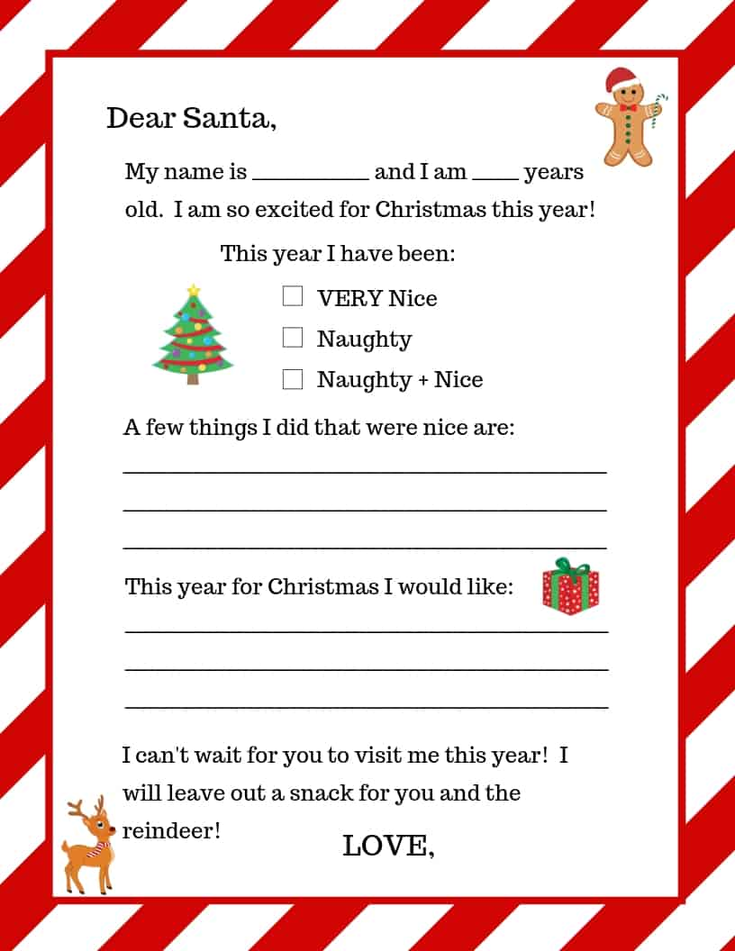

Activity D: Art time!
If you want, print and colour the Christmas picture you like! Or draw your own Christmas picture and show it to us next time!
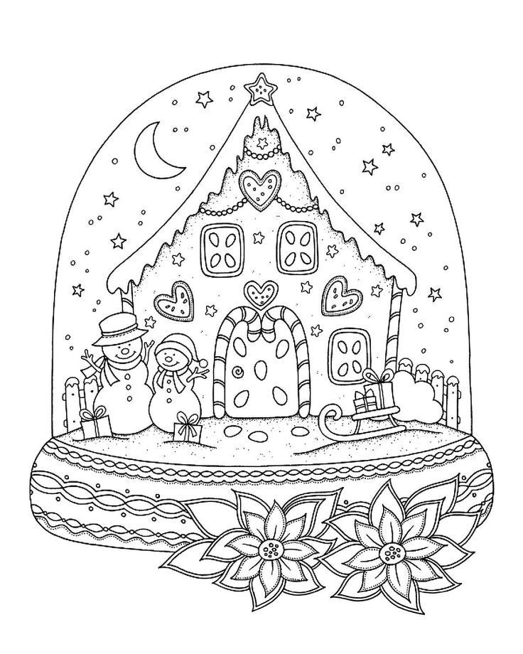

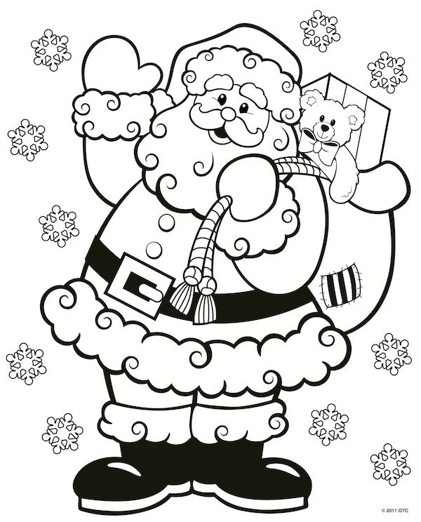

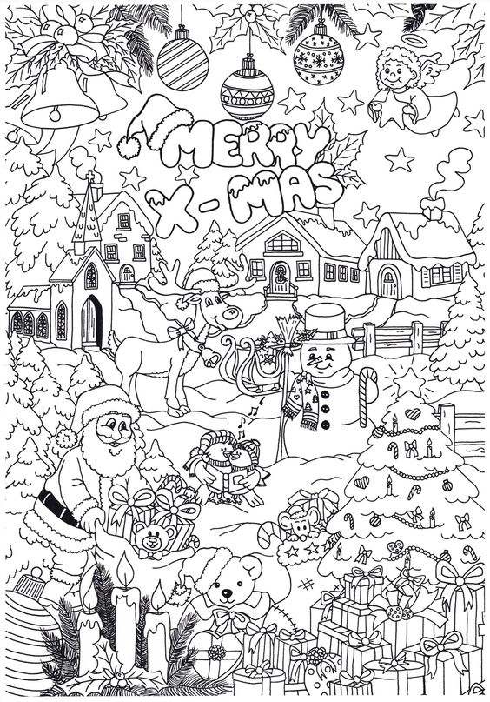

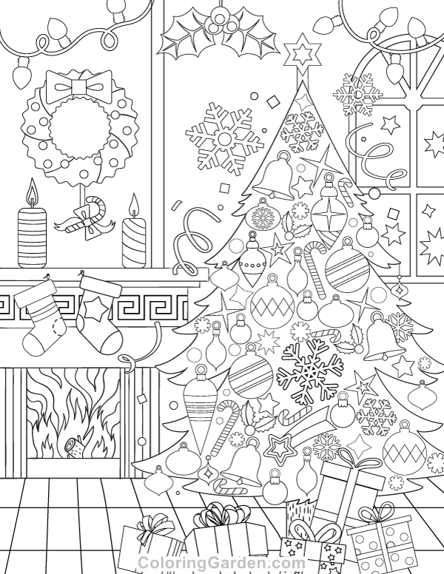

Πόροι εικόνων: coloringGarden.com, gr.pinterest.com

Thank you! See you soon!

