Tr@velling s@fely through the Net!
Activity 1: Internet Detectives! 
This is our second lesson on e-safety. We have started some of these activities on our Webex online meeting on Thursday (7/5) and we had a video about avatars in our e-class (10/5) (έγγραφο, τοίχος, εργασία).
This week we will have a look at a site first and then at a blog.
First follow the link to this site. Read the tips and tell me if you have problems with words.

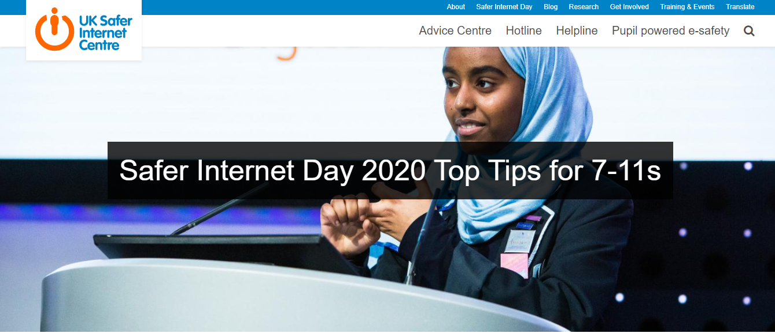
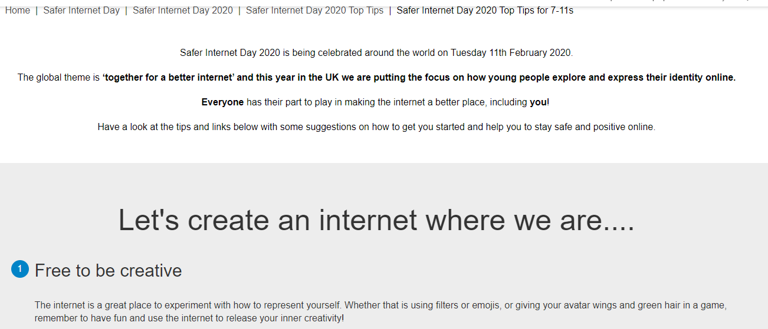
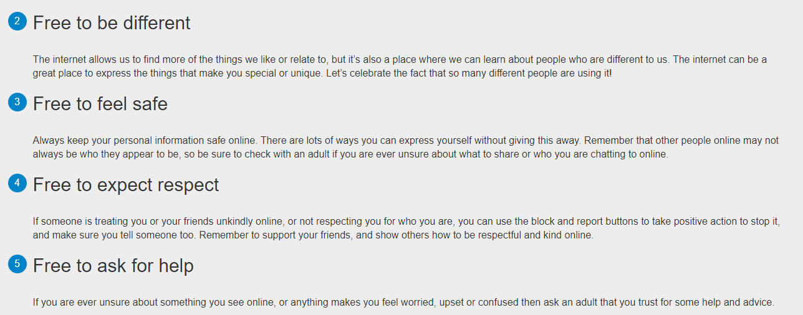
Vocabulary: Guess the meaning!
Inner
Allow
Unique
Unsure
Give away
Positive
Adult
Treat unkindly
Release

VERB | NOUN | ADJECTIVE
create =δημιουργώ | creation=δημιουργία  creator= δημιουργός  creativity=δημιουργικότητα | creative=δημιουργικός
experiment | experiment=πείραμα | experimental
express=εκφράζω | expression | expressive
celebrate=γιορτάζω | celebration | celebrated=famous  celebrating/celebratory
respect=σέβομαι | respect | respectful

Now, look at a blog.
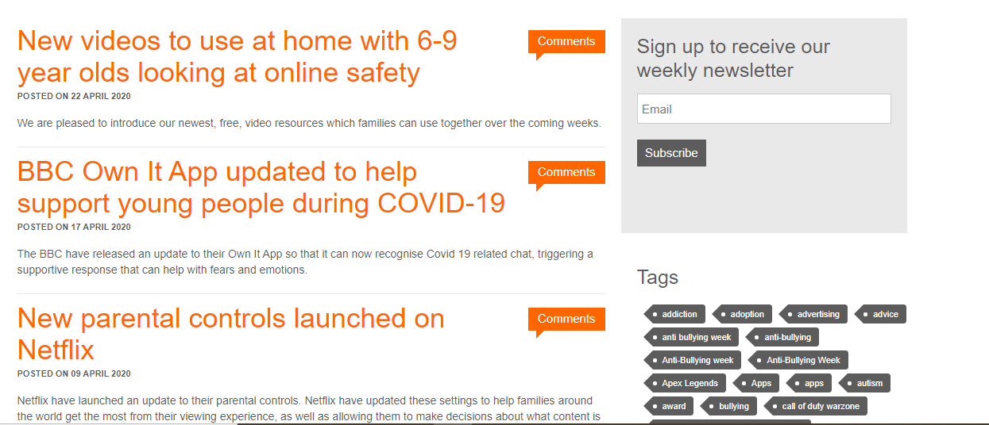
- Please, try to answer some questions. Some answers are up to you, so discuss in your teams and decide. Remember, the questions are in your team’s google.doc!
TEAM A
TEAM B

- Do the two ‘sites’ seem the same?
________________________________________
- Do you have great problems with words you don’t know? How do you understand their meaning?
________________________________________________________________________________
- Which is easier for you to understand, the blog or the site?
________________________________________
- Do we know who wrote the texts?
__________________________________________
- Which of the two is for children? Why?

________________________________________
- Are there new ideas in these texts? Give 1-2 examples.
________________________________________
________________________________________
- What text type are these texts? How are they different from others you have read?
________________________________________
- If you wanted to read some tips on e-safety, how would you
find them in the blog?
________________________________________

- Look at the blog posts. Is there a special order in which you can find them on this page? Does it help you?
__________________________________________

- Which looks more personal? Does this give you any idea about the one you can trust (εμπιστεύομαι) more? Please explain!
________________________________________

Now complete the table by putting a tick or a cross.
Which of the two… | Blog | Website
has more options (επιλογές)at the top
opens up new categories (οριζόντια μπάρα) at the top
has tags
allows/lets you write comments
has dates under the articles
is easier for you to ‘explore’(εξερευνώ)
has a search button? Show us!

Thank you! See you soon! 

