Travelling by tube/ metro


Unit 5, Lesson 2
ACTIVITY A (Reading the main text)
Let’s learn some new things about trains, using an educational website (εκπαιδευτική ιστοσελίδα). This time we will look at trains travelling underground, what we call tube or metro. Please follow the link and go to
https://www.dkfindout.com/uk/transport/history-trains/first-underground-railways/
(ctrl & click or copy the link & paste).
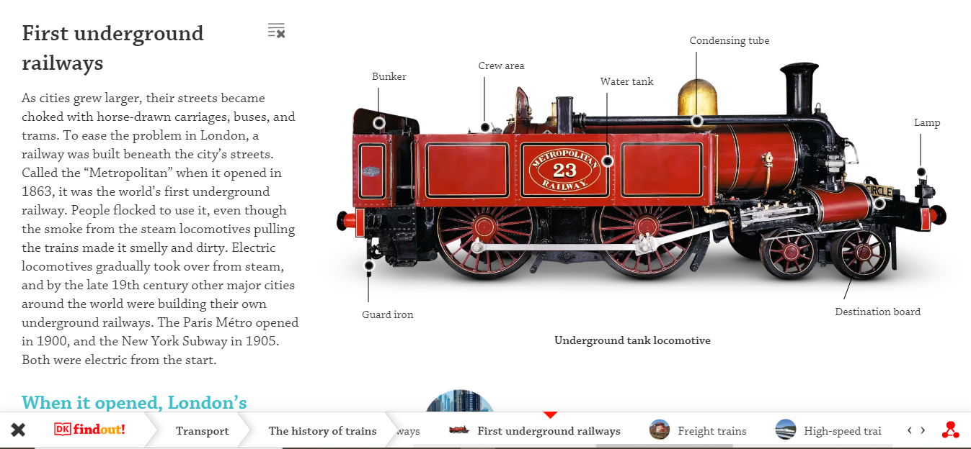
Read the text, as many times as you like, and write the words you don’t know, first. If you want, click on the flashing dots (on the train on the right) to learn more details about the different parts. Αν θέλετε, πατήστε πάνω στις τελείες που αναβοσβήνουν στο τρένο δεξιά για να μάθετε περισσότερες λεπτομέρειες.
Here is some basic vocabulary. Please copy it in your Vocabulary notebook (τετράδιο λεξιλογίου), too.

VOCABULARY
choke | can’t breathe because of smoke πνίγομαι από καπνό, ασφυκτιώ
horse-drawn | pulled by horse
(v)ease | free from care, lessen, διευκολύνω
beneath | below, under
(v)flock | gather (συγκεντρώνομαι) in large numbers, crowd
(n)flock | large number of animals(κοπάδι)
even though | although, in spite of the fact that  (παρά το γεγονός)
gradually | little by little (βαθμιαία)
steam | ατμός
take over | replace (αντικαθιστώ), control
locomotive 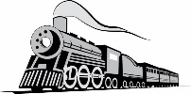 | front part of train with engine
elevated | placed higher, υπερυψωμένο

ACTIVITY B (Reading around the text)
Now read the blue text on the left and the grey at the bottom. Then, click on the modern metros, as you can see here and read the text.
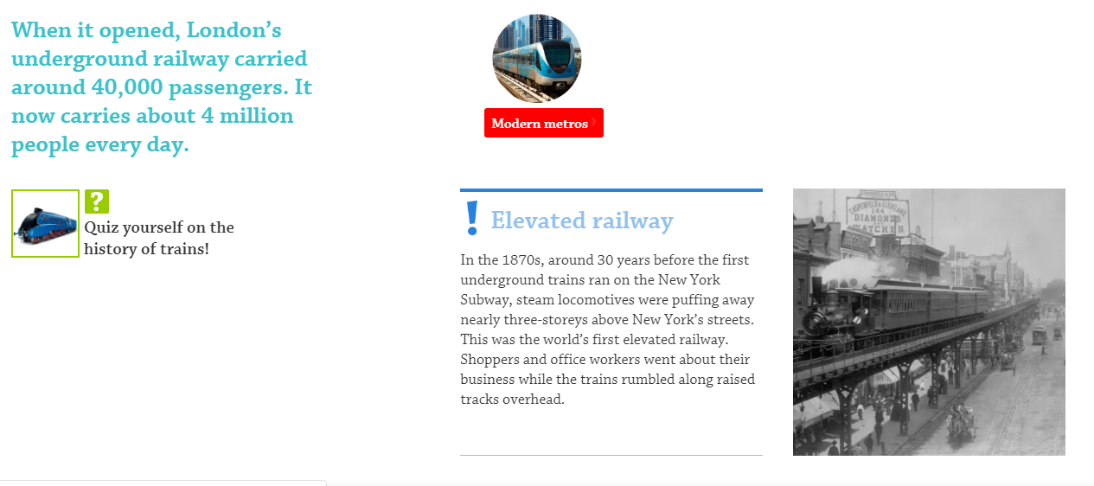
Διαβάστε τα κείμενα, όπως φαίνονται στην εικόνα και κάντε κλικ και στο modern metros. Finally, click again on the text to see some more! If you can’t, just click on the link below:
https://www.dkfindout.com/uk/transport/history-trains/modern-metros/
To read the whole text, click on the red dot and scroll down. Για να δείτε όλο το κείμενο πατήστε στην κόκκινη βούλα και προχωρήστε κάτω την μπάρα.
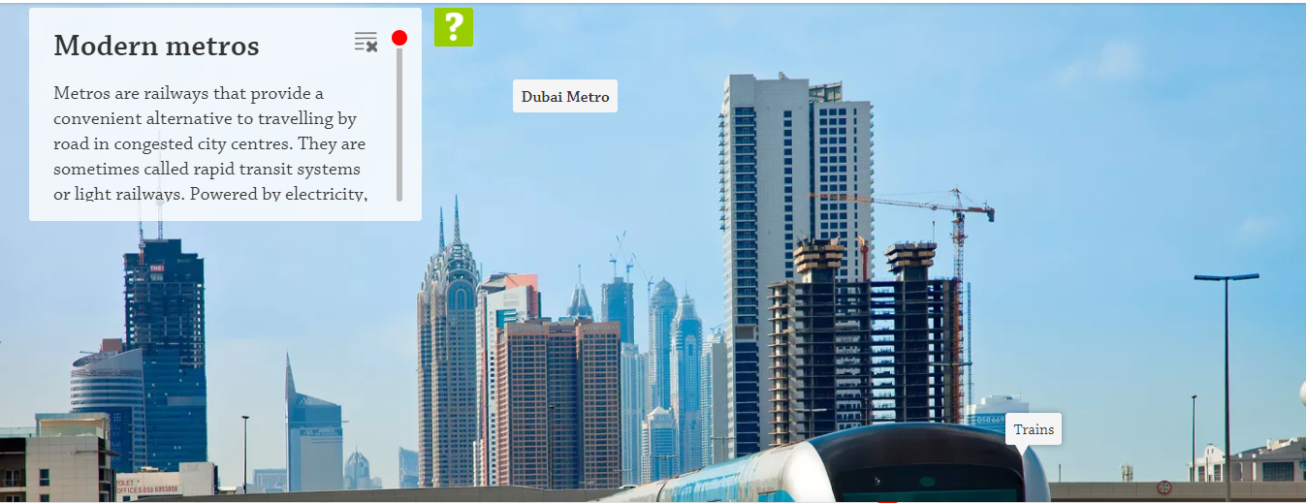

ACTIVITY C (Understanding the text)
Μετά πηγαίνετε στις εργασίες για να απαντήσετε στις ερωτήσεις από τα κείμενα. Μπορείτε να συμβουλεύεστε το κείμενο σας όσες φορές θέλετε. Για να σας διευκολύνω, τις ερωτήσεις τις έχω και εδώ, αλλά για να τις δω συμπληρώστε την εργασία και κάντε υποβολή.
- When did the London underground ‘open’?
- Why did they need to have an underground in London?
- How many people use London underground today? (not during coronavirus epidemic of course!)
- Which were the first 3 cities to have an underground? When?
- Were the first trains in New York under or over the ground?
- What is strange about the metro trains in Dubai?
- Is this text like others you have read (e.g. your book’s texts)? Why/not?
- Do you find this website helpful? Are there any new things you learnt? Give an example.
- What do you like about it?
- What else would you like to see in this site (e.g. text, photos, games etc.)?
Thank you and see you soon! Stay at home and be safe!
Ψηφιακός πόρος: https://www.dkfindout.com/uk

