Shopping!
Revision Unit 2
ACTIVITY A: Clothes vocabulary
Please go to S.B. p. 21

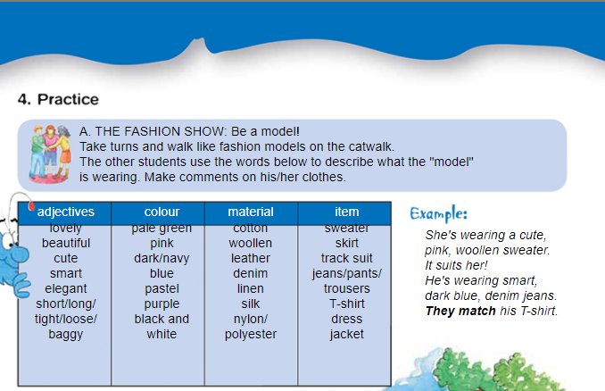
VOCABULARY
smart=elegant | Κομψός-ή-ό
tight | Σφιχτός-ή-ό
loose | Χαλαρός-ή-ό
Baggy  | Πολύ φαρδύ (για ρούχα)
woolen | μάλλινο
denim | τζιν
leather | δερμάτινο
silk | από μετάξι
linen | λινό

ACTIVITY B: Shops
Go to Multiple choice (Ctrl and Click) and choose the correct shop.

ACTIVITY C: Shopping gap-filling
Go to photodentro activity (Ctrl and Click) and choose the correct word to fill the gaps.
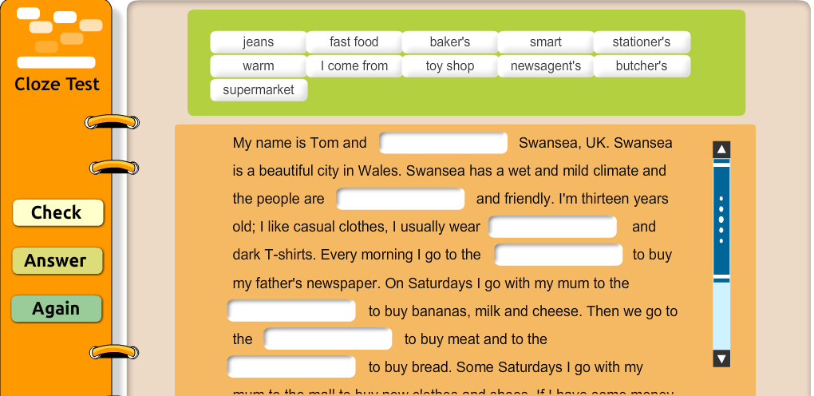

ACTIVITY D: Writing activity
E-shopping
Please write in your writing notebook or in e-class and tell us for our next lesson!
- Have you ever used the Internet to do your shopping?
- What do you usually buy?
- Do you prefer to buy online or in shops of your town? Why?
- If you wanted to buy Christmas presents for your family, what site would you visit and why? Give us a few ideas!

Thank you and see you soon!


