Let’s celebrate Easter together!

ACTIVITY A (A sweet video!)
It’s Easter time, so it’s time for celebration and having some fun! So, let’s get started! First watch a short video (I will also upload it in the wall τοίχος, for you to watch inside the e-class) and answer some questions.
This time, if you have unknown words try to guess or use an online English-Greek dictionary to look it up, by opening a new tab (καρτέλα):
https://www.wordreference.com/engr/
Please, watch
https://learnenglishteens.britishcouncil.org/study-break/video-zone/how-are-easter-eggs-made
I will have the questions here, but please go to Εργασία to answer them. Remember to submit your answers by clicking: Υποβολή εργασίας. Here are the questions:
- Where is the man in the 1st scene from? Can you understand his accent (προφορά)?
- When did the chocolate factory open?
- Is Easter a busy time for them? Why?
- How many different kinds of chocolate do they use? What is your favourite kind of chocolate?
- Did you learn something new in this video? Name one thing you didn’t know before watching this video.
- How do you feel after watching the video? What might happen after they finish shooting/recording it?
- If you could change something in this video, what would you change (e.g. people, filming, more close-ups, script/what they say etc.)?

ACTIVITY B (An easy recipe)
Now watch a recipe how to make chocolate eggs (you can also find it in the wall τοίχος, to watch it inside the e-class, if you prefer)
https://www.youtube.com/watch?v=NLTJYBGTlYQ
After you watch it, you can try to make some chocolate eggs yourself and send some photos. You could write a short recipe of your favourite Easter sweet or dish. Don’t forget to write the ingredients/ υλικά first and then the instructions/οδηγίες (5-6 sentences). If you want, you can take photos of your recipe and write the sentences under the photos. You can upload the recipe in e-class μηνύματα or send it to my e-mail:
kdermitz@sch.gr
kdermitz@gmail.com

ACTIVITY C
I have created a padlet wall for you to write your Easter wishes, in English, please! You can find it in:
https://padlet.com/kdermitz/1cnkjjty1la5
To create a post:
- Click the big pink (+) button at the bottom right or
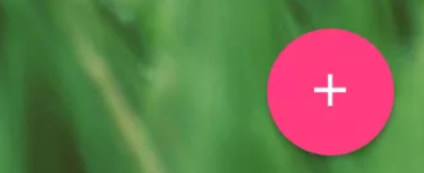
- Double click anywhere on the padlet wall. This will appear:
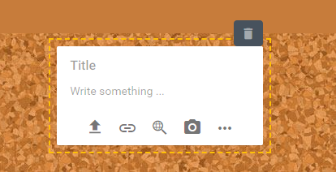
- Write inside your message and then, if you want look at the arrows to add things. For example:
- The first arrow is to upload from your desktop (e.g. a photo for Easter flowers, chocolate eggs, picture, food, wishes, or even an old Easter photo  No photos of faces, please!
- The second arrow is to link a video or something you like …
- The third is to google something
- The camera is to take a photo. Don’t use it, because remember, we can’t have faces!
- The last one is all your options (επιλογές):
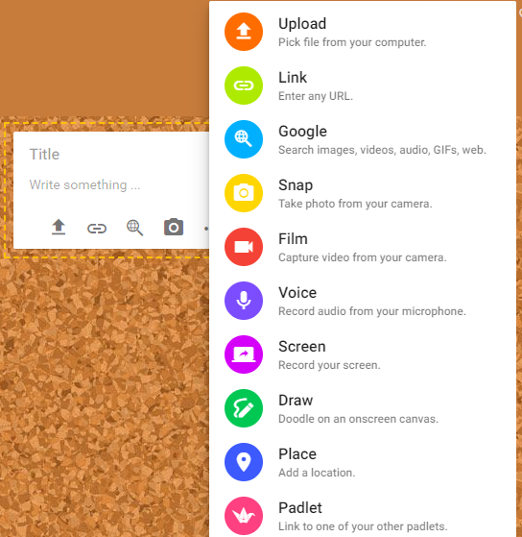

Good luck with your creations! You can write the above anytime during Easter holidays!
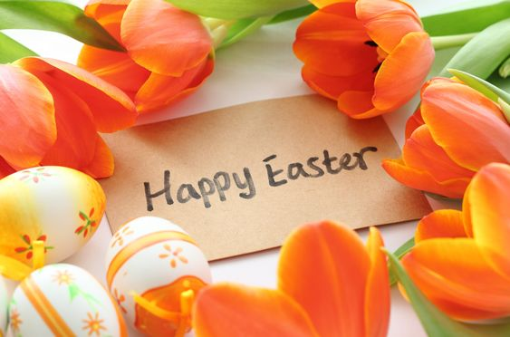
Ψηφιακοί πόροι: https://learnenglishteens.britishcouncil.org/
http://allrecipes.co.uk/
https://padlet.com/
Εικόνα: https://www.pinterest.ca/pin/778770960543979323/

