Tr@velling s@fely through the Net!

This is our third lesson on e-safety. We have started some of these activities on our Webex online meeting on Thursday (7/5) and we had a video about avatars in our e-class (10/5) (έγγραφο, τοίχος, εργασία). Then we looked at a site and a blog on our Webex meeting (21/5) and some of you worked on our google.doc.
This week we will have a look at the Greek site for Safer Internet first and then play a quiz on the British site.
Activity 1: # SaferInternet4U
Let’s continue our ‘investigation’. Please, try to finish Act. 1 & 2 so that we could work on Act. 3 together at school. Read carefully the information on the Greek infographic about Internet habits.

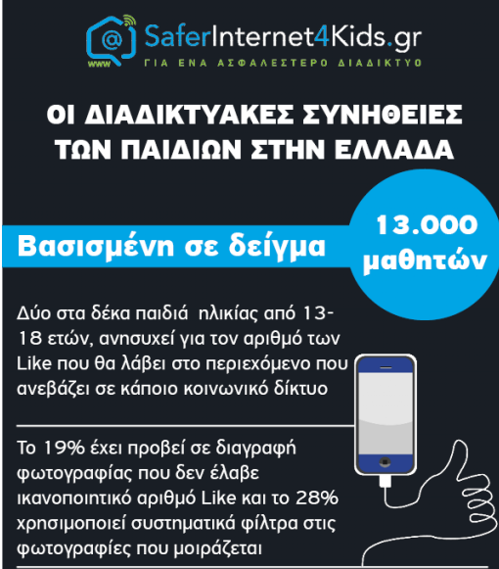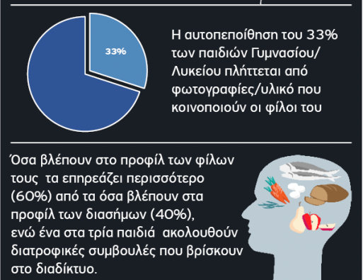

Then look at some basic tips for safer internet behaviour.

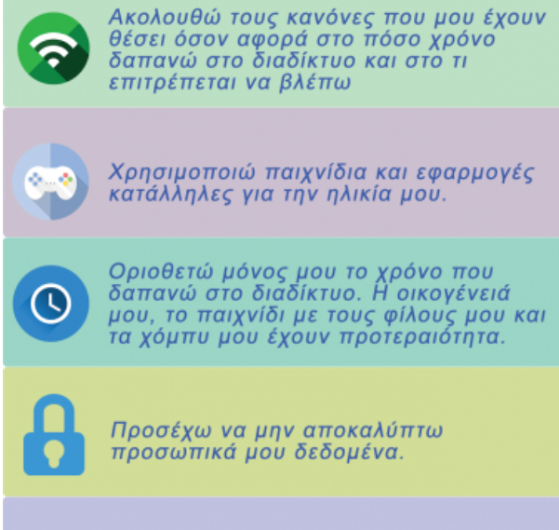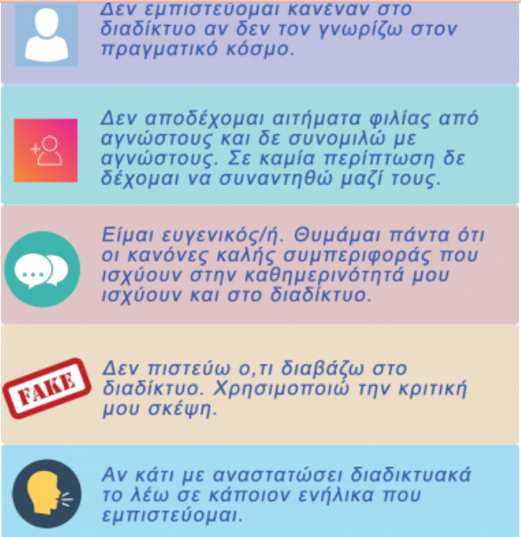


- Do you believe the infographic and the poster tips are for the same age group? Please explain in our next online lesson.

- How could you make them more attractive? Think about it, because you will need it for your own presentation.

- How different was the world without internet, or with very slow internet? Think about pros and cons! If you want, you can ask your parents or grandparents back at home!

Activity 2: Time for an online Quiz!
Let’s now do an online Quiz, to complete our net search! You choose what you think is correct, you see the correct answer and then you click on next. Take some notes (in your notebook or your team’s google doc) as you answer the questions. We will need them later (Act. 3).
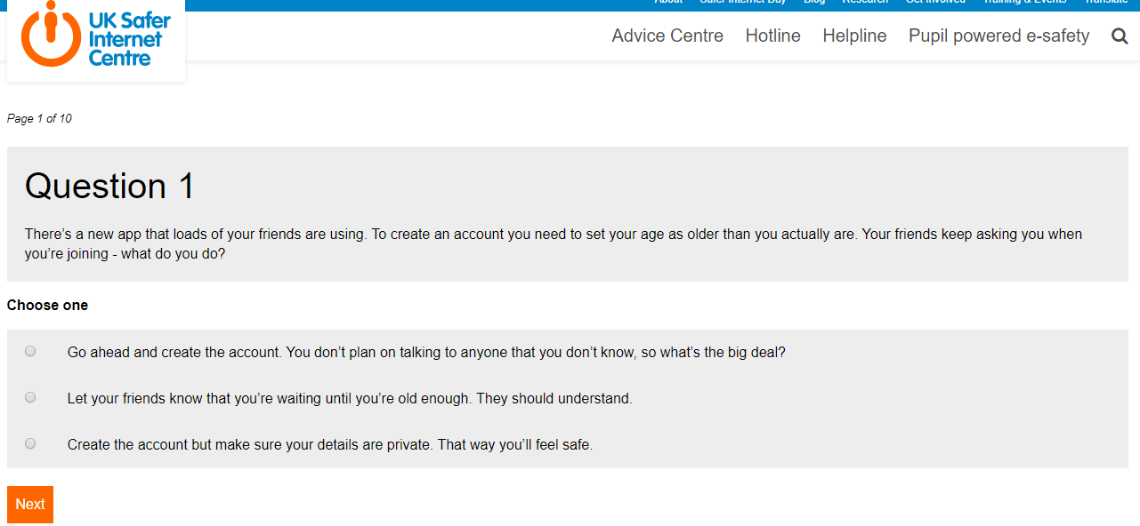

Activity 3: Our own creations!
Now, it’s time to create something new! Please, pick up your team! We will need artists, editors and digital creators (people who are good at working with technology) in each team! I know how difficult it is to work so far away from everybody, so please remember:
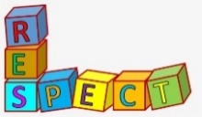
- Be kind to each other!
- Respect everybody’s opinion!
- If you don’t agree, say it nicely and explain!
- Remember to check your editing notes (for our writing together).
- Use these notes, while you are writing in the google doc, to give help to your friends’ writing (organisation, grammar, vocabulary…). Don’t erase anything!

TEAM A

TEAM B

Please, try to→ create your own poster/presentations Try to share your wisdom (σοφία) and the useful things on e-safety you have learnt in this project!
MAIN FOCUS: Our handy guide on our internet adventure!
- Present all your findings in a colourful and graphic way.
- Collect your ideas on the google doc or exchange via (through) e-mails/ messages.
- You will give your presentation/poster to the whole class, in 5 days.
- We will share details in our next lesson!
- Finally, we will upload them in our English blog
 Please, think:
- What is our audience?
- What new can we show/teach them?
- What text, images can we use to make somebody to understand our presentation better?
- How can everybody in our team evaluate (αξιολογώ) our graph before we share it with our classmates?
To get started, please decide and take notes on the following:
Title/ team’s logo or name
Introduction
Main pieces of advice/Tips | 1.  2.  3.  4.
Use of interesting data/ statistics (look at the Greek site, but also the English ones from last lesson, too!) | 1.  2.
Photos/pictures | 1.  2.  3.
Conclusion →Call to Action!
Strong message!

Now choose the template that you think will best suit the above. You can start writing and you can change font, colour later.

Thank you! See you soon!

Image: stock photo-online security protection

