Merry Christmas!
ACTIVITY A: Let’s listen to John Lennon’s song!
If you want to listen to the song again, click here! Happy Xmas (War Is Over). I have also put it (with lyrics) in your e-class wall!

ACTIVITY B: Look at your answers in a cloud!
I have made a wordcloud with your answers from your online polling. The bigger- letter words are the ones that appear more often in your answers!

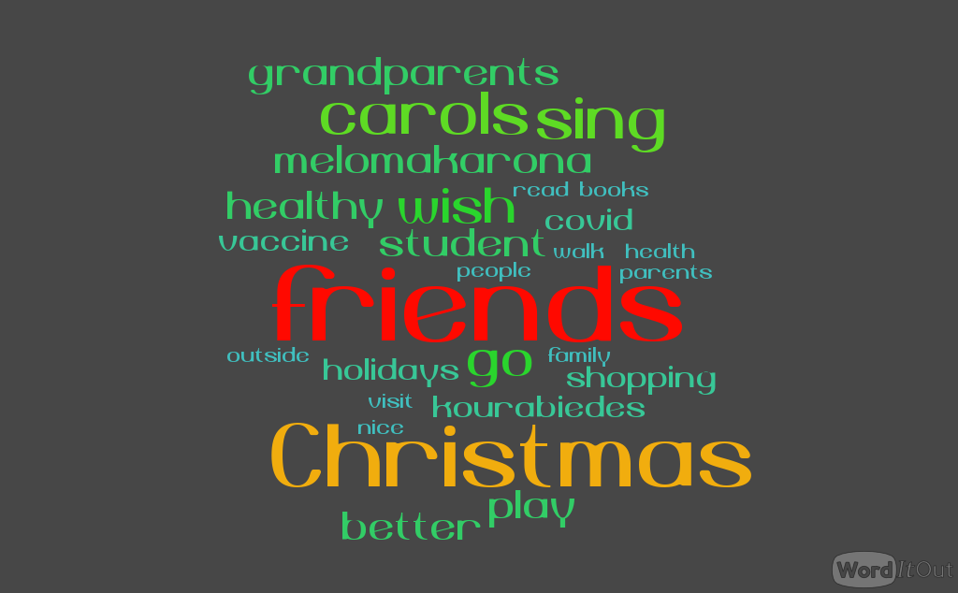

ACTIVITY C: Let’s connect all our Christmas activities together! Ctrl & Click here.

ACTIVITY D: A healthy recipe!
Let’s write a ‘healthy’ Mediterranean diet recipe! It could be an easy salad, a simple dish or a sweet.
For the food, please try to include(περιλαμβάνω) olive oil and fresh vegetables.
Here is an example:

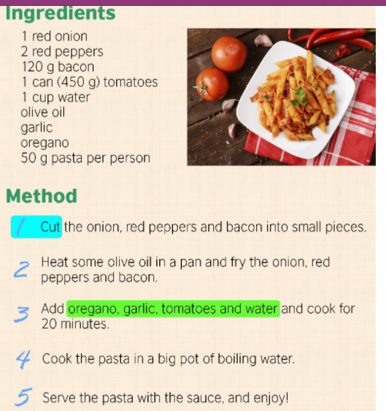

Tips for writing a recipe
- Put the name of the dish as the title
- First write the ingredients (υλικά)and then the instructions (οδηγίες)
- Use numbers to make it more clear and organised
- Try to use the base form of the verb, the imperative (προστακτική) to give the instructions.
- If you like, you can even take a photo of the recipe, as you are preparing it. Again, better no faces, please!
Μαθησιακός πόρος : learnenglishteens.britishcouncil

Thank you! Stay safe! See you soon!



