Old and modern creatures
Unit 3.1

Activity A: Reading
Please go to your S.B. p. 27. Let’s now read the second text together! Write the new words in your vocabulary notebook, please! If you have problems with other unknown words (άγνωστες λέξεις), please ask me!
VOCABULARY
Adjectives | Επίθετα
tiny | very small≠huge
winged | φτερωτός-ή-ό
good hearted | καλόκαρδος≠vicious
like | σαν, παρόμοια≠unlike=αντίθετα
predictable | προβλέψιμος ≠unpredictable=απρόβλεπτος
delightful | charming, lovely
delicate | easily broken, fine, λεπτεπίλεπτος
wicked | ≠good
playful | ≠serious
naughty | άτακτος

Please, try to have a look at S.B. p. 29. Write the opposite adjectives in your grammar notebook.
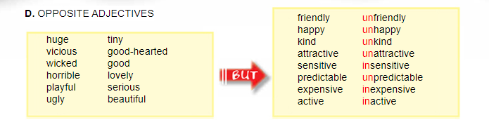

Activity B: Online reading

Read and listen to the story and choose the correct answer. Don’t forget to submit your answer! We can do the first text together as an example!
Reading comprehension

Activity C: Homework
Please, learn the adjectives and the word building for next time.

Thank you and see you soon! 

