Tr@velling s@fely through the Net!
This is our first lesson on e-safety. We have started some of these activities on our Webex online meeting last Thursday (7/5).
Be careful! Go to Τοίχος to watch the video (Act. 3) and then answer alone in Εργασία. If you like, just follow the link to your group’s google doc, write your name and please don’t erase anything!
Group A –Στ1΄
https://docs.google.com/document/d/13EsdSIpfoCaQQSueJex5fEG1NFakxAOAO34IOZs04s8/edit?usp=sharing
Group B –Στ2΄
https://docs.google.com/document/d/1_g6ZtNBERjytx-pyH1YTTfjcCTlBDTNvKvc0Sa3QyPU/edit?usp=sharing

Let’s start!
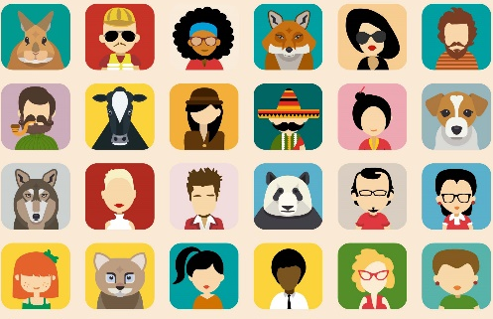
Activity 1: Let’s look up the words!
1. Have a look at the picture from your book (Unit 1, Lesson 2) What do you think about their computer lab?
- Does it look like ours? Explain in a message or in our google doc!
We will talk about it again on Thursday.
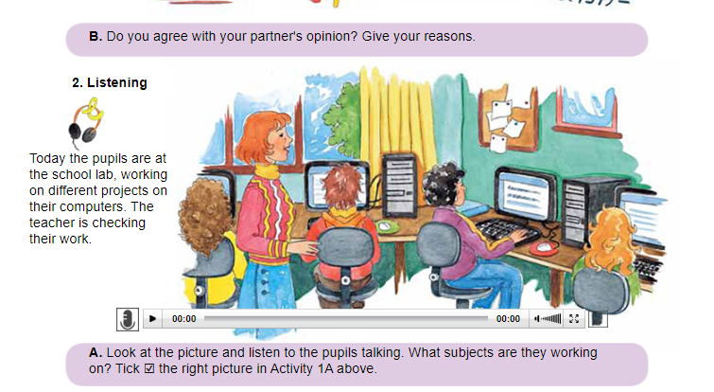
2. Now let’s play a word game. Please follow the link:
http://photodentro.edu.gr/v/item/ds/8521/4771

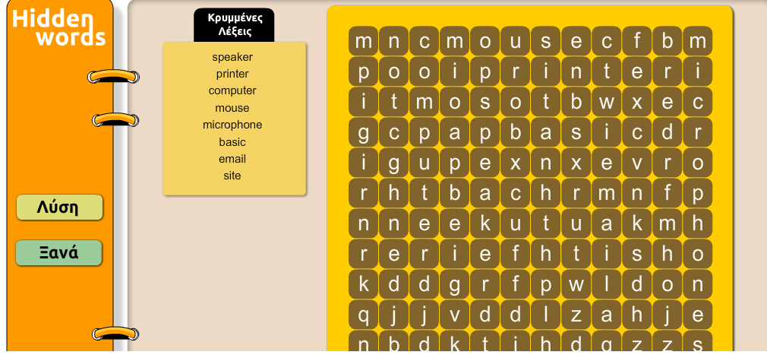

Activity 2: Let’s look up the word ‘avatar’!
Let’s find out the meaning of the word avatar now! Follow two of the links from the online dictionaries below search the word, take notes about the definition (ορισμός) and write two examples of sentences using this word. If you have time, search its origin, too!

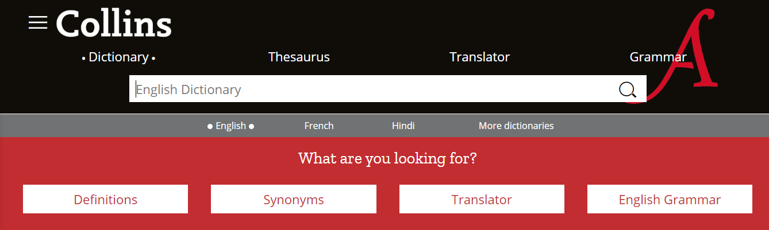

https://www.collinsdictionary.com/dictionary/english/
https://www.macmillandictionary.com/dictionary/
https://www.wordreference.com/engr/

Activity 3: What’s your avatar like?

- Watch the video about avatars:
https://www.saferinternet.org.uk/safer-internet-day/safer-internet-day-2020/i-am-educator/film-what-does-my-avatar-say-about-me
To watch the video, you can go to: Τοίχος.
- Take notes as you listen, discuss in your teams and write in your Google doc or in Εργασία your answers to the following questions. To work with the whole class, please write your answers in your google doc.

1. Did you have problems with words? How did you understand them?
2.Why did these children choose their avatars?
3. Do you find some of the reasons strange? Why?
4. What did you feel as you watched the video? What did you like about it?
5. Decide in your group (google doc) or alone ( Εργασία)which is your favourite avatar in the video. Please, explain, why.
6. Do you use avatars online? How do you choose them?
7. Are there any new ideas in this video? Do you feel these children are different from you? In what way?
8. Do you believe it is safer to use avatars or our photos online? Why?
9. Do you feel the need to be different online (personality, hobbies, clothes…) and why?
Thank you! See you soon!


Image: https://www.123rf.com/photo_41873627_online-security-protection-internet-safety-people-meeting-concept.html

