Let’s celebrate Christmas together!


ACTIVITY A: Christmas vocabulary!
Let’s remember some Christmas vocabulary (Ctrl and click) on the underlined word and let’s play with our new Quizlet vocabulary I prepared for all my students!
First click on the Flashcards to see the explanation of the words with images. Then click on the arrow → to move to the next word.
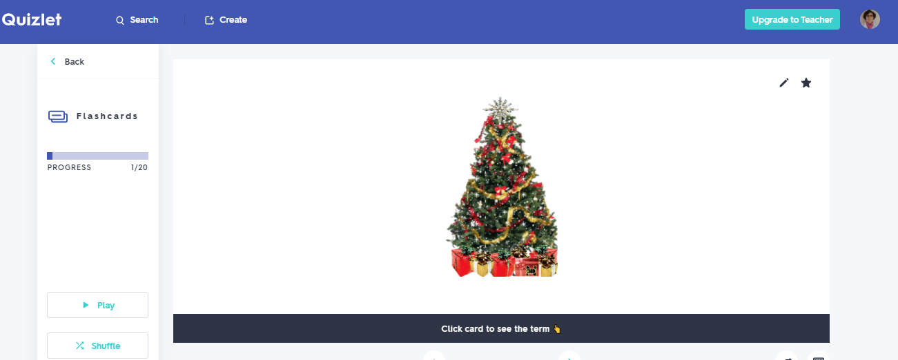
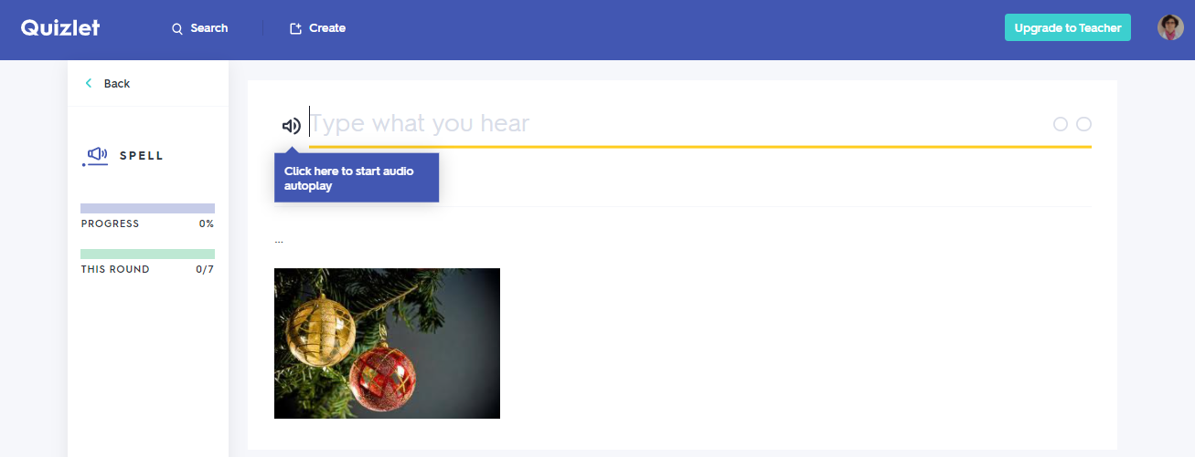

There are so many games to play, like Learn, Write
Spell (above) where you write the word you hear
Test, where you have to type your answers to 5 questions

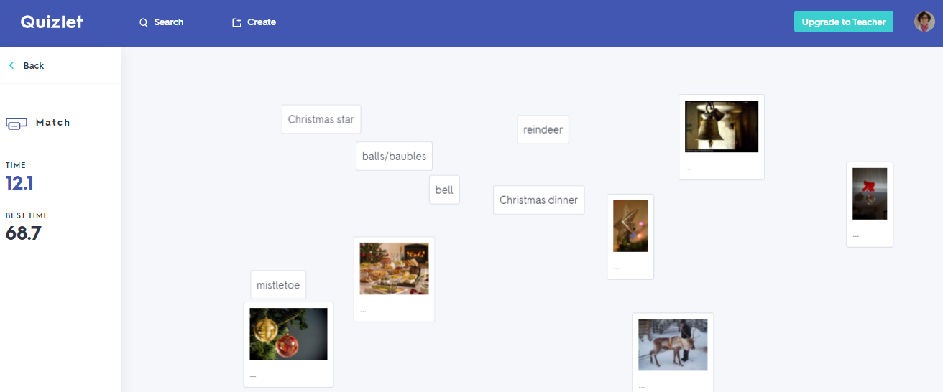

Match (above)and Gravity games, competing against time after you choose level of difficulty!

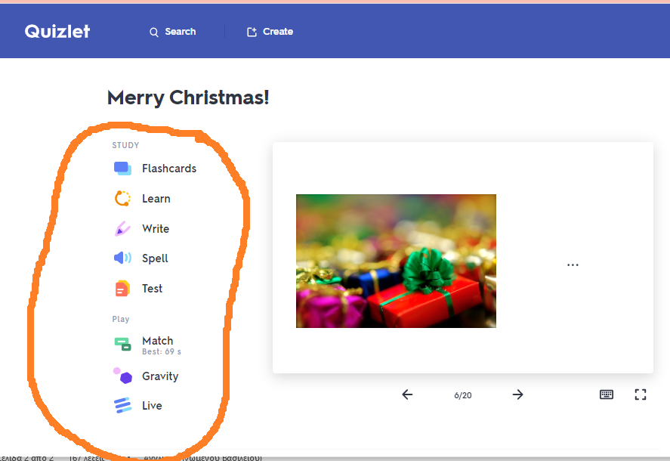
- Always remember to choose from the menu on the left!

ACTIVITY B: Christmas shopping!
Please read the information on this site. Next time, we can discuss together what to be careful of when we go shopping (after the lockdown) or even online shopping.

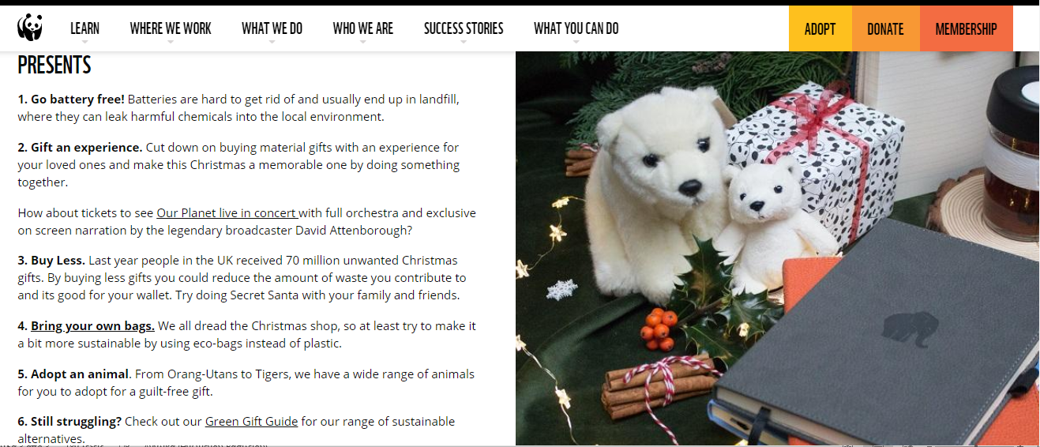

ACTIVITY C: Art time!

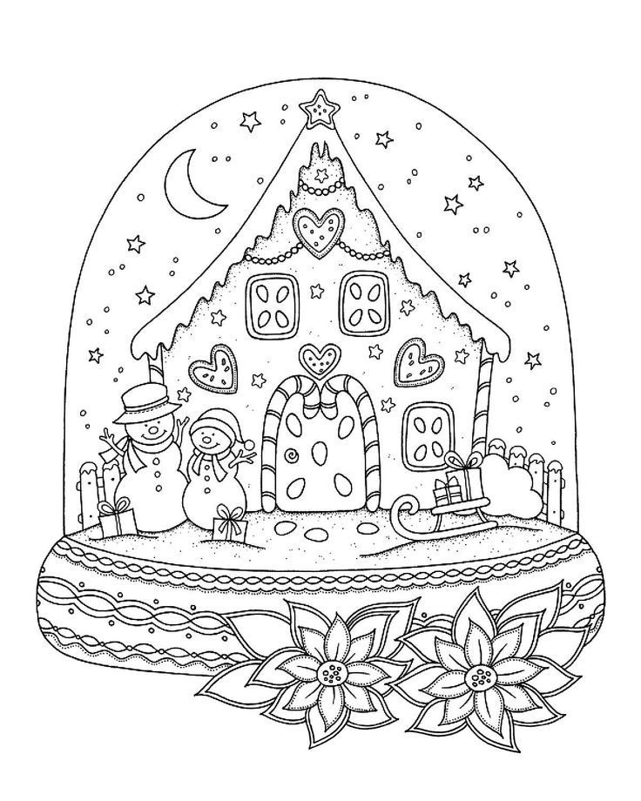

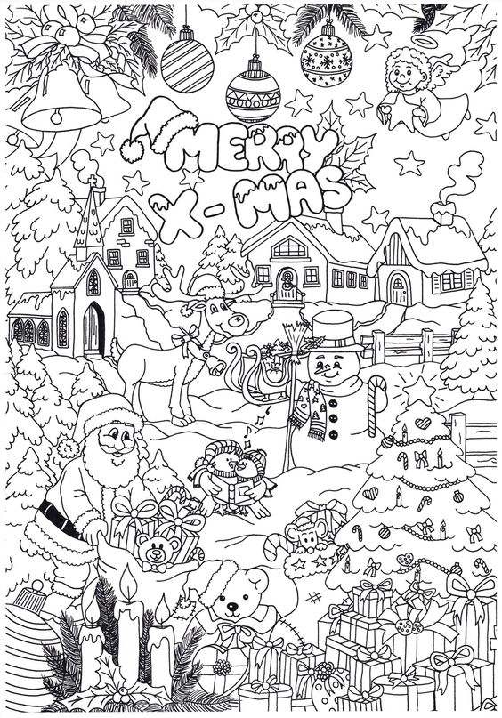

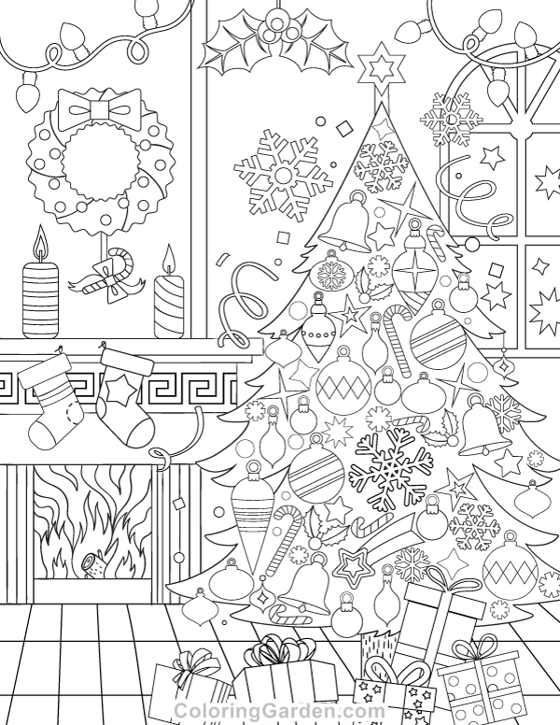

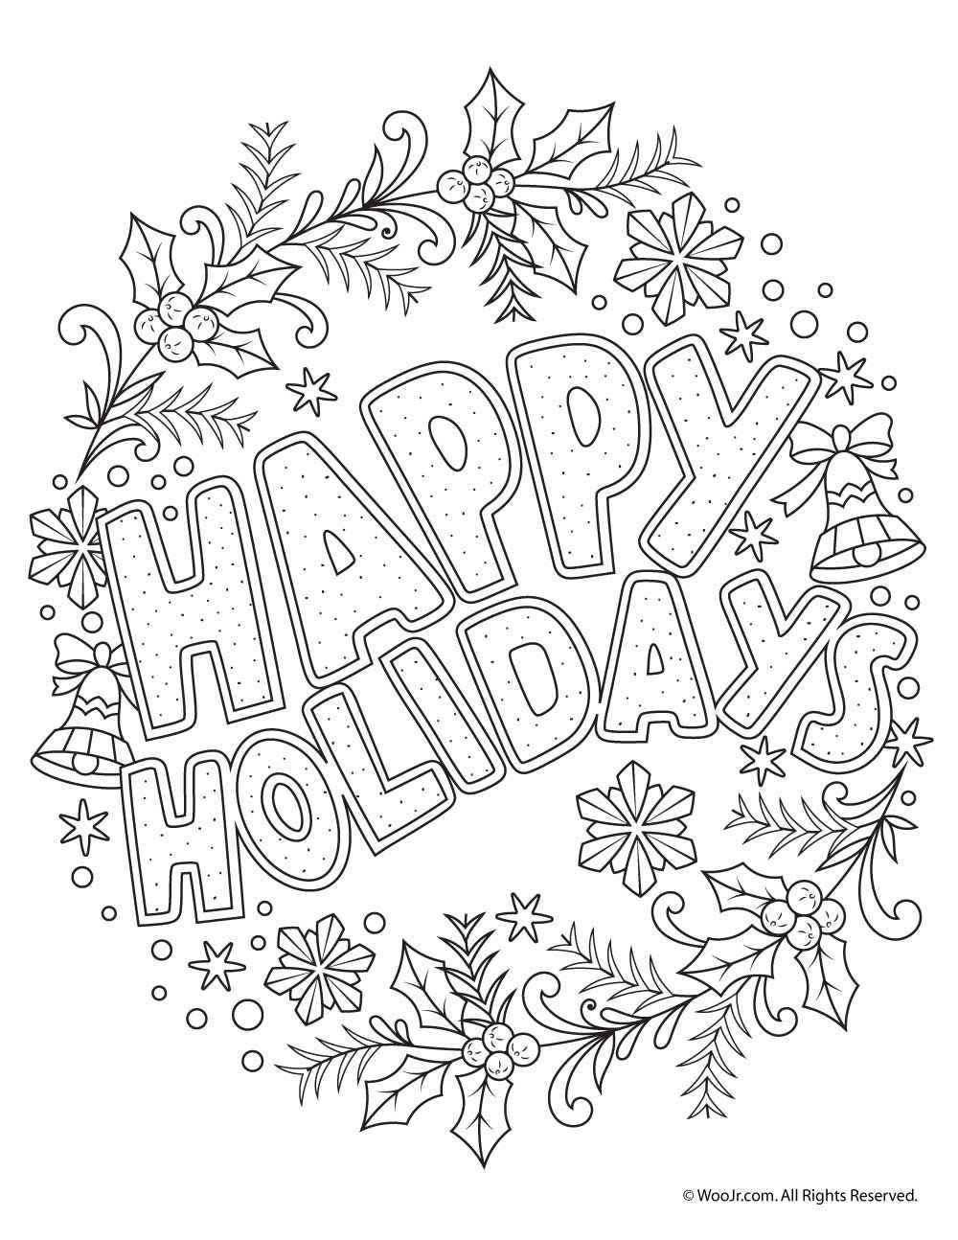

Πόροι εικόνων: coloringGarden.com, gr.pinterest.com

Thank you! See you soon! 🎅

