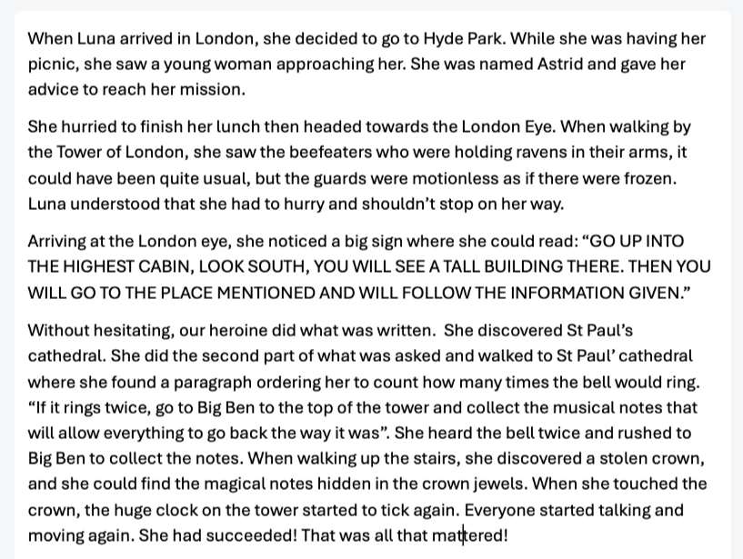
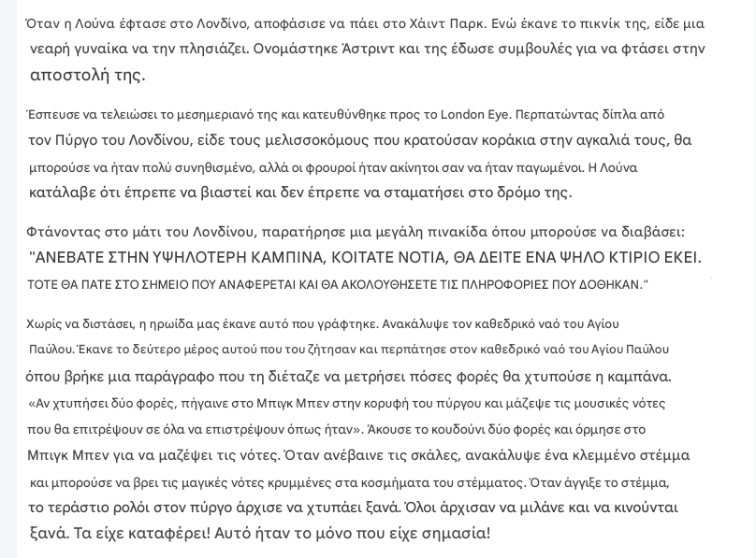

Logbook of Luna-Amelia’s Adventure in London
Day 1: Arrival and Mysterious Encounter Luna-Amelia arrived in London and decided to visit Hyde Park. While enjoying a peaceful picnic, she was approached by a young woman named Astrid. Astrid provided crucial advice that would guide Luna-Amelia on her mission.
Day 1: A Journey Through London’s Landmarks Determined, Luna-Amelia quickly finished her meal and proceeded towards the London Eye. On her way, she passed by the Tower of London, where she saw the Beefeaters holding ravens. However, something was amiss—the guards appeared completely frozen in time. Realizing the urgency of her task, Luna-Amelia continued without stopping.
Day 1: Deciphering the Clues Upon reaching the London Eye, she discovered a large sign with an enigmatic message:
“GO UP INTO THE HIGHEST CABIN, LOOK SOUTH, YOU WILL SEE A TALL BUILDING THERE. THEN YOU WILL GO TO THE PLACE MENTIONED AND WILL FOLLOW THE INFORMATION GIVEN.”
Without hesitation, Luna-Amelia followed the instructions. From the highest point of the London Eye, she identified St Paul’s Cathedral and made her way there.
Day 1: The Cathedral’s Secret Inside St Paul’s Cathedral, Luna-Amelia discovered a passage instructing her to listen for the bell’s chimes. She read:
“If it rings twice, go to Big Ben to the top of the tower and collect the musical notes that will allow everything to go back the way it was.”
Shortly after, the bell tolled twice. Without wasting time, she hurried towards Big Ben.
Day 1: The Final Discovery Ascending the tower, Luna-Amelia made a shocking discovery—a stolen crown! Within the crown’s jewels, she found the hidden magical notes. As soon as she touched them, the enormous clock on the tower began to tick once more. The city resumed its normal rhythm; people moved and spoke again.
She had succeeded! That was all that mattered.

