TIME FOR BREAKFAST
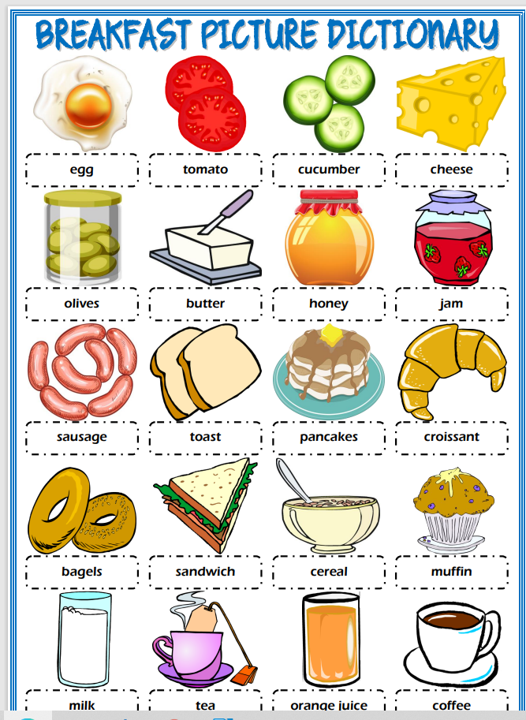

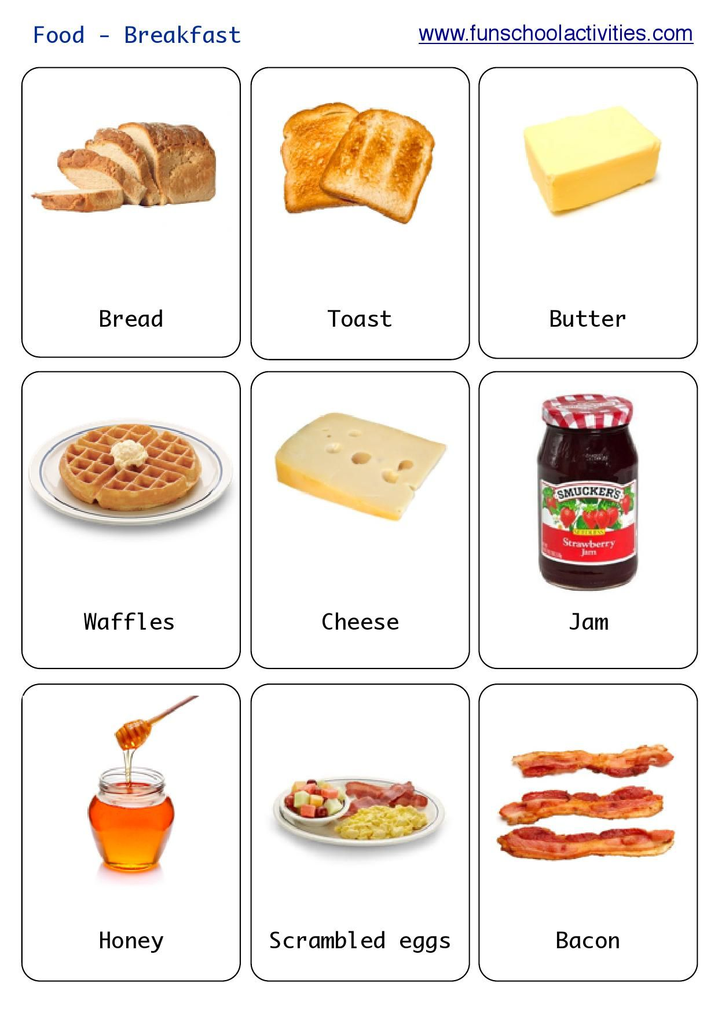

https://www.youtube.com/watch?v=FoXv5X4Y9PM&ab_channel=BabykidTV
breakfast vocabulary

*** “I’m very hungry. Can I have toast, please?”
*** It’s time for breakfast. Let’s make toast!
Τα παιδιά επιλέγουν τι θέλουν στο ψωμί τους: Can I have toast with honey? And some orange juice, please?!
It’s time for breakfast,
let’s make toast
This is what I like the most
I need energy, I am hungry
strawberry jam, juice and honey,
Yes, my breakfast is so yummy!

Peppa pig and the toaster
https://www.youtube.com/watch?v=OJd35E1i0wA

breakfast songs
https://www.youtube.com/watch?v=zT9Qg4pHO8s&ab_channel=KidloTV-EducationalCartoons%2CVideos%26Games
https://www.youtube.com/watch?v=RcAZhPxx_nc&ab_channel=AxieScholarshipProgram

