**UNIT 4, THE WEASEL AND THE MOLE**

**WHAT ARE THEY DOING?**

**e.g. He is playing**

**She is running**

* **Look at the picture and write**

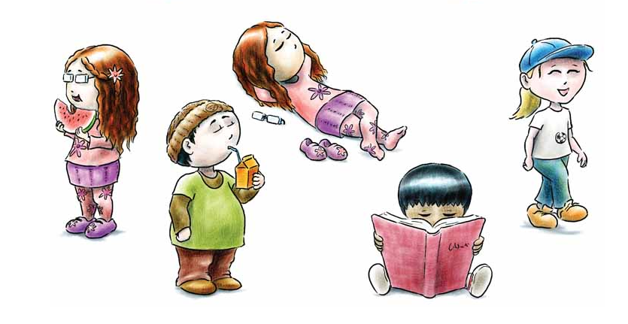 **(LENA, TAMMY, ALEX, YURI )**

**1. _________________________________________________**

**2._________________________________________________**

**3._________________________________________________**

**4.__________________________________________________**

**5.__________________________________________________**