
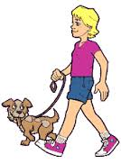
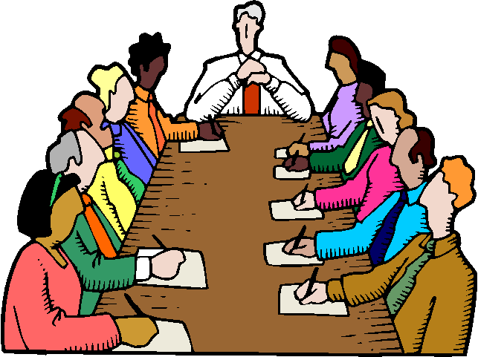
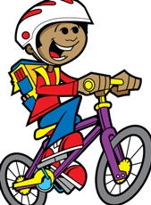
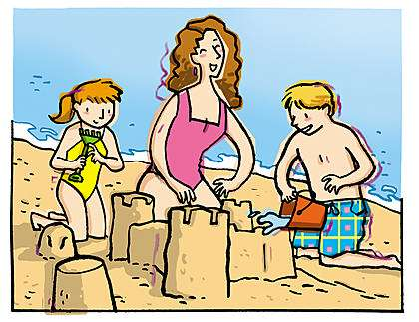
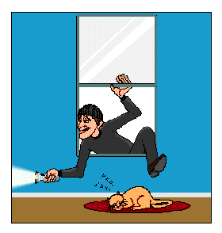
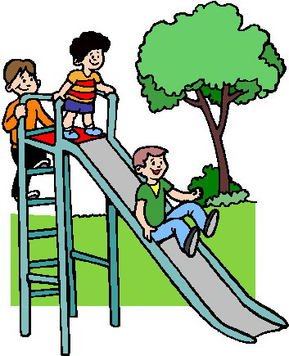

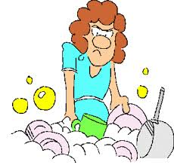
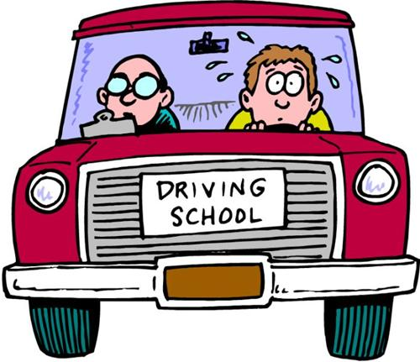
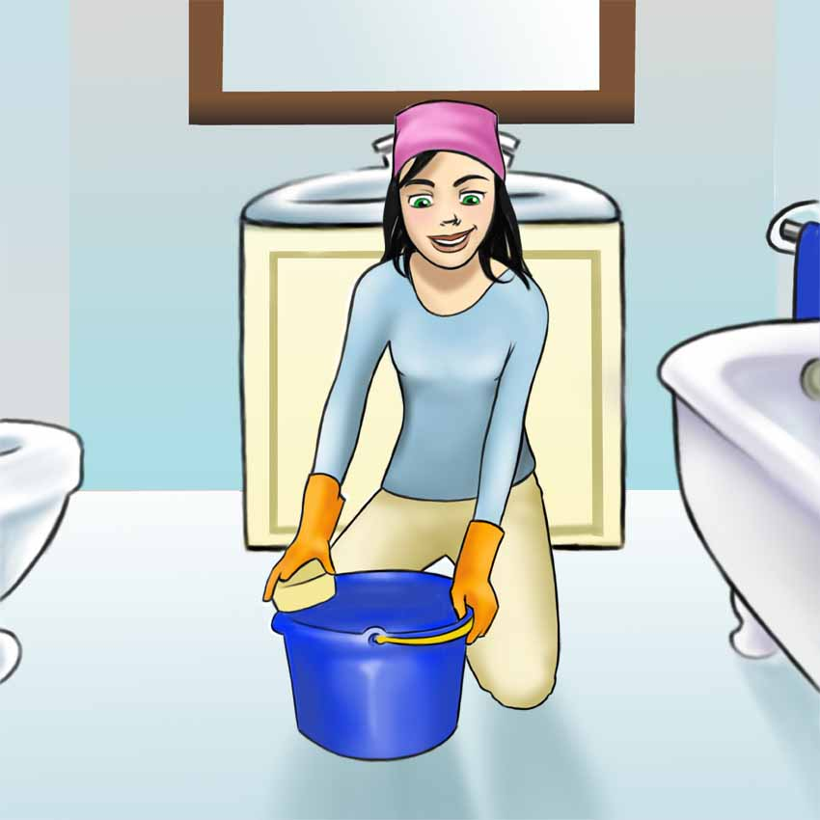
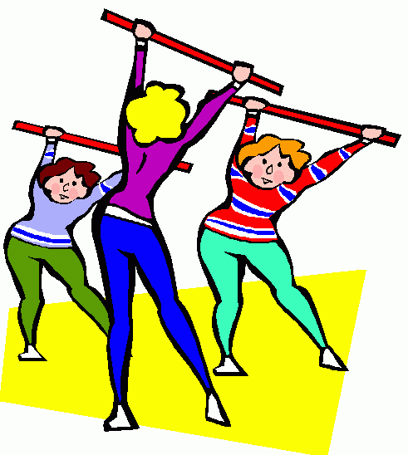
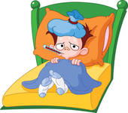
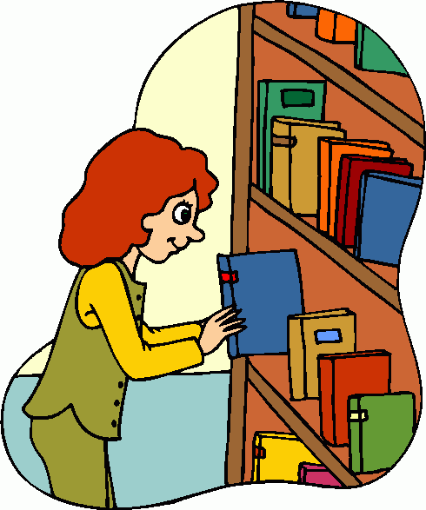

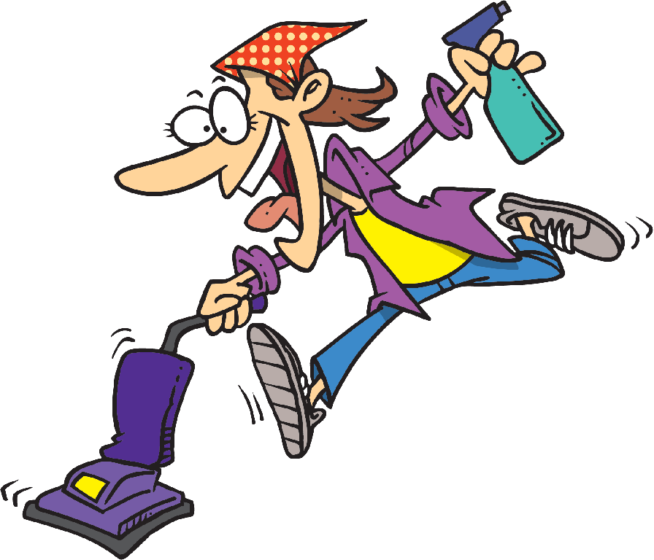

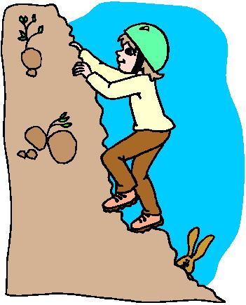


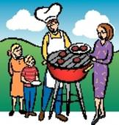
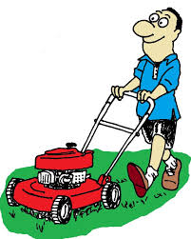
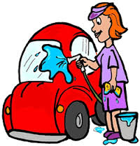
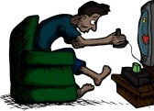
He (watch)-------------------------television
Sam (walk)---------------------------his dog.
Dad (attend) -----------------------a meeting.
Bob(ride) ---------------------------his bike
They (make)-------------------------sandcastles on the beach
The robber (break in) ------------------the neighbour’s house
Ally (clean) ------------------------ her bathroom.
Mum (do) ---------------gymnastics with her friends.
Luke(lie) -------------- in bed because of the flu.
They (play) --------------------------in the park.
The librarian(put) -------------------away the new books
They (enjoy) -------------------------themselves in the sea
Ken (vacuum)---------------------his living room.
Mike( read)---------------------------comics.
Sally(practise) ------------------------ for her concert.
Ann (climb)-------------------rocks all alone.
Debby (draw)----------------------for her Mum.
Kate(do) -------------------------the washing up
David (have)------------------------a driving lesson

They ((have) ------------------------a barbecue together
The twins (work) --------------------on the computer.
John (mow) ----------------------the lawn in his garden.
Sue ( wash) --------------------her car before selling it.
Steve (play)-------------------------video games

Jane (plant) -------------------new flowers in her garden
Choose the correct answer.
Make correct sentences using the past continuous

