Name:
Classic Literature: Aesop’s The Fox and the Stork
Aesop was an ancient Greek writer. He is said to have written many fables, or short stories that have a moral at the end. Below is one of Aesop’s fables. The moral, or lesson, is the last line of the story.

nd

he Fox one day thought of a plan to amuse himself at the expense of the Stork, at whose odd appearance he was always laughing.
T
“You must come and dine with me today,” he said to the Stork, smiling to himself at the trick he was going to play. The Stork gladly accepted the invitation and arrived in good time and with a very good appetite.
For dinner the Fox served soup. But it was set out in a very shallow dish, and all the Stork could do was to wet the very tip of his bill. Not a drop of soup could he get. But the Fox lapped it up easily, and, to increase the disappointment of the Stork, made a great show of enjoyment.
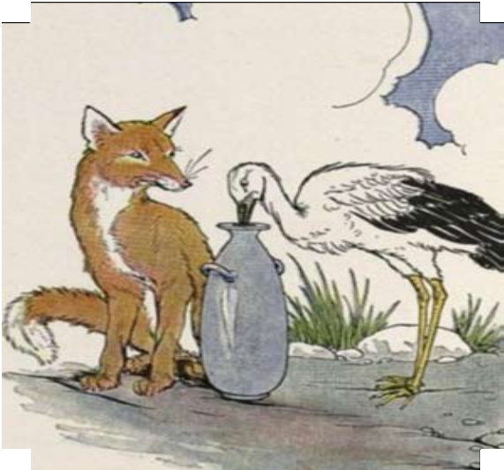
The hungry Stork was much displeased at the trick, but he was a calm, even-tempered fellow and saw no good in flying into a rage. Instead, not long afterward, he invited the Fox to dine with him in turn.

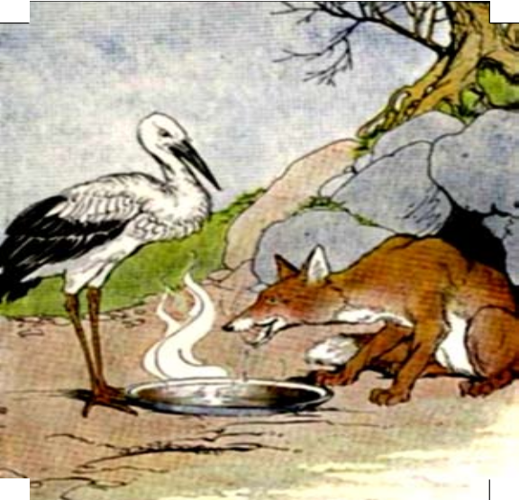
The Fox arrived promptly at the time that had been set, and the Stork served a fish dinner that had a very appetizing smell. But it was served in a tall jar with a very narrow neck. The Stork could easily get at the food with his long bill, but all the Fox could do was
to lick the outside of the jar, and sniff at the delicious odor. And when the Fox lost his temper, the Stork said calmly:
Do not play tricks on your neighbors unless you can stand the same treatment yourself.

The Fox and the Stork: Reading Comprehension
- Order of Events
Put the following events in the passage in the order they happened. Mark the first event with a 1, the second with a 2 and so on.

The Stork could not eat the dinner. The Fox got mad.
The Fox invited the Stork to dinner. The Fox could not eat the dinner.
The Stork invited the Fox to dinner.

The Fox thought of a trick to play on the Stork.

Who Was It?

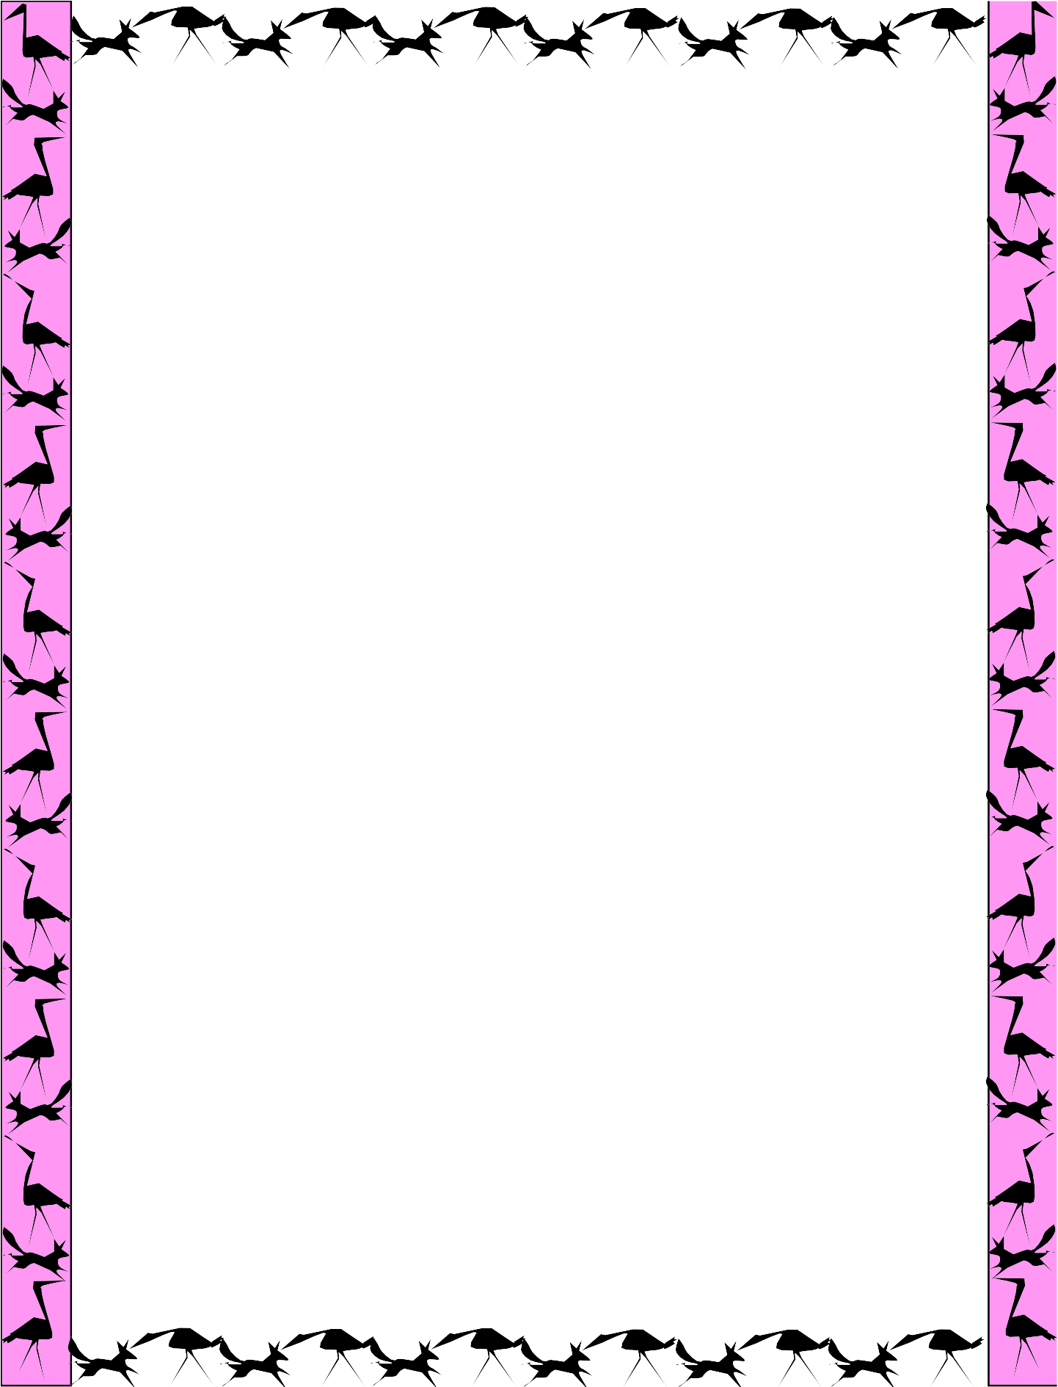

- Who served dinner in a jar?

- Who thought the other one looked odd?

- Who “saw no good” at getting angry?

- Who said the moral of the story?

- Who couldn’t eat the fish?

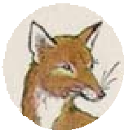
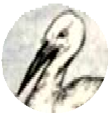

The Fox and the Stork: Words and Phrases
  - Vocabulary Match
Match each word in Column A with its meaning in Column B.

Column A Column B
- appetite A. unhappy

- lapped B. desire to eat

- promptly C. good tasting

- displeased D. drank

- delicious E. at the exact time

Idioms and Expressions
Below are idioms and expressions from the fable. Write what you think each one means.

- “amuse himself at the expense of the Stork”

- “even-tempered fellow”

- “flying into a rage”

- “great show of enjoyment”

- “lost his temper”

Main Idea in The Fox and the Stork
Below is one of the main ideas of the passage. Find three examples from the text that support this main idea.

1. _______________________________________________________________________

The Stork didn’t get mad about the trick played by the Fox.
2. ______________________________________________________________________
3. _______________________________________________________________________

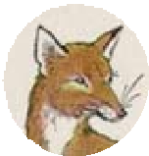
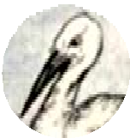

Characters in The Fox and the Stork
The moral of the fable was, “Do not play tricks on your neighbors unless you can stand the same treatment yourself.” Think about how the moral relates to the characters in the fable. Compare the Fox and the Stork. How are they alike? How are they different?
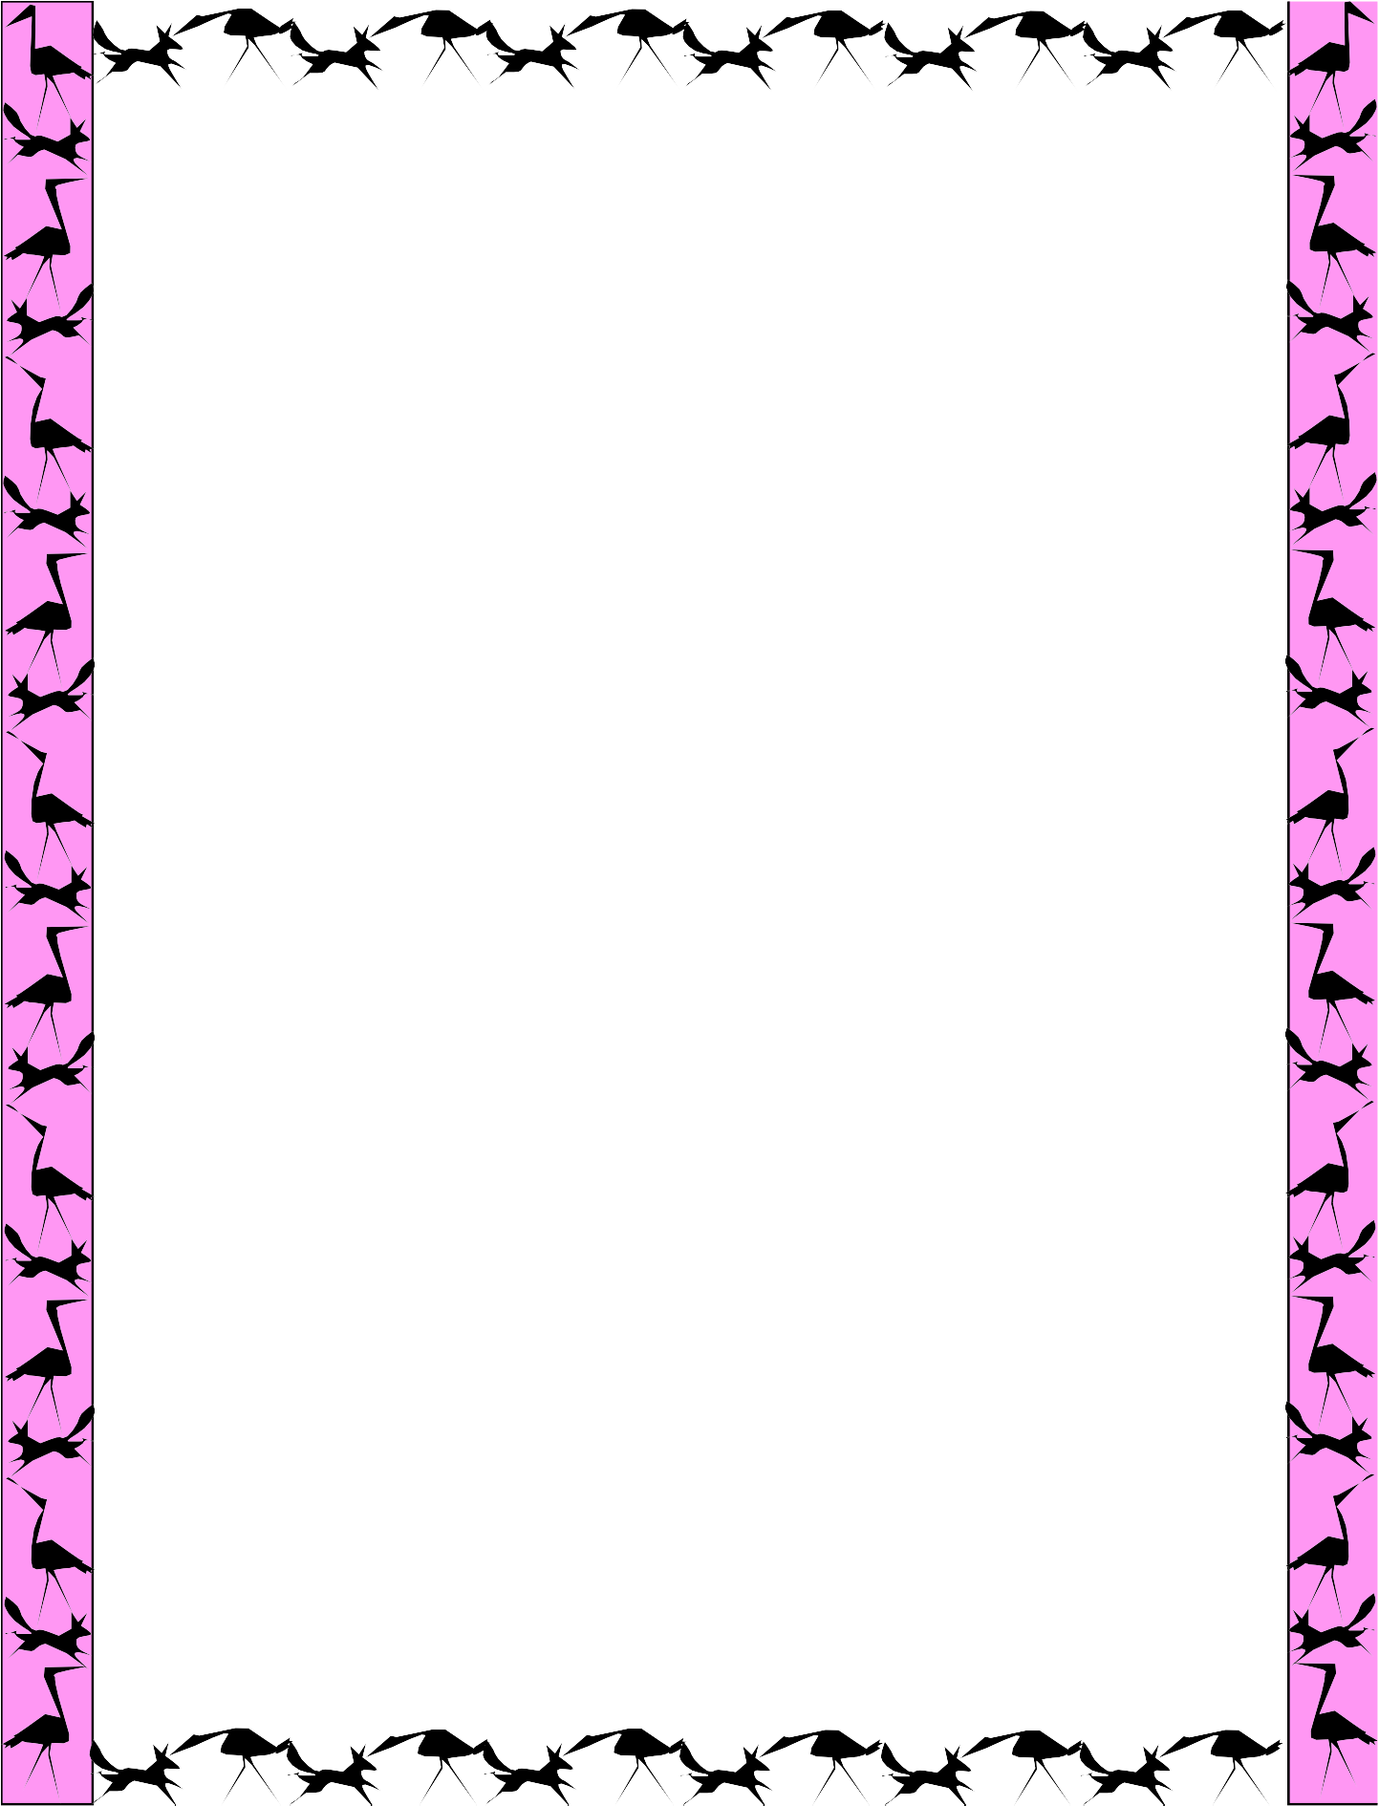

The Fox and the Stork Word Search
Circle each word from the list in the puzzle. The words can go in any direction.

i | f | Z | t | m | o | r | a | l | a | b | W | D
p | i | v | n | h | r | Y | o | Q | s | t | o | O
d | s | n | e | v | c | a | l | m | d | r | Q | K
f | h | o | i | n | v | i | t | a | t | i | o | N
o | e | b | b | t | t | h | d | G | t | c | d | S
a | d | u | u | f | a | b | l | e | G | k | i | O
k | p | l | f | e | s | a | Q | i | d | o | n | E
t | n | p | s | t | o | r | k | W | t | d | n | U
e | Q | Z | e | l | u | r | f | n | t | l | e | I
m | i | c | h | t | p | o | W | p | e | o | r | K
p | m | d | G | p | i | Q | W | h | l | s | k | K
e | e | f | c | G | d | t | t | f | o | x | r | M
r | s | W | Q | d | h | G | e | G | u | Y | v | A

appetite calm
dinner
fable fish
fox
invitation moral
soup
stork temper
trick

