*NAME: _______________________________________*

**The giving tree by Shel Silverstein**

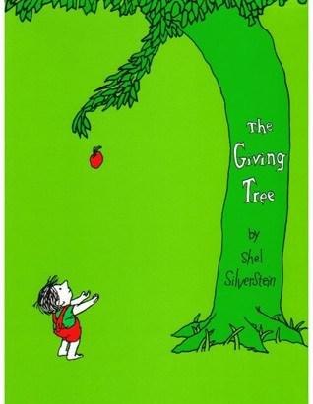

**Read the story** <https://allpoetry.com/poem/8538991-The-Giving-Tree-by-Shel-Silverstein>

**Watch the video** <https://www.youtube.com/watch?v=XFQZfeHq9wo>

**and answer the questions**

1. What’s the title of the story?
2. Who wrote this story (author/writer)?
3. Can you suggest another title for this story?
4. Think of adjectives to describe the characters in this story
5. What’s this story about? (topic, meaning)
6. Write a summary of the story
7. Did you like the story (opinion)? Why? Think of 1-2 adjectives to describe this story