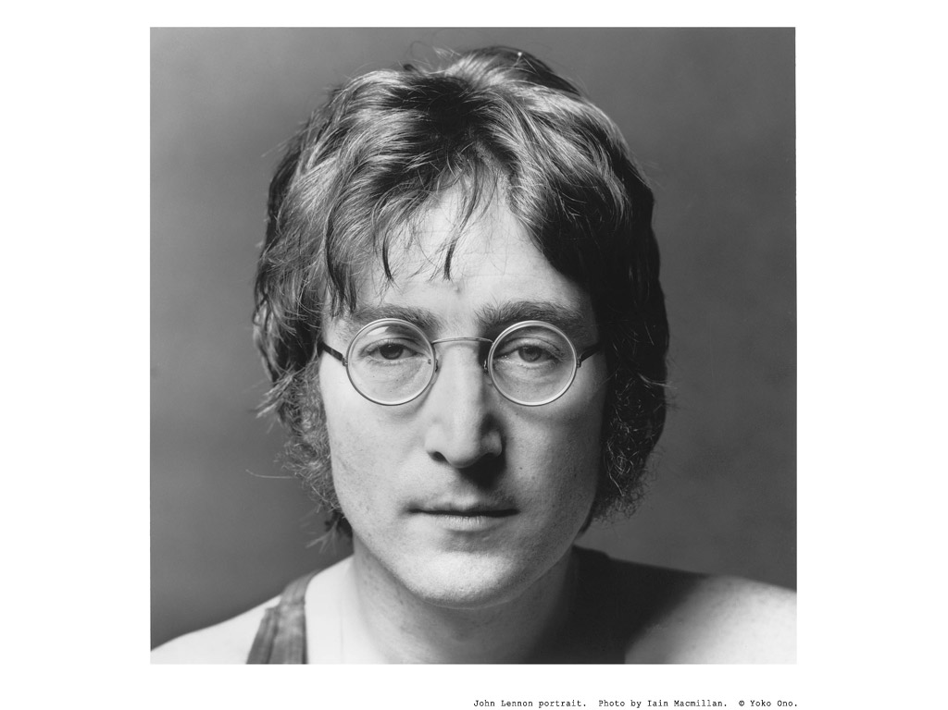
John Lennon - Imagine
Imagine there's no ____________
It's easy if you try
No ____________ below us
Above us only sky
Imagine all the ___________ living for today
Imagine there's no _____________
It isn't hard to do
Nothing to _____________ or die for
And no religion too
Imagine all the people living life in ___________
You, you may say
I'm a ______________, but I'm not the only one
I hope someday you'll join us
And the ______________ will be as one
Imagine no ______________
I wonder if you can
No ___________ for greed or hunger
A brotherhood of man
Imagine all the people _____________ all the world
You, you may say
I'm a ______________, but I'm not the only one
I hope someday you'll join us
And the _______________ will live as one

https://www.youtube.com/watch?v=YkgkThdzX-8

https://www.youtube.com/watch?v=L6svOHFSAH8

