UNIT 2- FOOD PROJECT
HEALTHY FOOD PYRAMID
https://www.youtube.com/watch?app=desktop&feature=share&v=FvqHuoZlKmc&ab_channel=PhilPhilms the countable noun song

https://docs.google.com/presentation/d/e/2PACX-1vRVL0DMbSXPTYsqQO-Nz5J41-MO5K9UZGyM0jEnRBgTNVj5RXQjLeqGz33Gu2DoJXSrAhW3n5dfctXM/pub?start=false&loop=false&delayms=3000&slide=id.p
unit 2, lesson 1, vocabulary

https://docs.google.com/presentation/d/1cTLx-kF-pdoCL-QXn_ko0Ip26BcPGT8MaGBM66VT7-I/mobilepresent?slide=id.gaca6f6f103_0_126

lesson 1, vocabulary quizlet games
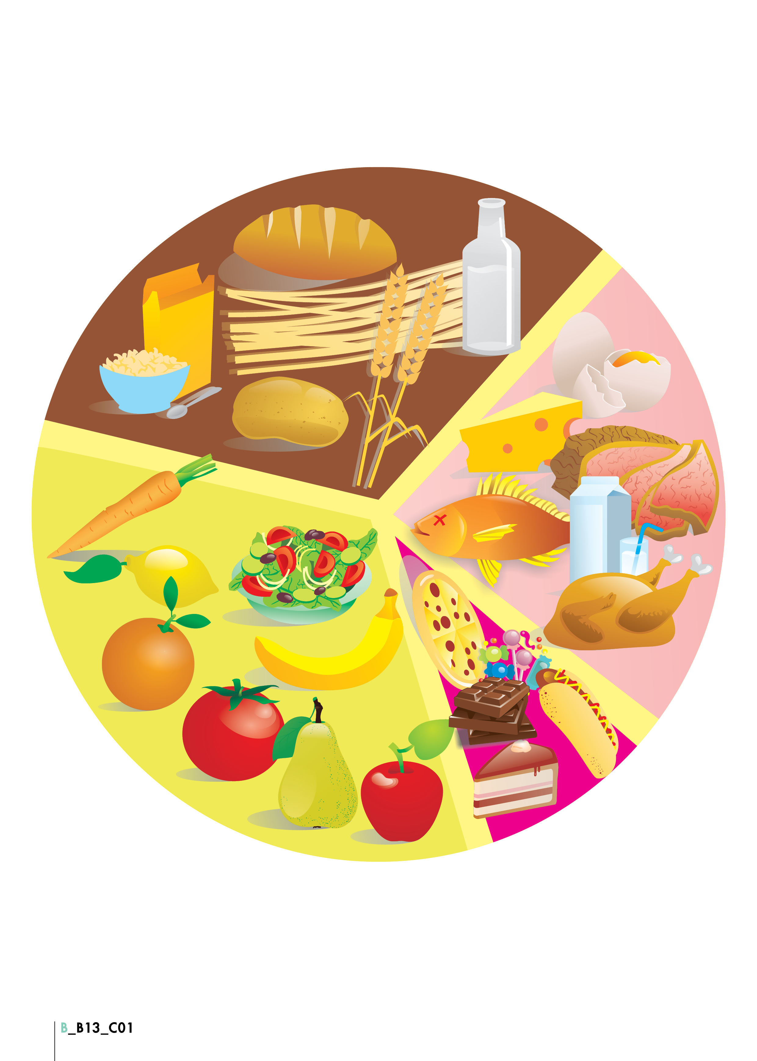

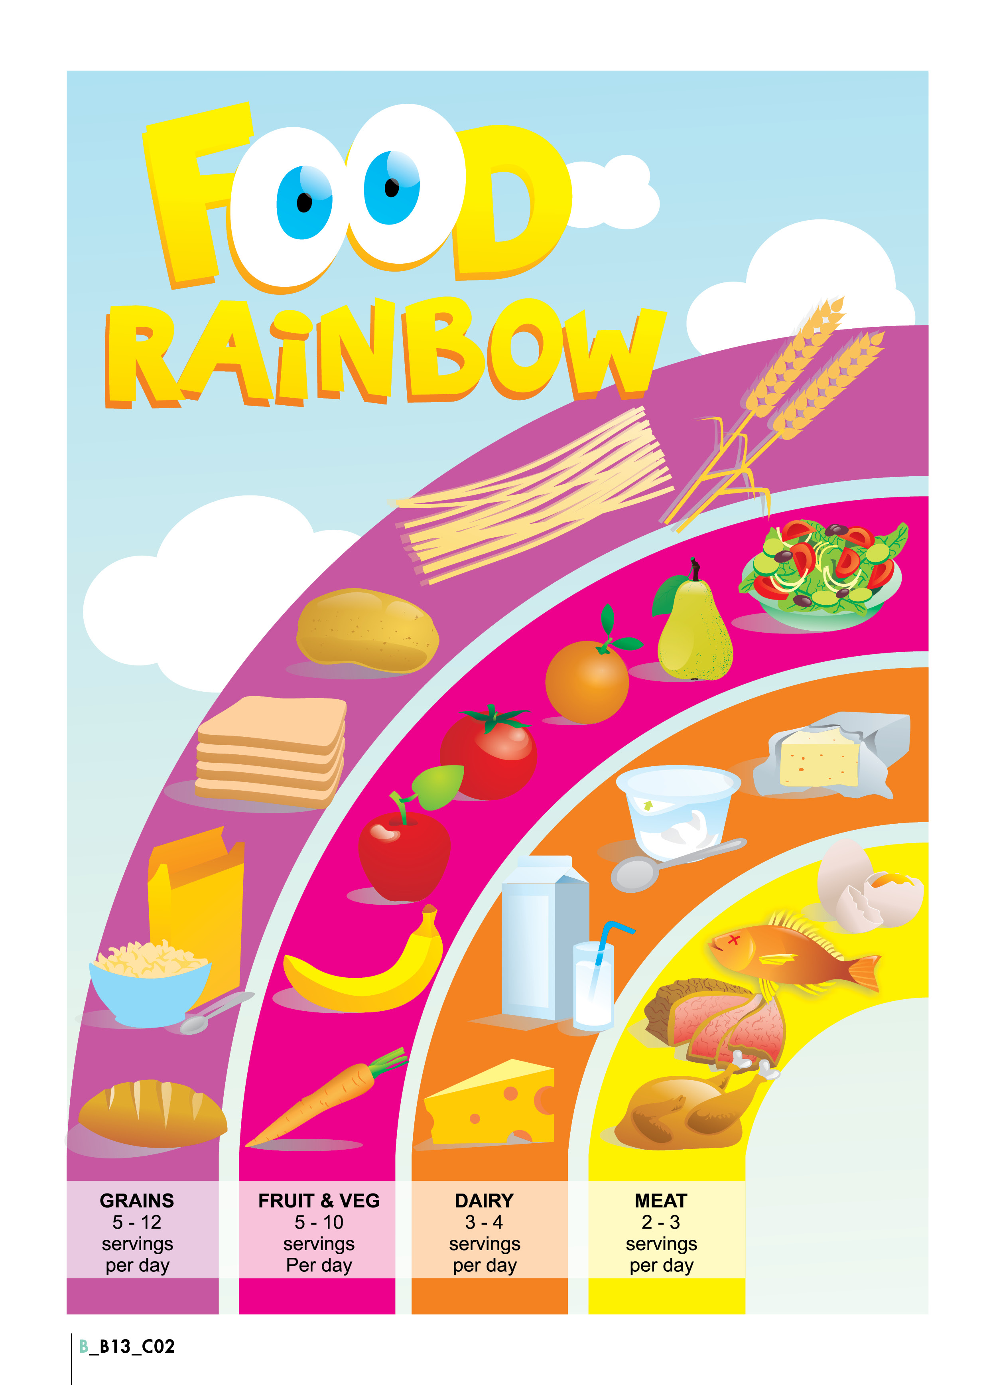

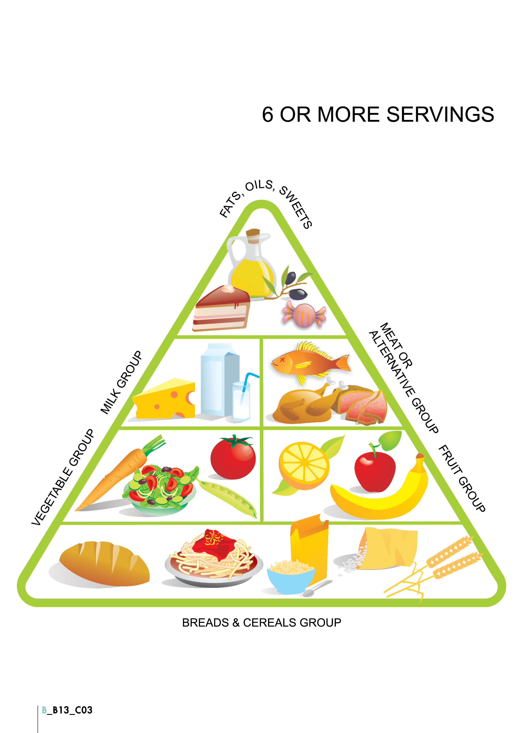
https://view.genial.ly/61803bb67516f70d8cd3a6a7/interactive-content-food-quiz

https://wordwall.net/resource/24279256/at-the-supermarket

https://docs.google.com/presentation/d/1_1QIFaMhJ92yt4xvGCDMZ8QjneQ_GEjyivRvhQ6BhRM/mobilepresent?slide=id.gaf8fae9e71_0_3
vegetables

https://wordwall.net/resource/1221197/countable-uncountable-food-result-unit-3

https://docs.google.com/forms/d/1bkWHQe5A9tYf61_zd9g3lNcDfphWoFL2PXrhymMkx84/edit?usp=sharing

quiz, lessons1+2, grammar, google forms

https://wordwall.net/resource/5535874/places-to-shop

https://quizlet.com/544823534/going-shopping-flash-cards/?x=1jqt

https://quizlet.com/532713111/6th-grade-unit-2-shopping-places-flash-cards/

https://youtu.be/RQfdJCn1xA8

my shopping list

https://edpuzzle.com/media/5fb6473fe736f740e9adf38b

