UNIT 5, READY FOR ACTION

**MODALS- CAN, MUST, SHOULD**

[**https://safeYouTube.net/w/uicF**](https://safeYouTube.net/w/uicF) **(a short video)**

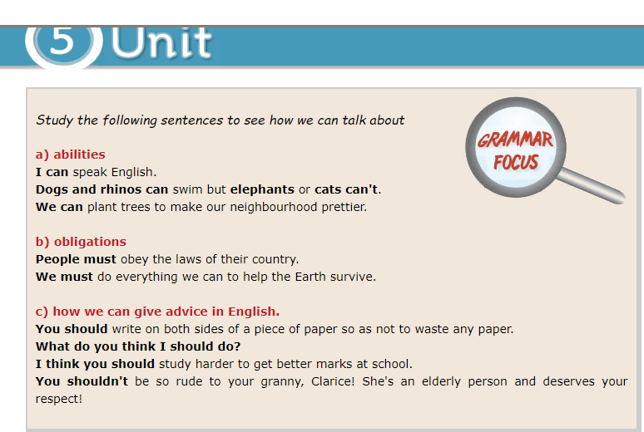

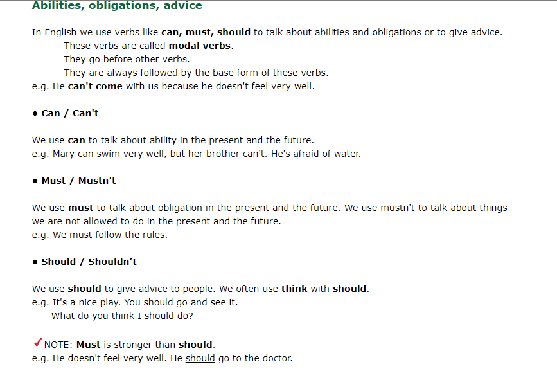

* **Study the theory and the rules first and then try the activities**

1. Can/can’t, must/mustn’t OR should/shouldn’t

a. ________ you help me, please?

b. You __________ do more sport if you want to lose weight.

c. I ___________ speak Chinese, it’s too difficult!

d. You ________ do your homework first if you want me to let you go out with your friends!

e. He _________ smoke so much, it’s bad for his health.

f. We _________ eat in the classroom.