El Greco (Domenikos Theotokopoulos), UNIT 7, LESSON 1

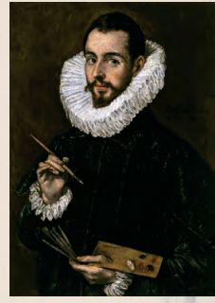
Write the verbs in the Simple Past tense

El Greco was born in Crete in 1541. As a young man he ____________ (study) Byzantine icon painting. He __________ (travel) to Venice in 1567. He ________ (live) and ________ (work) in Rome until 1577. In 1577 he _________ (move) to Spain in Toledo, near Madrid. He __________ (die) in 1614 at the age of 73. His paintings __________ (influence) many famous artists after him. In honour of El Greco, Nikos Kazantzakis __________ (call) his autobiography ‘’ A tribute to Greco’’.

SIMPLE PAST OF REGULAR VERBS
show ___________
stop ____________
plan _____________
play _____________

