

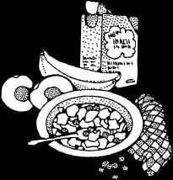


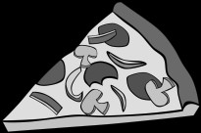





NAME: ________________________ DATE: ______________
FUTURE: GOING TO
● The weekend starts tomorrow and Sam is going to be very busy.
Write sentences using the picture prompts and ‘going to’.

1. 5.
2. 4
3.

6. 7. 8. 9.
10.

1. ___________________________________________________________________
2.___________________________________________________________________
3. ___________________________________________________________________
4. ___________________________________________________________________
5.___________________________________________________________________
6. ___________________________________________________________________
7. ___________________________________________________________________
8.___________________________________________________________________
9. ___________________________________________________________________

10. __________________________________________________________________

