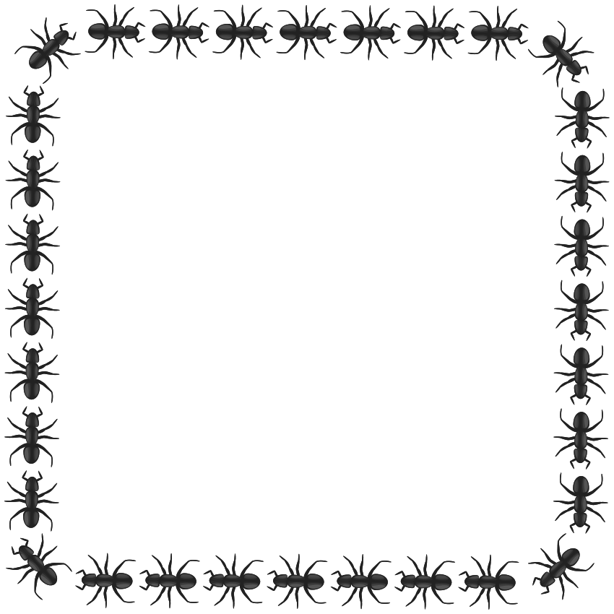

A DAY IN THE PARK!

**1. Complete the text with the correct form of the verb in brackets. Use the present simple or present continuous.**

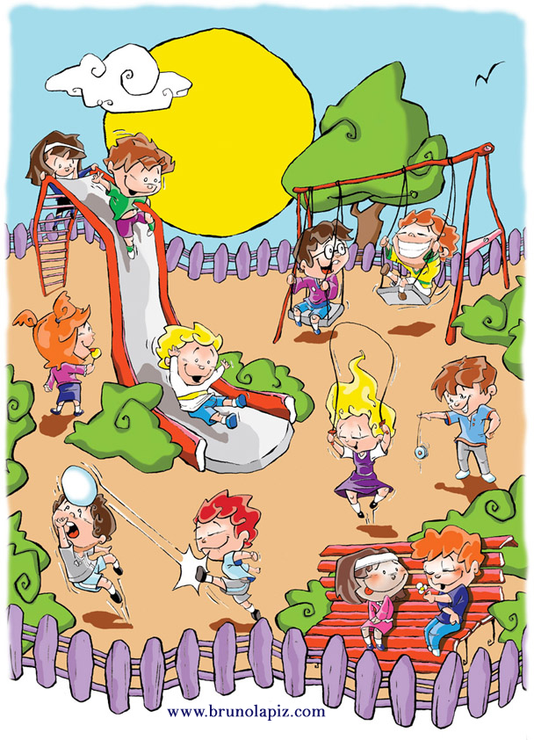 Hello! I’m Lisa and I am 10 years old. Today it ___________ (be) sunny in my town. My parents _____________ (buy) some food for lunch in the supermarket and I _____________ (play) at the park near my house. Every Sunday, I _____________ (play) here with my friends.

In the park, there are a lot of people. I ______________ (wear) a purple skirt with a pink T-shirt. I ______________ (eat) a sweet. Tom and David ______________ (have) fun on the swings. David always ____________ (wear) glasses. Rachel ___________ (skip). She _______________ (wear) a purple dress with a white T-shirt. Jenny and Mike ________________ (chat) on a bench. Tim and Kevin _____________ (play) football. Tim ___________ (have got) red hair like me. Michael is playing with a yo-yo. And Luis, Imran and Jenny _____________ (play) on the slide. Luis __________________ (wear) blue shorts with a white and yellow T-shirt and he ______________ (have got) blond hair. It ____________ (be) 12 p.m. and I _______________ (go) home to have lunch.