NAME: ______________________________________

DATE: ______________________________________

The two main **British Isles** are:

a) _________________________________________________

b) _________________________________________________

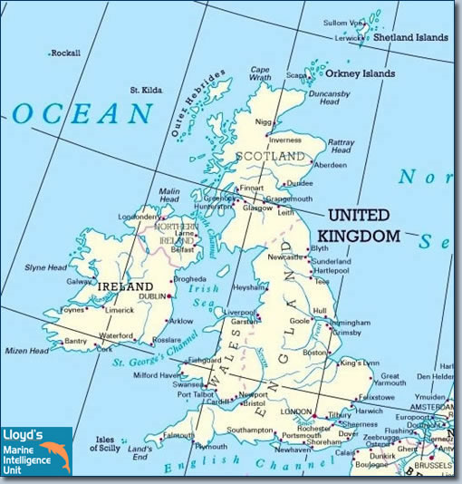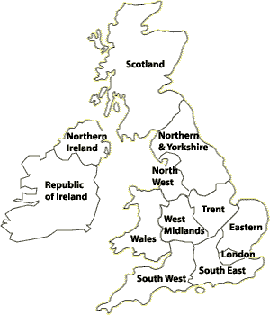

Colour the map of **the United Kingdom**:

England: red, Wales: orange, Scotland: blue, Northern Ireland: green

1. THE UNITED KINGDOM

The island of **Great Britain** is made up of:

a) _________________________________________________

b) _________________________________________________

c) _________________________________________________

The **United Kingdom**:

a) _________________________________________________

b) _________________________________________________

c) _________________________________________________

d) _________________________________________________

The **population** of the United Kingdom is _________________________________________ million people.

The **capital** of the United Kingdom is ______________________________________.

The **population** of London is _________________________________________ million people.

The national flower of ________________________________ is the rose (τριαντάφυλλο).

The national flower of ________________________________ is the daffodil (ασφόδελος).

The national flower of ________________________________ is the thistle (γαϊδουράγκαθο).

CLASS 5 UNIT 1 page 22 WORKSHEET 5.1.3

1. THE **REPUBLIC** OF **IRELAND (EIRE)**

The **Republic of Ireland (Eire)** is the southern part of the island of Ireland.

The **population** of the Republic of Ireland (Eire) is _____________________________________ million people.

The **capital** of the Republic of Ireland (Eire) is ______________________________________.

The **population** of Dublin is _________________________________________ million people.

The national flower of___________________________________________ is the shamrock. (τριφύλλι)

1. **GREECE**

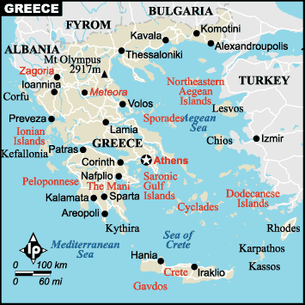 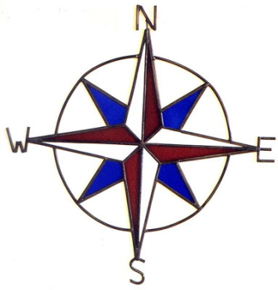

W=west (δύση), N=north (βορράς), S=south (νότος), Ε=east (ανατολή)

The **population** of Greece is _________________________________________ million people.

The **capital** of Greece is ______________________________________.

The **population** of Athens is _________________________________________ million people.