



# Write the adjectives in brackets in the Comparative form.

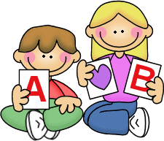

* 1. 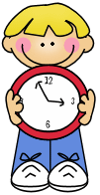John Lennon was (OLD) Paul McCartney.
  2. Some people think the Met is (GOOD) the Louvre.
  3. Eric was (AFRAID) in Harlem in the Subway.
  4. Cats are (NICE) dogs.
  5. Cartoons are (GOOD) music programmes.
  6. The Empire State is (BIG) the Chrysler Building.
  7. Barcelona is (SMALL) Madrid, but (BIG) Valencia.

# Write the adjectives in brackets in the Superaltive form.

* 1. Samantha is the (PRETTY) girl that Paul has ever met.
  2. I think that King Kong was the (BAD) film ever!
  3. Mounth Everest is the (HIGH) mountain in the world.
  4. Our English teacher is the (GOOD) teacher ever!
  5. My room is the (CLEAN) room in my house.
  6. Ron is the (CLEVER) person I’ve ever met.
  7. The Millenium Star is one of the (EXPENSIVE) diamonds in the world.

# Complete the table. Pay attention and don’t forget *than* or *the*.

|  |  |  |
| --- | --- | --- |
| ADJECTIVE | COMPARATIVE | SUPERLATIVE |
| Good |  |  |
| Nice |  |  |
| Dangerous |  |  |
| Expensive |  |  |
| Bad |  |  |
| Big |  |  |
| Pretty |  |  |
| Fast |  |  |
| Happy |  |  |
| Friendly |  |  |
| Sad |  |  |
| Boring |  |  |



