Likes and Dislikes Worksheets

# s

I like

I like

I don’t like

I don’t like

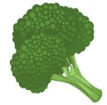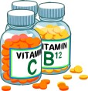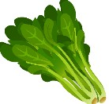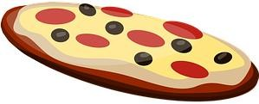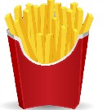

**Complete the sentences using the verb in the affirmative or negative**

James **likes** pizza. Emma chicken. Emma eggplant. James carrots.

Emma chocolate. Emma ice cream. James milk.

Emma candies.

James spinach.

Emma **likes** fries.

Emma **doesn’t like** cheese. James egg. James ice cream. Emma spiders.

James computer. Emma broccoli. James bats.

James burgers.

<https://whatistheurl.com/>

# Likes and dislikes Worksheets

Clue: Name of all items available in the previous page)

**What does James Like?**

**(Name the items below)**

**What does Emma Like? (Name the items below)**

_

_

_

_

_

_

_

_

_

_

**What doesn’t James like?**

**(Name the items below)**

**What doesn’t Emma like?**

**(Name the items below)**

_

_

_

_

_

_

_

_

_

_

<https://whatistheurl.com/>