# Name: Date:

**GRAMMAR WORKSHEET**

**PRESENT CONTINUOUS**

**Describing a picture**

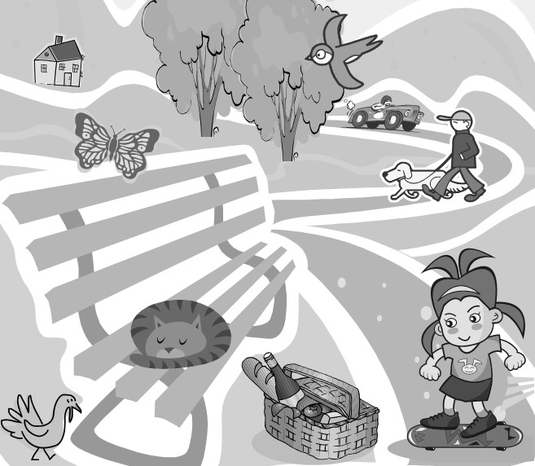

# Use the ‘ing’ form of the verbs.

In the picture, there is a young girl in a park. She ***(stand)*** on a skateboard and she ***(smile)*** and ***(look)*** at a picnic basket full of food. Next to the basket there is a cat. It ***(sleep)*** on a bench, and behind the bench there is a bird. It ***(walk)*** on the ground. There is another bird, as well, but it ***(fly)*** . There is also a butterfly, and it ***(fly)*** , too. In the background there is a man. He ***(walk)*** his dog. He should be careful because there is a man ***(drive)*** a car very fast on the road behind him.

* ***Bench= παγκάκι, on the ground= έδαφος***