**Name: Date:**

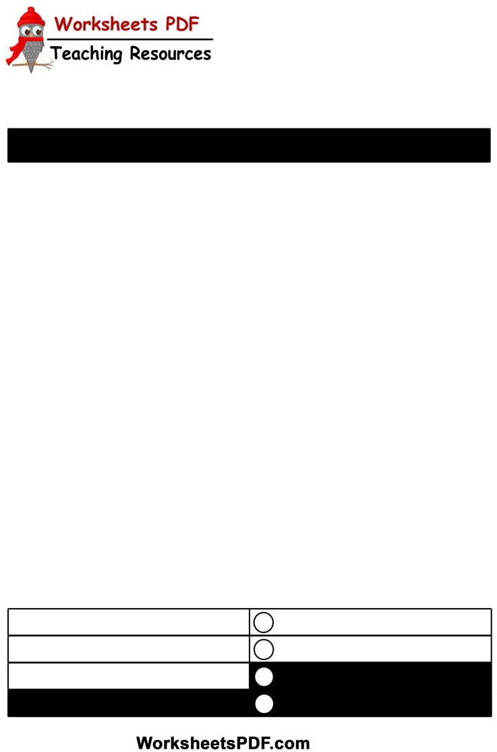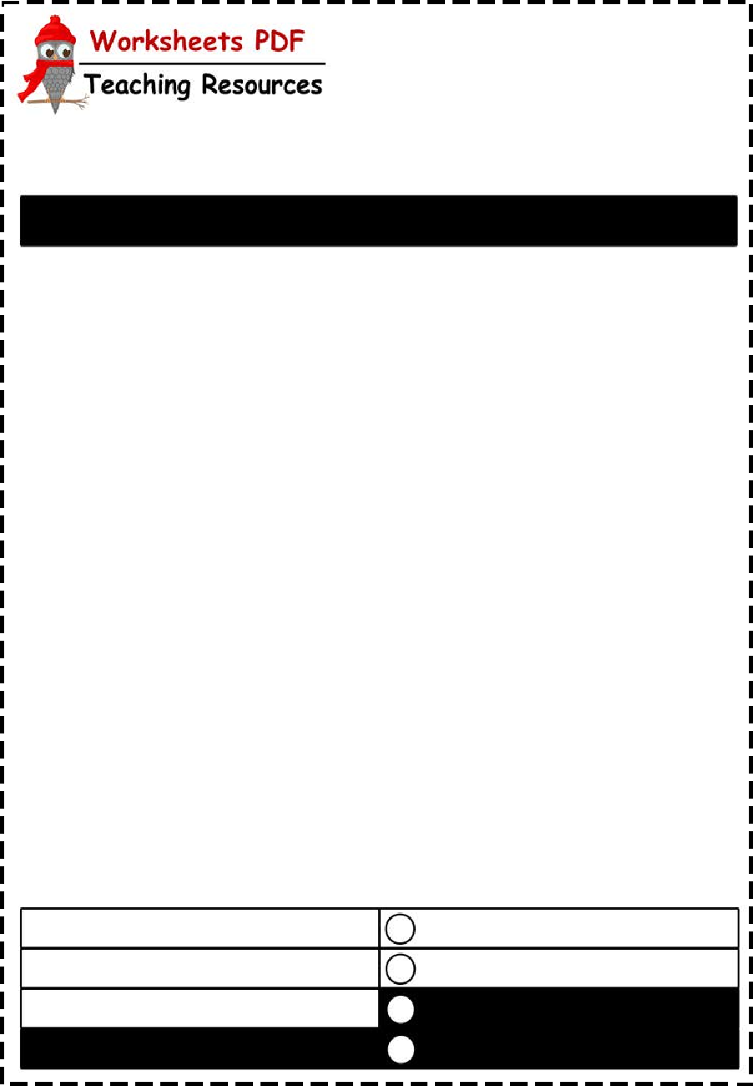

PRESENT SIMPLE

1. Complete the sentences using the following verbs:

cause(**s**), connect(**s**), drink(**s**), live(**s**), open(**s**),speak(**s**), take(**s**)

1 Tanya **speaks** German very well.

2 I don't often coﬀee.

3 The swimming pool at 7.30 every morning. 4 Bad driving many accidents.

1. My parents in a very small flat.
2. The Olympic Games place every four years.
3. The Panama Canal the Atlantic and Pacific Oceans.
4. Put the verb into the correct form
   1. Julie **do**_**e**_**s**_**n**_**’t d**_**ri**_**n**_**k**_ (not / drink) tea very often.
   2. What time (the banks / close) here?
   3. I've got a car, but I (not / use) it much. 4 Where (Ricardo / come) from?
5. What (you/do)?
6. It (take) me an hour to get to work. How long_______________________________ (take) you?
7. Look at this sentence. What (this word / mean)?
8. David isn't very fit. He (not / do) any sport.
9. Form positive, negative statements or questions.

She sits on a chair. **?**

You read a book. ?-

Mary doesn't like apples. +

My dog plays with a ball. -