1° Answer the questions: /20
a) Today is Friday.
- What day was it yesterday? (1 pt) Yesterday ……………….……………..………………………………………………..………
- What day will it be tomorrow? (1 pt) Tomorrow ……………………………………………………………………..…………….
b) (YES / NO QUESTION) Have you got French on Friday afternoon ? (0,5) ……………………………………………………
c) (YES / NO QUESTION) Have you got English on Wedsneday? (0,5) ………..………………………………………..………..
2° SCHOOL SUBJECTS
 | MONDAY | TUESDAY | WEDNESDAY | THURSDAY | FRIDAY
  CAROL |  | 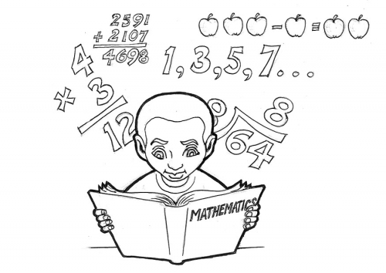 |  |  | 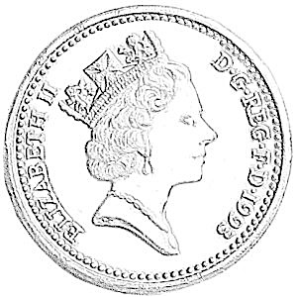
  SAM |  |  |  | 
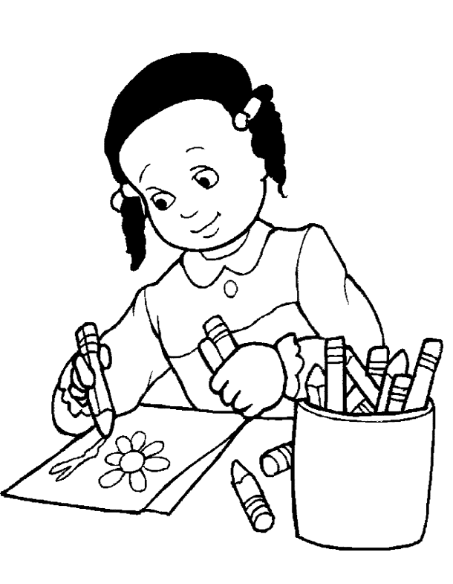  BETTY |  | 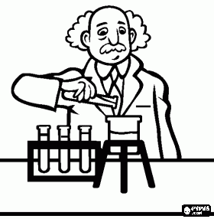
- Παρατηρώ το σχολικό πρόγραμμα της Κάρολ, του Σαμ και της Μπέτυ και σημειώνω Σωστό (Σ) ή Λάθος (Λ): (4 pts)
Carol has got Sciences on Wednesday  Carol and Betty have got French on Monday  Betty has got Art on Tuesday  Carol hasn’t got English on Friday | ☐ true ☐ false  ☐ true ☐ false  ☐ true ☐ false  ☐ true ☐ false | Sam has got Music on Friday  Carol has got French on Thursday  Betty has got English on Tuesday  Sam hasn’t got PE on Thursday | ☐ true ☐ false  ☐ true ☐ false  ☐ true ☐ false  ☐ true ☐ false
b. Συμπληρώνω με τη σωστή μορφή του ρήματος HAVE GOT όπου είναι απαραίτητο και το κατάλληλο μάθημα (10 pts):
Carol ……………..……………………….…………………….. on Monday.  Sam …………………………………………..…………………. on Monday.  Betty …………..…………………………………….…………. on Monday.  Carol …………………………………………………………….. on Tuesday.  Sam and Betty haven’t got ……………………………. on Tuesday. | Carol hasn’t got ………………………..……..…….. on Monday.  Sam hasn’t got …………………………………….…. on Monday.  Betty hasn’t got …………………….…………….…. on Monday.  Betty has got ………………………………………….. on Wednesday.  Sam hasn’t got ……………………………………….. on Wednesday.
c. Απαντώ τις ερωτήσεις (YES / NO QUESTIONS) αντικαθιστώντας τα υπογραμμισμένα ονόματα με προσωπικές αντωνυμίες (3 pts):
- Has Carol got Music on Wednesday ? ……………………………………………………………………………………………………
- Have Betty and Sam got Art on Monday ? …………………………………………………………………………………………….
- Has Betty got English on Friday ? …………………………………………………………………………………………………………

