**Test Unit 4 - E class Name:**

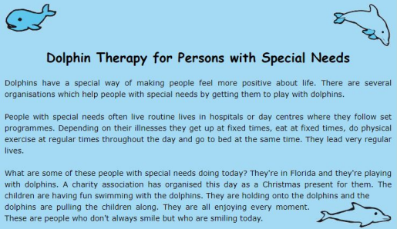**Διάβασε το κείμενο και κάνε την άσκηση που ακολουθεί Σωστό ή λάθος;**

Dolphins make people happy.

**T**

**F**

People with special needs don’t usually follow a programme. **T**

**F**

They are at a dolphin centre in Florida now. The children are swimming with the dolphins. The children with special needs always smile.

**Διάλεξε τη σωστή ερωτηματική λέξη**

**Who/Where** are you from? I’m from England. **Who / Whose** is that car? It’s John’s. **When / How** do you travel to school? By bus.

**T**

**T**

**T**

**F**

**F**

**F**

**Where / Why** are you happy? Because I’m going on a trip to Paris! **How much / How long** is it? It’s 20 euros.

**Διάβασε το κείμενο και συμπλήρωσε τις λέξεις που λείπουν**

postcard historic enjoying speak tastes Hi, Nadine!

Tunisia is beautiful and a lot of people __________ French here. We are visiting a lot of ______________ places. The food _____________ "different", - sometimes I don't know what I'm eating!

Today we are visiting a town near the Sahara. Lots of people have camels!We are ______________every moment of our holiday. Hope you like my________________!

Love,

Mark

**Τι λένε τα άτομα στη κάθε φωτογραφία; Χρησιμοποίησε τα ρήματα αίσθησης feel - look - taste - smell και κατάλληλα επίθετα για να συμπληρώσεις τα συννεφάκια.**

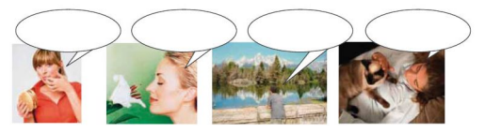**Να βάλεις τα ρήματα στο σωστό χρόνο (Present Simple ή Present Continuous)**

They ________________________ (**not eat**) rice every day.

Sarah _____________________ (**have**) a bath now.

Sam _________________ (**work**) in a bank.

__________________________ (**you / come**) with us to the cinema tonight? __________________________ ( **Susan / walk**) to school every morning? I _________________________ (**not want**) to go fishing this weekend.

