Τμήμα: E……. Name: ………………………………………………………….. Date: ……./2/2017

**Unit 3 Test**

**PART A: VOCABULARY (40 points)**

**A. Fill in the blanks from the list of words in the box below: (………/20 points)**

**Mark:** Hello there! As you both know, I live in London, a very big 1)......................... My father is a shop owner and he always goes to work on 2).......................... His bookstore is in our 3).......................... .  
**Kostas:** I live in Athens and our 4)......................... is in Nea Ionia, a 5)......................... of Athens. My mum, who is a bank 6)......................... in the city centre, usually drives to work and it takes her over an hour to get there. She doesn't use public 6).......................... I don't think it's a good idea she drives to work.   
**Nadine:** Well, my family and I live in the centre of Marseilles, which is a big city in the 7)......................... of France. My parents work in a 8)......................... outside the city and they go to work 9)......................... bus. Many of their 10)......................... drive to work but it seems to me my parents are doing the right thing.

**B. Fill in the missing words (………/16 points)**

1. A ................................... is a place where we can buy eggs, sugar, milk, etc.

2. We go to the cinema to ...............................................

3. If I want to send a letter or a postcard, I must go to the ................................

4. Children or teenagers go to a sports centre to ...........................................

5. I need a book to take it to my friend as a birthday present; I must go to the ................

........................

6. Weddings usually take place in a ........................................

7. A ......................................... is a place where we can buy toys.

8. If we need money, we go to a ......................................

**PART B: GRAMMAR (60 points)  
C. Give your opinion and make a suggestion for the following: (………../30 points)**

*1. Playing Computer games for 2 hours a day:*

a. ……………………………………………………………………………………………………………………………………………………………………………………

b. …………………………………………………………………………………………………………………………………………………………………………………..

*2. Eating healthily:*

a. ………………………………………………………………………………………………………………………………………………………………………………….

b. …………………………………………………………………………………………………………………………………………………………………………………...

3. *Crossing the street without looking:*

a. ………………………………………………………………………………………………………………………………………………………………………………….

b. …………………………………………………………………………………………………………………………………………………………………………………...

**D. This is the centre of London Give directions how to go to the places below. (…………/30 points)**

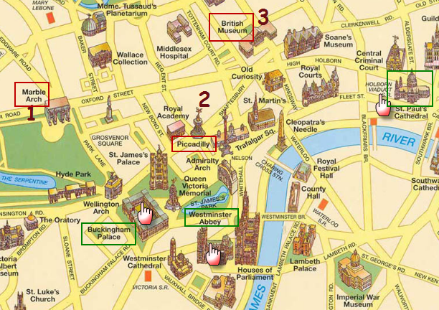1. How can ……………………………………………………………from the **Marble Arch** to **Buckingham Palace**, please? I’d love to see where the Queen lives. ……..……………………………………………………………..…………………… .………………………………………… …………… …… …………..…………………………..………………………………………………………………….. ……………………………………………… ……………………………………………………………………………………………………………………………..

2. How can ……………………………………………………………from **Piccadilly** to **St Paul’s Cathedral**, please? Let me see, …………………………………………………………………………………………………………………. …………..…………… ……… …… … ………………………………………………………………….……………………………………………………………………………………………………………………………………………………………………………………………………………………………………………………………………………………………

3. How can ……………………………………………………………from the **British Museum** to **Westminster Abbe**y?

Well, go …………………………………………………………………………………………….……………………………………………………………… ………………………………………………………………………………………………………………………………………………………………………………………………………………………………………………………………………………………………………………………………………………………………