
RUDOLPH THE RED NOSED REINDEER

A CHRISTMAS PLAY

CHARACTERS

NARRATOR 1
NARRATOR 2
NARRATOR 3
NARRATOR 4
RUDOLPH
PENGUINS
SNOWMEN
ELVES
REINDEERS
SANTA

I created this play based on the song to perform it in our schools festival. It can be adapted to any group size, since penguins, snowmen, elves and reindeers act out in groups. I did it with fifty children (seven years old) and it worked perfectly. Just choose the stronger students for the roles of Rudolph and Santa. I have given different colors to each character to make it easier for students to follow. I hope you enjoy it. ¡Happy Christmas!

N1: This is the story of Rudolph, a very special reindeer.
N2: Rudolph is sad and lonely.
N3: He has no friends. He looks funny with his red and shiny nose.
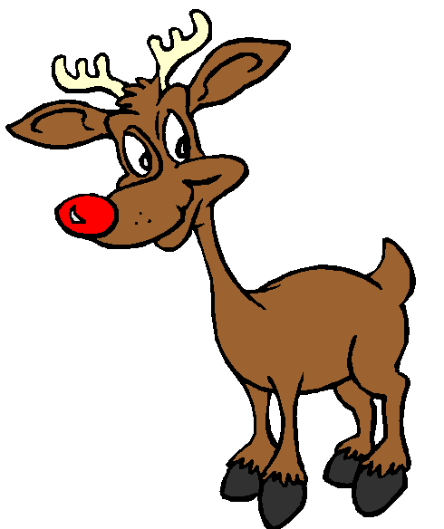
N4: Everybody laughs at him.
RUDOLPH: Can I play with you?
REINDEERS: No, we don´t play with red noses.
RUDOPLH: Can I play with you?
SNOWMEN: No, no, go home pinoccio.
RUDOPLH: Can I play with you?
ELVES: No, we are very busy.
RUDOPLH: Can I play with you?
PENGUINS: No, we don’t like reindeers.
N1: He is always trying to help… but he is very clumsy.
REINDEERS: Rudolph, you broke it, go away!
SNOWMEN: Rudolph, you dropped it, go away!
ELVES: Rudolph, that’s wrong, go away!
PENGUINS: Rudolph, what a mess, go away!

N2: Poor Rudolph. He is very sad.
N3: He decides to leave Santa’s home and live alone in a cave.
N4: It’s very cold in the North Pole!

N1: It’s Christmas Eve.
N2:It’s very windy and foggy.
N3: Santa is very worried.

SANTA: How can I ride my sleigh? I can’t see. It’s very foggy. I can’t take the presents to the children.

REINDEERS: What a disaster!
SNOWMEN: Oh my god!
ELVES: What can we do?
PENGUINS: No presents for the children!

N4: Suddenly, Santa has an idea.
SANTA: I know, Rudolph can guide my sleigh with his red nose!! Where is he? We have to find him!

ALL: Rudolph!! Where are you?
REINDEERS: Come back, please!
SNOWMEN: We are very sorry!
ELVES: We need you!
PENGUINS: Please, forgive us!

RUDOLPH: Yes, Santa. Can I help you?
SANTA: Yes Rudolph. It’s snowing and it’s very foggy. Can you guide my sleigh full of presents?

RUDOLPH: Of course Santa, I’m so happy!!

REINDEERS: Hoorray for Rudolph!!
SNOWMEN: You are the best!!
ELVES: Thank you!!
PENGUINS: You saved Christmas!!

N1: And from that day Rudolph is very happy
N2: and he’s the most famous reindeer in the world.

N3: Remember, you are different, you are special, you can be a hero!
N4: Do you want to hear his song…
Narrators: Listen carefully!

(Everybody sings the song)

