**VOCABULARY ENGLISH 4TH GRADE**

n. =noun =ουσιαστικό v. =verb =ρήμα adj. =adjective = επίθετο

**Unit: 1 – Back to school!**

**Page: 9**

1. Today = σήμερα e.g. Come to my house today!

2. New ≠ old = καινούριο ≠ παλιό

3. Meet (v) = συναντώ

4. Unit (n)= ενότητα,

5. Learn to (v) = μαθαίνω να

6. Describe (v) = περιγράφω

7. Classroom (n) = αίθουσα διδασκαλίας e.g. I like my new classroom.

8. Talk about (v) = μιλάω για κάτι

9. Talk to (v) = μιλάω σε κάποιον

10. Timetable (n) = ωρολόγιο πρόγραμμα

11. Subject (n) = μάθημα

12. Use (v) = χρησιμοποιώ

13. surname - επίθετο (ονόματος)

**Lesson:1 A new student in class (page: 10)**

1. Student (n) = pupil = μαθητής

2. How many? = Πόσα;

3. Class (n) = τάξη e.g. I`m in D class

4. England - English =Αγγλία – Άγγλος, Αγγλικά

5. Greece – Greek = Ελλάδα – Έλληνας, Ελληνικά

6. Nice (adj) = ωραίος

7. Large (adj) =big = μεγάλος

8. Sunny (adj) = ηλιόλουστος e.g. It’s a sunny day today!

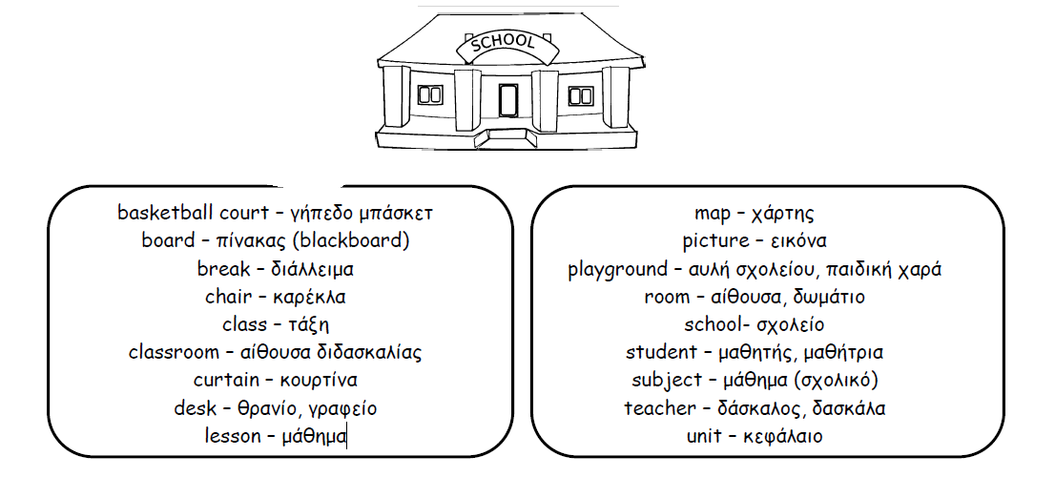

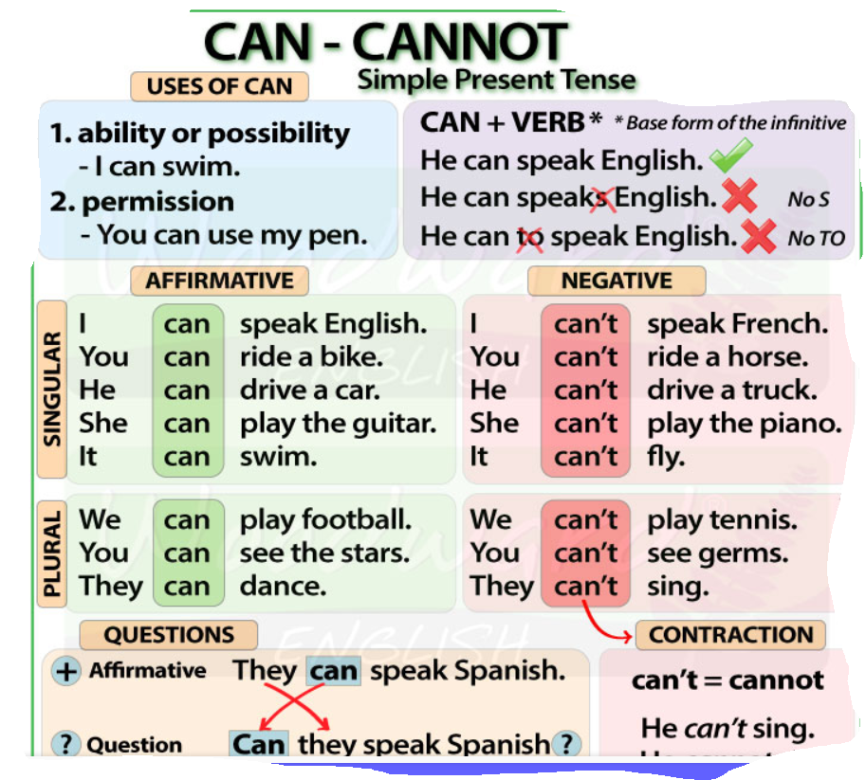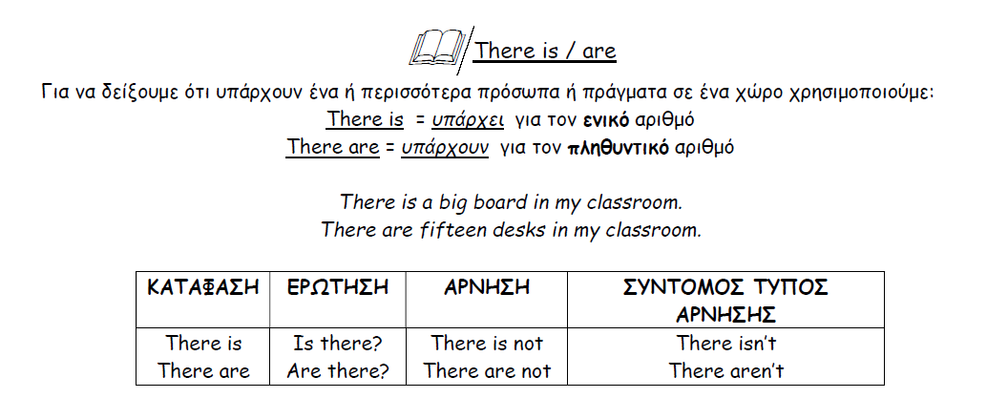

**Lesson:2 My timetable = το πρόγραμμα μου(page: 14-15)**

1. Tomorrow = αύριο

2. Favourite (adj) = αγαπημένος e.g. My favourite day is Sunday!

3. Again = πάλι, ξανά

4. Year (n) = έτος, χρόνος

5. Ancient (adj) = αρχαίος= very old

|  |
| --- |
| **6. SCHOOL SUBJECTS**  7. Language (n) = Γλώσσα e.g. Andrew speaks two languages!  8. Maths (n) = Μαθηματικά  9. Environmental Studies (E.S.) = Μελέτη Περιβάλλοντος  10. Physical Education (P.E) = Γυμναστική  11. Religious Education (R.E)= Θρησκευτικά  12. Art (n) = Τεχνικά e.g. My favourite subject is Art!  13. Music (n) = Μουσική  14. History (n ) =Ιστορία |

15. Break (n) = διάλειμμα

16. Because = επειδή

17, Learn about = μαθαίνω για eg I can learn about ancient Greece

**THE DAYS OF THE WEEK (page: 15)**

Monday = Δευτέρα

Tuesday = Τρίτη

Wednesday = Τετάρτη

Thursday = Πέμπτη

Friday = Παρασκευή

Saturday = Σάββατο

Sunday = Κυριακή

**NUMBERS 10-100 (page: 11)**

10 = ten

20 = twenty

30 = thirty

40 = forty

50 = fifty

60 = sixty

70 = seventy

80 = eighty

90 = ninety

100 = one (a) hundred

**Exercise: 1 Answer the following questions.**

1. Where is Andrew from? _______________________________________________

2. Where is his mother from? _____________________________________________

3. Where is his father from? ______________________________________________

4. What is his teacher’s name? ____________________________________________

**Exercise: 2 Answer the following questions.**

1. Which are Andrew’s favourite days? _____________________________________

2. What is his favourite subject? __________________________________________

3. Why does Andrew like History? ________________________________________

**Exercise: 3**

**Fill in the right word .Choose from the list.**

**( playground, nice, school, is, room, isn`t, classrooms, basketball, isn`t, field, are sunny,)**

My school is so ……….. !

It`s quite big with large , …………… classrooms. There …………. a computer ……………. but there ………….. a music room. There is a large …………. with a ………………….. court but there …………….. a football …………….. There …………………. twelve ………………. and a canteen .

I like my …………………………

