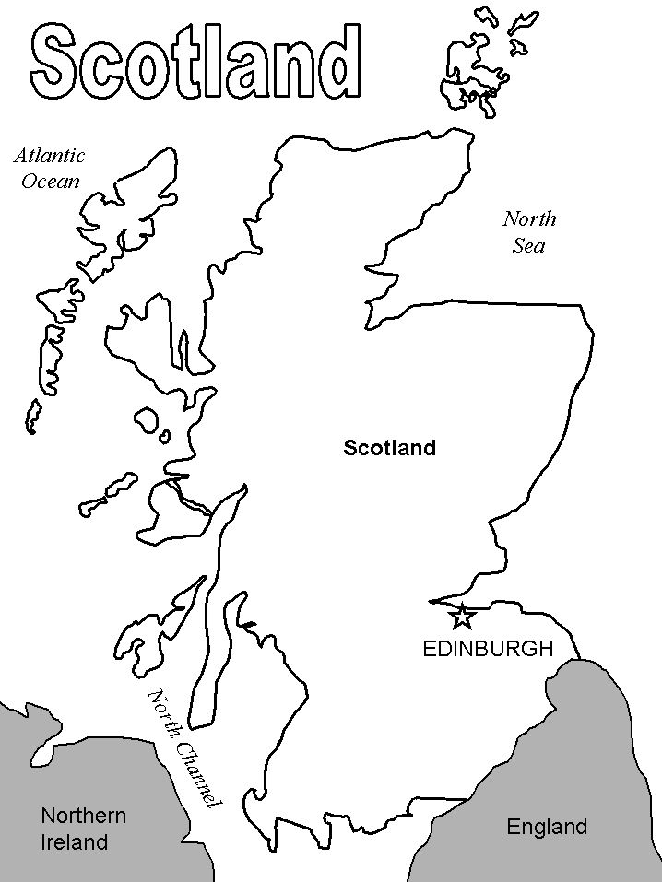
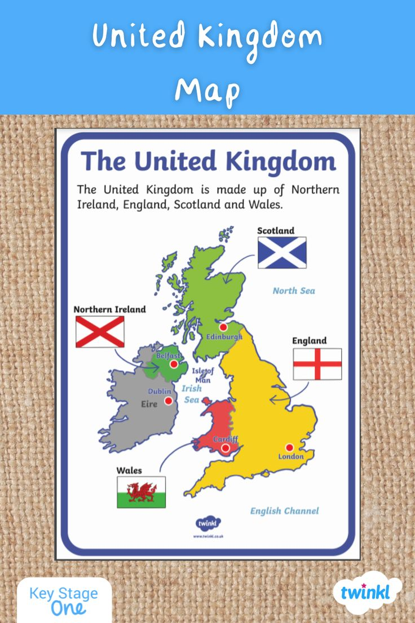

- Scotland is a country in the north of Great Britain.
- It is a part of the United Kingdom
- The capital of Scotland is Edinburg.
- The flag of Scotland is blue and white.
- The thistle is the national flower of Scotland.
- The Lochness lake is in Scotland.
- The lake is famous for its monster.
- The bagpipe is a traditional musical instrument of Scotland.
- The kilt is the formal clothing for men.

