A) LET’S REMEMBER WORDS ABOUT HOBBIES
http://photodentro.edu.gr/v/item/ds/8521/6365
B) DO THE CLOZE TEST
http://photodentro.edu.gr/v/item/ds/8521/4783
(Ασκήσεις που κάνετε στους συνδέσμους δεν είναι απαραίτητο να μου τις στέλνετε. Είναι για δική σας επανάληψη).

C) My School Day
a.Write the subjects under the picture
b.Write sentences with: like/enjoy/prefer…to/don’t like .
a. computer science geography history maths music science language English language art
1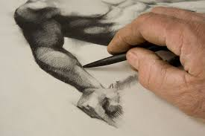2 3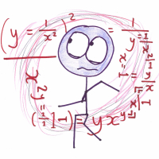 4 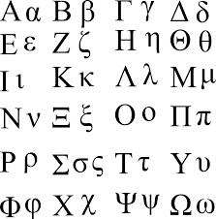
……………………… ………………………………… ……………………… ………………………….
5 6  7  8  9 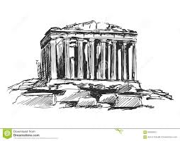
…………………… …………………….. ……………………… ……………………….. ……............

b. 1. ………………………………………………………………………………………….
2. ………………………………………………………………………………………………
3. ………………………………………………………………………………………………
4. .……………………………………………………………………………………………
5. ………………………………………………………………………………………………
6. ………………………………………………………………………………………………
7. ………………………………………………………………………………………………..
8. ………………………………………………………………………………………………..
9. ………………………………………………………………………………………………..

D) ADVERBS OF FREQUENCY
(always, usually, often, sometimes, scarcely, rarely, seldom, never)
Η ΘΕΣΗ ΤΟΥΣ: Πριν το κύριο ρήμα, μετά το ρήμα to be (am, is, are)
Write about Peter.
Peter ’s Activities | always | usually | sometimes | never
1. Do you do your homework before dinner? |  | +
2. Do you practice the piano in the afternoon |  |  | +
3. Do you play sports at the weekend? |  | +
4. Do you paint in your bedroom? |  |  |  | +
5. Do you clean your bedroom on Saturday? | +

1. Peter usually …………………………………………………………………
2. ………………………………………………………………………………………
3. ………………………………………………………………………………
4. ……………………………………………………………………………………
5. ……………………………………………………………………………………….

D) Write about the things you do
1. What do you do on Wednesday afternoons after school? ___________________________________________________________
2. Do you get up early on Sunday morning? _______________________________________________
3. What do you do on Tuesday morning? ___________________________________________________________
4. Do you go to bed late on Friday? ______________________________________________
5. What do you do on Saturday? _______________________________________________

E) READ THE TEXT AND ANSWER THE QUESTIONS

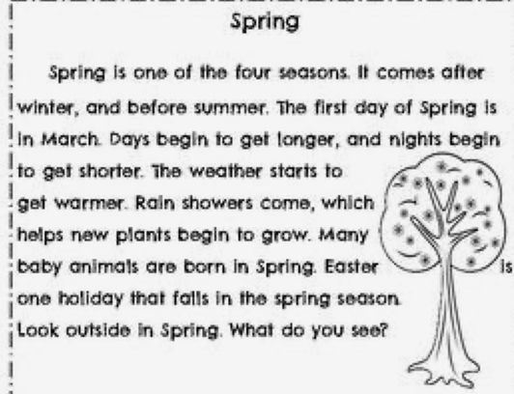
1. What seasons come before and after Spring?

2. What happens to days and nights in Spring?

3. What is the weather like in Spring?

F) EASTER IS COMING! Let’s read about Easter in Africa:

Easter Celebrations in Africa
In Africa, Easter is celebrated as a main function of the Christian communities. In the Easter Vigil hundreds of people assemble in the church building.
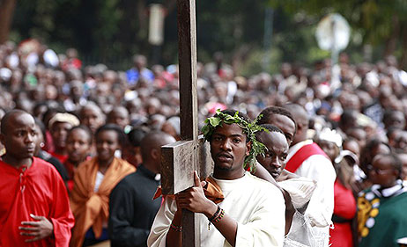In most parish churches the Easter Vigil is anticipated, because there are no lights, usually beginning at 3pm and finishing at dark, around 6pm.
The church is decorated by Vitenge and Kanga, clothes made up in the form of butterflies, flowers, banana trees etc.
Christian hymns are accompanied by the beating of drums and Kigelegele, the high-pitched sounds made by women.
After the Mass, traditional dances are held outside of the church. Then people return home to continue their celebrations with local food and drinks.
In some parishes the people remain around the church after Mass and sit in their small Christian communities to continue the celebration of eating and drinking, as ceremonial dances and entertainments continue around them.
In Africa, Easter has a social dimension as well as a spiritual one. At Easter families come together. They share special food with Christians and non-Christians indulging in boiled or roasted rice with meat or chicken.

VOCABULARY
1. parish church = εκκλησία της ενορίας
2. Mass = λειτουργία
3. continue = συνεχίζω
4. local = ντόπιος
5. community = κοινότητα
6. celebration = γιορτή
7. entertainment = διασκέδαση
8. social dimension = κοινωνική διάσταση
9. spiritual = πνευματικός,η,ο (HAVE FUN!)

