UNIT 4
A) VOCABULARY REVISION
Dolphin Therapy For Persons With Special Needs (p 51) 1. positive ≠ negative (adj) = θετικός ≠ αρνητικός 2. organization (n) = οργανισμός, οργάνωση 3. depend on (v) = εξαρτώμαι από 4. illness (n) = ασθένεια, αρρώστια 5. fixed times = καθορισμένες/ σταθερές ώρες 6. throughout the day = καθ’ όλη την διάρκεια της μέρας 7. same ≠ different (adj) = ίδιος ≠ διαφορετικός 8. regular (adj) = τακτικός, κανονικός 9. charity association = φιλανθρωπικό σωματείο 10. hold onto = κρατιέμαι από 11. pull ≠ push (v) = τραβώ ≠ σπρώχνω
A1) ΜΠΕΙΤΕ ΣΤΟΝ ΠΑΡΑΚΑΤΩ ΣΥΝΔΕΣΜΟ ΑΚΟΥΣΤΕ ή ΔΙΑΒΑΣΤΕ ΤO ΚΕΙΜΕΝO - Dolphin Therapy For Persons With Special Needs (p 51) http://photodentro.edu.gr/v/item/video/8522/863

A2) ANSWER THE FOLLOWING QUESTIONS
1. How do several organizations help people with special needs?...

2. Where do people with special needs often live? …

3. Do they get up at fixed times? …

4. Where are some of these people today? …

5. What are the children doing today?

A3) ΜΠΕΙΤΕ ΣΤΟΝ ΠΑΡΑΚΑΤΩ ΣΥΝΔΕΣΜΟ κ ΣΥΜΠΛΗΡΩΣΤΕ ΤΙΣ ΛΕΞΕΙΣ στο κειμενο για τα δελφίνια. http://photodentro.edu.gr/v/item/ds/8521/4795

B) GRAMMAR REVISION
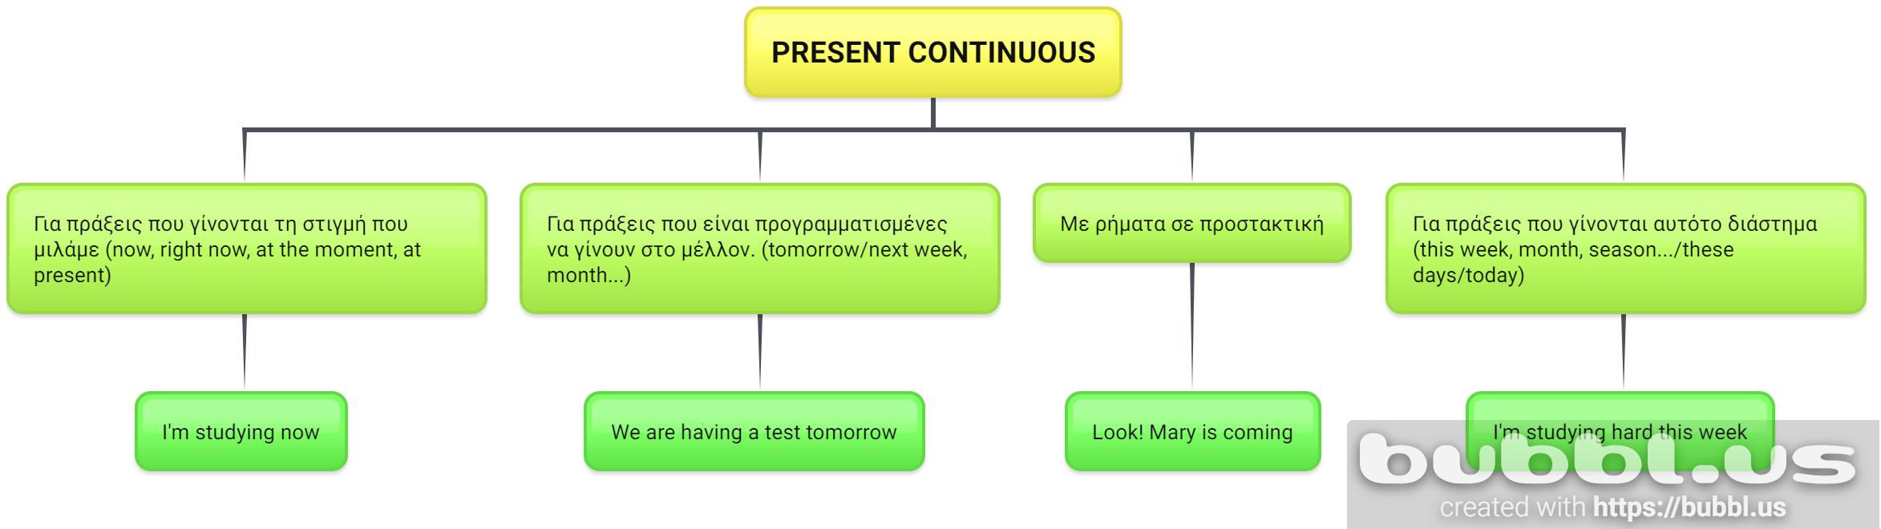
See how English people talk about
facts and habits vs actions happening now or "around now"

Nadine and Jacques usually buy their Christmas decorations at the supermarket, but this year they are making them themselves.

We often go abroad for our Christmas holidays, but this year we are spending it with Maria's parents.
B1) DO THE ACTIVITY: PERESENT SIMPLE or CONTINUOUS? http://photodentro.edu.gr/v/item/ds/8521/4796

B2) PERESENT SIMPLE or CONTINUOUS?
1. Look! Tom ____ his bike over there. ( ride)
2. Nora ____ a lot of books every week. (read)
3. Alec ____ a test right now.(write)
4. Pam often ____ funny animals at school. ( draw)
5. The boys ____ in the yard at the moment. (run)
6. We always ____ to school in time.(come)
7. I ____ a very interesting film now.(watch)
8. You often ____ a lot of mistakes.(make)
9. We ____ to the classical music now.(listen)
10. Paul never ____ SMS to his friends.(send)
11. I ____ (not) the flowers at the moment.(water)
12. Tim ____ (not) his friends every day.(call)
13. They ____ (not) football now.(play)
14. Anna ____ (not) to the zoo every day.(go)
15. We ____ (not) Andrew at the moment. (help)

B3) COMPLETE THE SENTENCES : PERESENT SIMPLE or CONTINUOUS?
1) James (live)  in a little village.
2) He (be) in his last year at school.
3) After school, James (want) to become a banker.
4) So this week, he (do) a practical course in a bank.
5) There (be) a bank in a nearby town, but James (have) to take the bus to get there.
6) The bus (leave) at 5.30 in the morning and (return) at 8.15 in the evening.
7) James (not / like) to spend so much time in town before and after work, waiting for the bus.
8) Therefore, this week he (stay) with his aunt, who (live) in town.
9) James usually (wear) jeans and t-shirts, but while he (work) for the bank now, he (wear) a suit and a tie.

B4) Match the halves.
1. Slice the bread and | a. grate some cheese on your spaghetti
2. Peel and cut | b. into small pieces
3. Pancakes is one of | c. America’s traditionaldishes
4. You must eat | d. fruit and vegetables
5. Cut the onion | e. the potatoes
6. If you want more taste | f. on top of the salad
- 7. Put some oil in | g. the frying pan to fry the chips
- 8. Sprinkle some salt | h. spread some butter on every slice
1. … 2…. 3……… 4…
5…. 6….. 7….. 8…….

B5) DO THE CROSSWORD
 ΔΙΠΛΟ ΚΛΙΚ ΣΤΟ ΕΙΚΟΝΙΔΙΟ για να ανοίξει.
Μόλις ανοίξει κάντε κλικ πάνω στο νούμερο κ εμφανίζεται η ερώτηση. Γράψτε την απάντηση στο κουτάκι δίπλα από την ερώτηση, όχι πάνω στο σταυρόλεξο. Πατήστε Enter. Για βοήθεια πατήστε Hint. (Γράψτε μου πώς τα πήγατε)

C) Alice is on holiday in Ierapetra with her parents and brother. RΕΑD her postcard and FILL IN the missing sentences. Two sentences do not fit. (2 ΠΡΟΤΑΣΕΙΣ ΔΕΝ ΤΑΙΡΙΑΖΟΥΝ)
C1) HOLIDAY PASTCARD 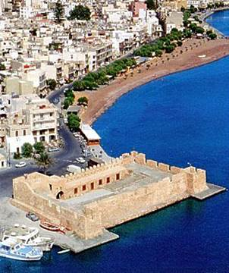
Dear Bill,
1)………We’re in a beautiful seaside town called Ierapetra. It’s on the south coast of Crete. We’re staying at a small hotel near an indoor market. 2) … The sun’s shining and it’s very hot. Robert is learning to scuba dive. Mum’s visiting the market-she loves shopping but the market is too crowded for me. Dad’s taking photographs of an ancient temple near our hotel. He likes old buildings but I find them boring. 3)……… It has some lovely restaurants. My favourite one has delicious fresh shrimps. After dinner we usually go for a walk around the town or have a cup of coffee in one of the great cafés here.
4) ……
Bye for now,
Alice
- I miss you! See you in two weeks.
- Rhodes is a wonderful place for a holiday.
- I’m in the mountains.
- Right now, I’m sitting on a beautiful beach.
- It’s raining all the time.
- I’m having a fantastic time here.

C1) Read the postcard and fill in the missing words.
snowvillageusuallyHavetownwoodtreedecorationscabinpostcard
Hi, Molly!
I’m sending you this ____________ from Finland. We ____________ spend Christmas at my father’s home ____________, but this year we are in Finland enjoying Santa’s ____________. Oh, it’s great! Everything is white with ____________ and there are beautiful ____________ everywhere. We are staying in a log ____________, it’s a house made of ____________ - and there is a lovely Christmas ____________ in the garden.
____________ a nice holiday!
Sandy

C2) NOW WRITE a postcard to your friend:
….
…
…
…

VIRTUAL TOUR OF LONDON http://photodentro.edu.gr/v/item/video/8522/767
Στον σύνδεσμο θα απολαύσετε το κέντρο του Λονδίνου με τον ποταμό Τάμεση να το διασχίζει. Διακρίνεται το London Eye ( το Μάτι του Λονδίνου), μια γιγαντιαία ρόδα-τροχός στη νότια όχθη του Τάμεση. Επίσης βλέπετε τη διάσημη Trafalgar Square με την πανύψηλη στήλη του Νέλσον (ο μεγαλύτερος στρατιωτικός ήρωας της Βρετανίας.

