UNIT 3
VOCABULARY REVISION
THE PLACE WE LIVE IN
1. countryside (n) = ύπαιθρος, εξοχή
2. own (v) – owner (n) = κατέχω, ιδιοκτήτης
3. bookstore = bookshop (n) = βιβλιοπωλείο
4. neighbourhood (n) – neighbour (n) = γειτονιά, γείτονας
5. flat / apartment (n) = διαμέρισμα
6. suburb (n) = προάστιο
7. bank clerk = τραπεζικός υπάλληλος
8. public transport = δημόσια συγκοινωνία
19. huge= very big = τεράστιος
10. factory (n) = εργοστάσιο
11. colleague = συνάδελφος
12. It seems to me that … = Μου φαίνεται ότι…
13. heavy traffic = πυκνή κυκλοφορία / κίνηση (στους δρόμους)
14. newsstand (n) = περίπτερο (με εφημερίδες / περιοδικά)
15. by bus, by car, by bike BUT ON FOOT
16. The town is situated … = Η πόλη βρίσκεται…
17. in the middle of = στη μέση
18. peace (n) - peaceful (adj) = ειρήνη, ειρηνικός/ήσυχος
19. environment (n) = περιβάλλον
20. grocer (n) = μπακάλης, παντοπώλης
21. means of transport = μέσα μεταφοράς
A) ΠΑΤΗΣΤΕ TON ΣΥΝΔΕΣΜΟ ΚΑΙ ΚΑΝΤΕ ΤΟ ΣΤΑΥΡΟΛΕΞΟ: file:///C:/Users/user00/Desktop/shopsE'.htm Κάντε κλικ πάνω στο νούμερο κ εμφανίζεται η ερώτηση. Γράψτε την απάντηση στο κουτάκι δίπλα από την ερώτηση, όχι πάνω στο σταυρόλεξο. Πατήστε Enter. Για βοήθεια πατήστε Hint. (Γράψτε μου πώς τα πήγατε)

B) ΜΠΕΙΤΕ ΣΤΟΝ ΠΑΡΑΚΑΤΩ ΣΥΝΔΕΣΜΟ ΑΚΟΥΣΤΕ ΤΑ ΚΕΙΜΕΝΑ ΚΑΙ ΑΠΑΝΤΗΣΤΕ: http://photodentro.edu.gr/v/item/ds/8521/6715
1st paragraph
1. Your father is… a) a bookseller b) a bookkeeper
2. He works in a … a) bookshop b) library
3. He obviously …. to work a) walks b) takes the bus
2nd paragraph
1. Your mother is a a) banker b) bank clerk
2. She goes to work a) by bus b) by car
3. She works in a) the centre of Athens b) the neighbourhood
3rd paragraph
1. Your parents are… a) factory workers b) factory owners
2. They work in a factory a) in the centre of Marseilles b) outside Marseilles
3. They go to work … a) by car b) by bus

C) TΩΡΑ ΚΑΝΤΕ ΤΗΝ ΑΣΚΗΣΗ Μy family (jumble words)
http://photodentro.edu.gr/v/item/ds/8521/4790

D) ΑΚΟΥΣΤΕ ΤΟ ΚΕΙΜΕΝΟ ΓΙΑ ΤΑ ΙΩΑΝΝΙΝΑ, ΕΠΙΛΕΞΤΕ ΤΗ ΣΩΣΤΗ ΑΠΑΝΤΗΣΗ, ΠΑΤΗΣΤΕ SUBMIT και μετά CONTINUE για να συνεχίσετε: http://photodentro.edu.gr/v/item/ds/8521/6697
1st paragraph
1. Which of the headings matches?
a) The old and the new parts of the town.
b) Where the town is built c) The surroundings
2. What is unique about the island? a) It is in a Greek lake with the longest history b) It is the biggest island in a Greek lake c) It is the only island in a Greek lake where people live.
2nd paragraph
1. Which of the headings matches?
a) The old and the new parts of the town
b) Where the town is built c) The environment surrounding the town
2.What happens as a result of the high mountains surrounding the town?
a) There is a lot of vegetation around the city
b) It’s usually quite cold in winter
c) There are lot of wild animals that people can hunt
3rd paragraph
1. Which of the headings matches?
a) The old and the new parts of the town
b) Where the town is built c) The environment surrounding the town
2. What is the difference between the old and the new parts of Ioannina?
a) There are fewer blocks of flats in the old part of the town than in the new.
b) The view over the lake from the old town is not as interesting as from the modern neighbourhoods.
c) The old part is quiet and the new part is busy.

E) EΠΙΣΚΕΦΤΕΙΤΕ ΤΟΝ ΠΑΡΑΚΑΤΩ ΣΥΝΔΕΣΜΟ, ΔΙΑΒΑΣΤΕ ΚΑΙ ΣΥΜΠΛΗΡΩΣΤΕ ΤΟ ΚΕΙΜΕΝΟ:
http://photodentro.edu.gr/v/item/ds/8521/4793 (CORINTH-CLOZE TEST)

F) READ THE TEXT and put + for the items which are in the village and - for the items which aren’t in the village. WRITE the name of the place or thing under the pictures

Hi, friends. My name is Pierre. I live in an old village, in the South of France, called Gordes. It is in the mountains. There aren’t so many things to do as in a big town, but we have everything we need.
My school is near my house and I can go there riding my bike. There isn’t any supermarket, but there are many stores. We don’t have a theater, but we have a cinema. There is a nice restaurant where I can have a pizza. There aren’t any museums, but there is a library where I go to read. We have a stadium where my football club plays every Sunday . I go there to watch them with my dad after church.
Most people have a farm and work in the fields, grow plants or raise animals. Our village is famous for its lavender plants. People make perfumes out of the flowers. There is also a big castle that tourists love.

 | 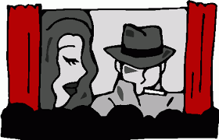 |  |  | 
 | 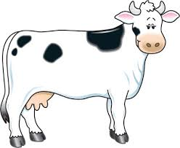 | 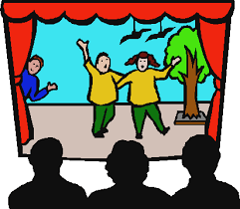 |  | 
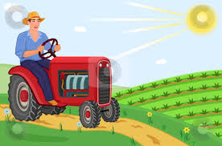 | 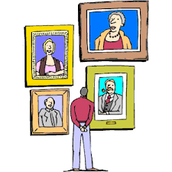 | 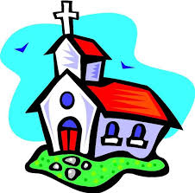 | 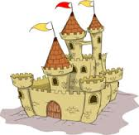 | 

Answer true or false.
Pierre lives in a big city. ( )
He lives in France. ( )
There are many stores. ( )
He rides a bike. ( )
He likes football. ( )
His club plays on Friday. ( )
He is a farmer. ( )
There are sunflowers. ( )
There is a palace. ( )
There are many tourists. ( )

Answer the questions.
Where does Pierre live? ...........
Are there any supermarkets?..........
What can you eat at the restaurant?............
Where can Pierre read.............
What does he do on Sunday?........
What do farmers do?............
What plant do they grow?...........
What do the tourists like?...........

