C Class Date:
Alphabet Name: _____________________________________
Ww (ντάμπλεγιου)  wave = κύμα  wind = άνεμος  window = παράθυρο  watch = παρακολουθώ, κοιτάζω | listen = ακούω

 | 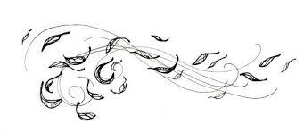 | 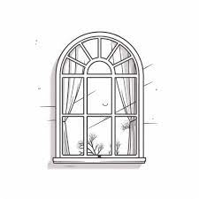
wave  ………………………………….  ………………………………….  ………………………………….  ………………………………….  …………………………………. | wind  ………………………….  ………………………….  ………………………….  ………………………….  …………………………. | window  ………………………………….  ………………………………….  ………………………………….  ………………………………….  ………………………………….
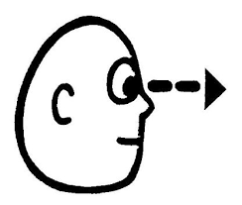 | 
watch  ………………………….  ………………………….  ………………………….  ………………………….  …………………………. | listen  ………………………….  ………………………….  ………………………….  ………………………….  ………………………….

Notes: _____________________________________________________________________________________________________________________________________________________________________________________________________________________

