C Class Date:
Alphabet Name: _____________________________________
Qq (κιού)  queen = βασίλισσα  quilt = πάπλωμα  quick = γρήγορος-η | Rr (αρ)  rabbit = κουνέλι  room = δωμάτιο  broom = σκούπα | It’s freezing cold = κάνει παγωνιά  Come quick = έλα γρήγορα

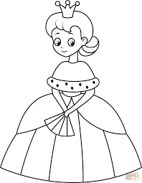 | 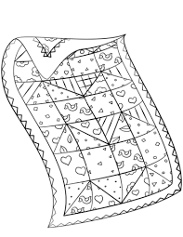 | 
queen  ………………………………….  ………………………………….  ………………………………….  ………………………………….  …………………………………. | quilt  ………………………….  ………………………….  ………………………….  ………………………….  …………………………. | quick  ………………………………….  ………………………………….  ………………………………….  ………………………………….  ………………………………….
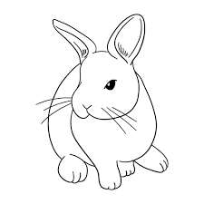 | 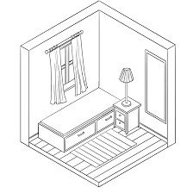 | 
rabbit  ………………………….  ………………………….  ………………………….  ………………………….  …………………………. | room  ………………………….  ………………………….  ………………………….  ………………………….  …………………………. | broom  ………………………….  ………………………….  ………………………….  ………………………….  ………………………….

Notes: _____________________________________________________________________________________________________________________________________________________________________________________________________________________

