I, i

igloo = ιγκλού, σπίτι Εσκιμώων 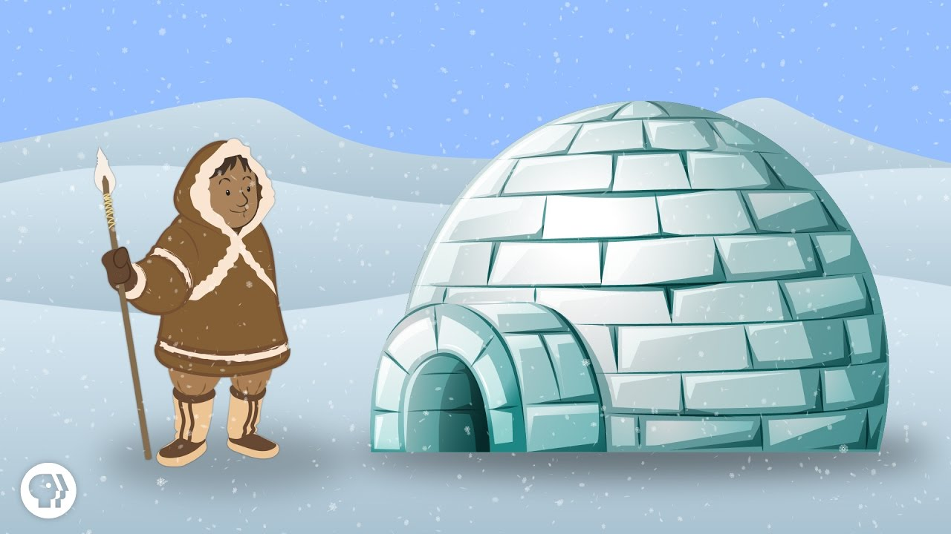

I_________________________________________________________

i_________________________________________________________

igloo_____________________________________________________Name:_____________