G g 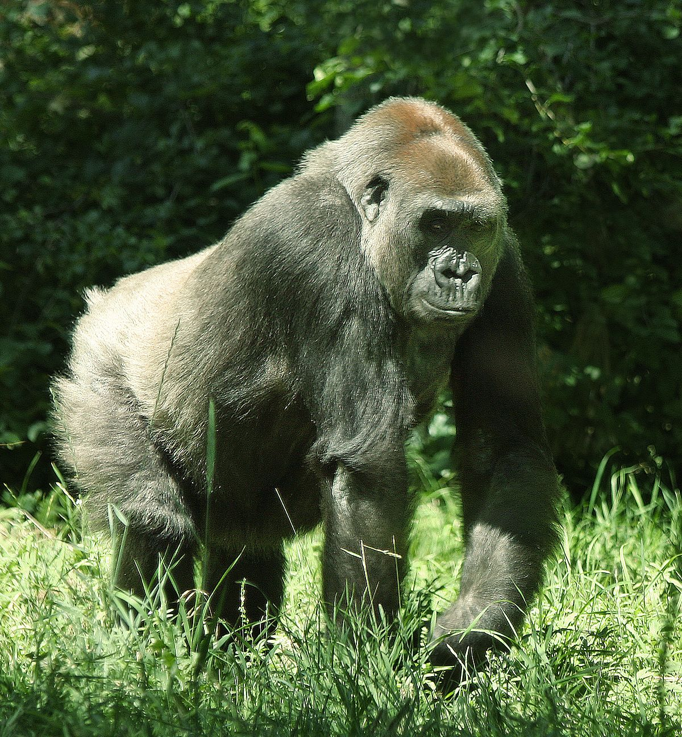
gorilla=γορίλας
G________________________
g____________
_____________gorilla_________________
Name = _____


