Fish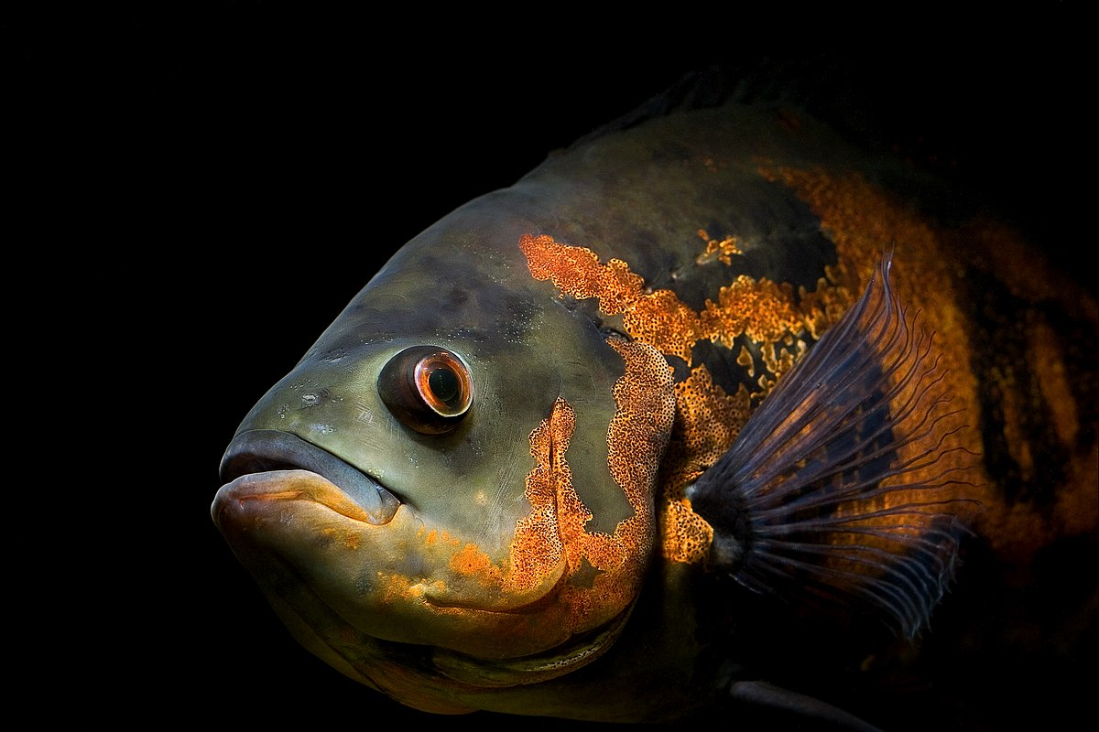F_________________________f_________________________fish__________
_____________
Name: ______

