E e 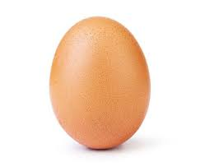
egg = αυγό (εγκ)
E________________________________
e__________
______________________
egg_________
_____________
Name:________ 

