A Haunted House
Welcome to my haunted house. The roof is red. The chimney is pink. The windows are green. The door is yellow. The gate is purple. The fence is blue. The tree is brown. The pumpkins are orange.

1.
2.

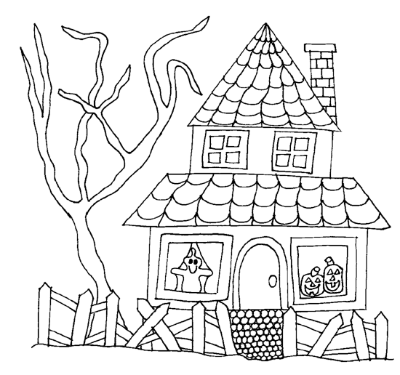
3.

9.

8.

5.

4.

6.

7.

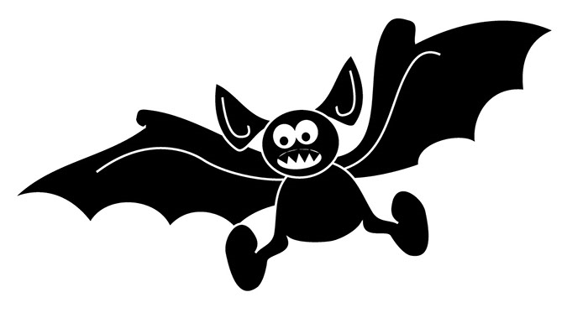

Now label the haunted house:
The chimney a pumpkin a window the door the roof the gate the fence a tree a ghost

