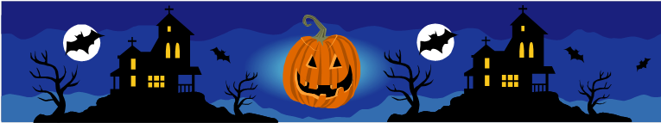

**HALLOWEEN**

**Instructions: *Read the story. Read the questions. Answer the questions with SHORT answers.***

Today is Wednesday, October 31st, 2012. It is Halloween. Halloween is a fun holiday in Canada and the United States. People wear funny clothes. Children eat candy. Kathy is ten. Kathy likes Halloween. She loves candy. Her mom doesn’t give her candy. Kathy has a little brother. His name is David. He is four. Kathy and David go outside on Halloween night. They walk down their street. They knock on the doors of all the houses. They ask the people for candy. They say “Trick or Treat!” The people in the houses give all the children candy. Halloween is a good holiday for dentists!!

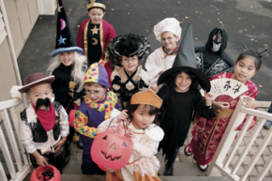  C:\Documents and Settings\leek\Local Settings\Temporary Internet Files\Content.IE5\UHJL744R\MC900436111[1].wmf

1. What is the date today? _______________________________________________
2. What is the name of the holiday today? _________________________________
3. Where is Halloween a fun holiday? ________________________________________________________________________
4. What do people do? ____________________________________________________
5. What do children do? __________________________________________________
6. How old is Kathy? _____________________________________________________
7. Does she like Halloween? ______________________________________________
8. What does she love? ___________________________________________________
9. Does her mom give her candy? _________________________________________
10. What is Kathy’s little brother’s name? __________________________________
11. How old is he? _________________________________________________________
12. Where do Kathy and David go on Halloween night? ________________________________________________________________________
13. Where do Kathy and David walk? ______________________________________
14. What do they do on the doors of all the houses? ________________________
15. What do they ask people for? ___________________________________________
16. What do they say? _____________________________________________________
17. Do the people in the houses give the children candy? ___________________
18. Why is Halloween a good holiday for dentists? ________________________________________________________________________

C:\Program Files\Microsoft Office\MEDIA\CAGCAT10\j0305493.wmf