**Φύλλο** **Εργασίας** **1**

Fill in the gaps with the right word

1)Halloween is my ……………………………….. holiday.

2)I love choosing a ……………………… and getting dressed.

3)Let’s go ………………. or treat.

4)We usually get lots of………….. and other treats.

5)Late at night we go to Halloween ………………

6)We play ………………… and eat snacks.

7)I hope I win the competition for the …………………. Costume.

8)We enjoy playing …………………… for apples and pin the ……….. on the

donkey.

9)We also listen to ……………… songs.

10)I can’t wait for …………………….

parties,games,spooky,favourite,costume,trick,candies,scariest,bobbing,tail

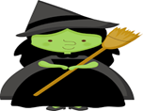Halloween