**REMEMBER!!!**

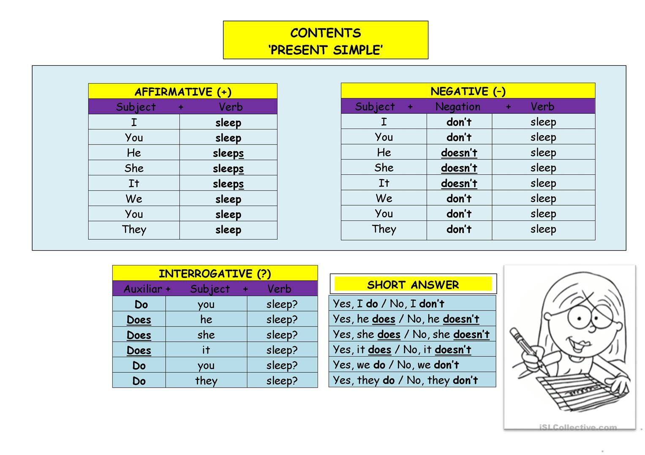

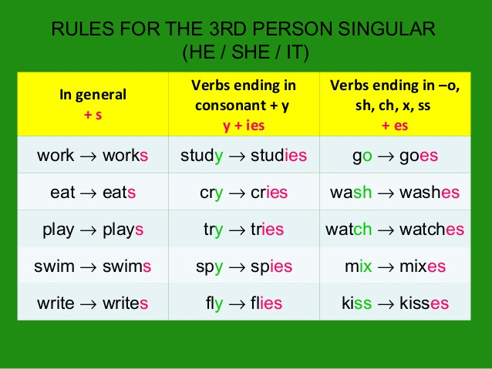

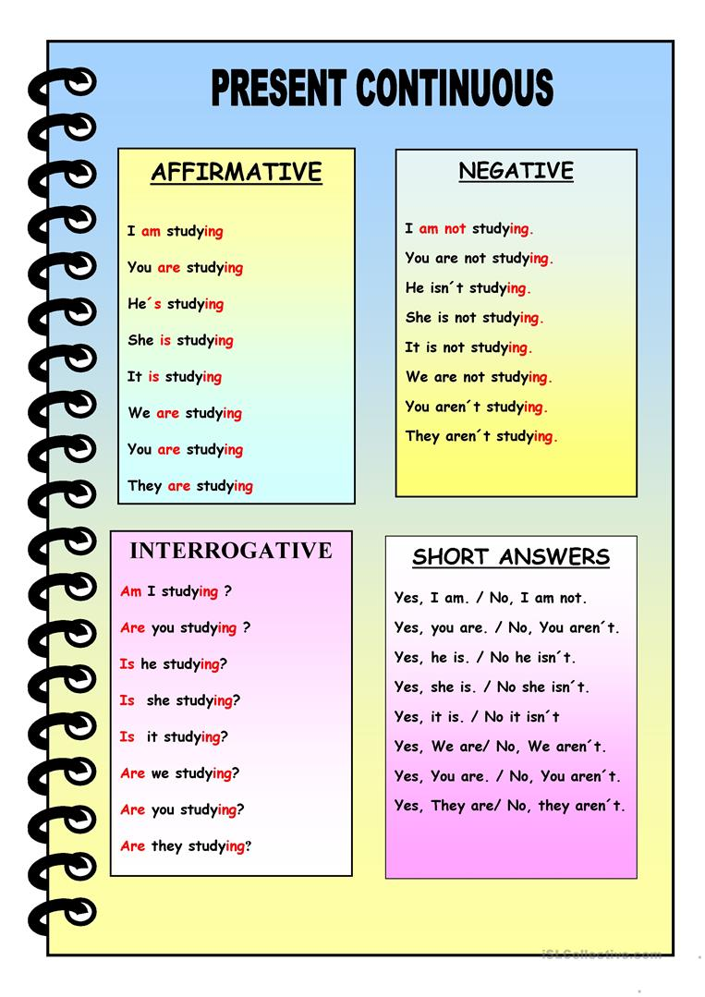

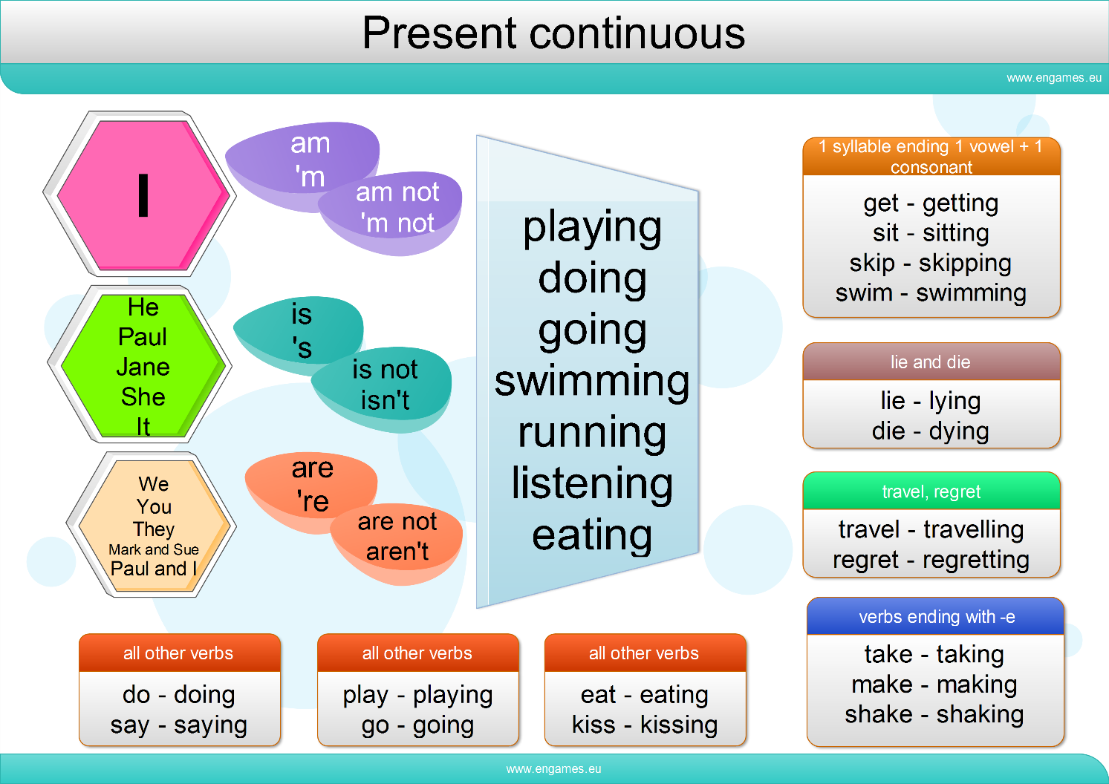

|  |  |
| --- | --- |
| **PRESENT SIMPLE** | **PRESENT CONTINUOUS** |
| **TIME EXPRESSIONS** | **TIME EXPRESSIONS** |
|  |  |
| Always = πάντα | Now = τώρα |
| Usually = συνήθως | At the moment = αυτή τη στιγμή |
| Often = συχνά | Right now = ακριβώς τώρα |
| Sometimes = μερικές φορές |  |
| Rarely / Seldom = Σπάνια |  |
| Never = ποτέ |  |