Crossword
 |  |  |  | 1
 |  | 2 |  | O
 |  |  |  |  |  |  | 3 |  |  |  |  |  |  |  | 4
 |  |  | 5 |  |  |  | P |  |  | 6
 |  |  |  |  | 7 |  |  |  | 8 | P
 |  |  |  |  |  |  |  |  |  |  |  |  | 9 | 10 | A
 |  |  | 11 |  | R |  |  |  |  | R
 |  |  |  |  |  |  |  |  |  |  |  |  | H
 |  | 12
 |  |  |  |  |  |  |  | 13
14 |  |  |  | K

1. | 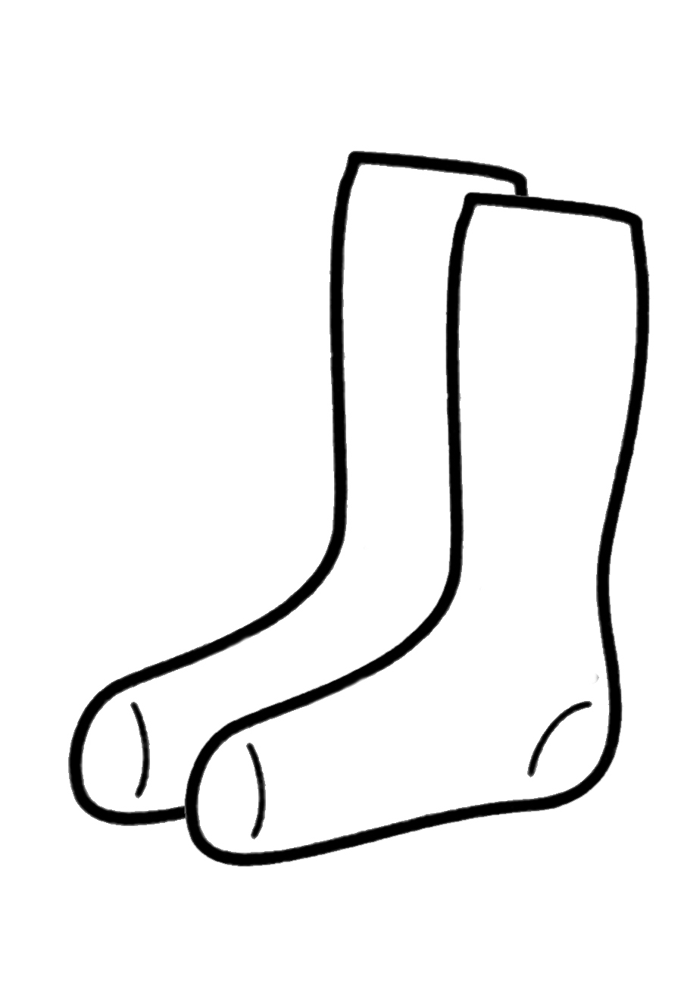 | 8. | 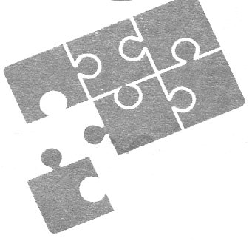
2. | 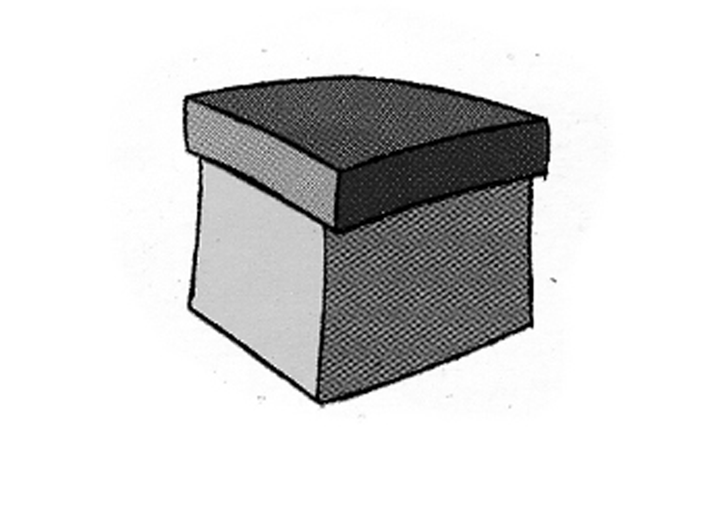 | 9 | 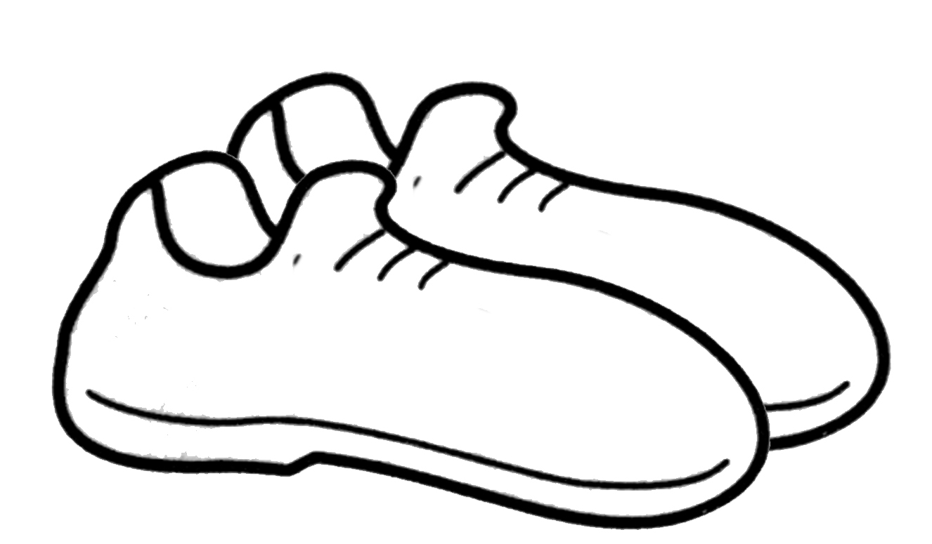
3. | 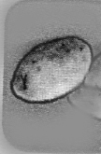 | 10 | 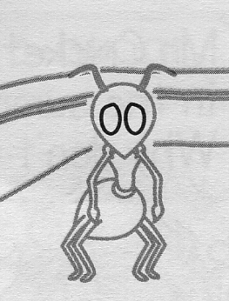
4. | 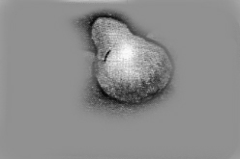 | 11 | 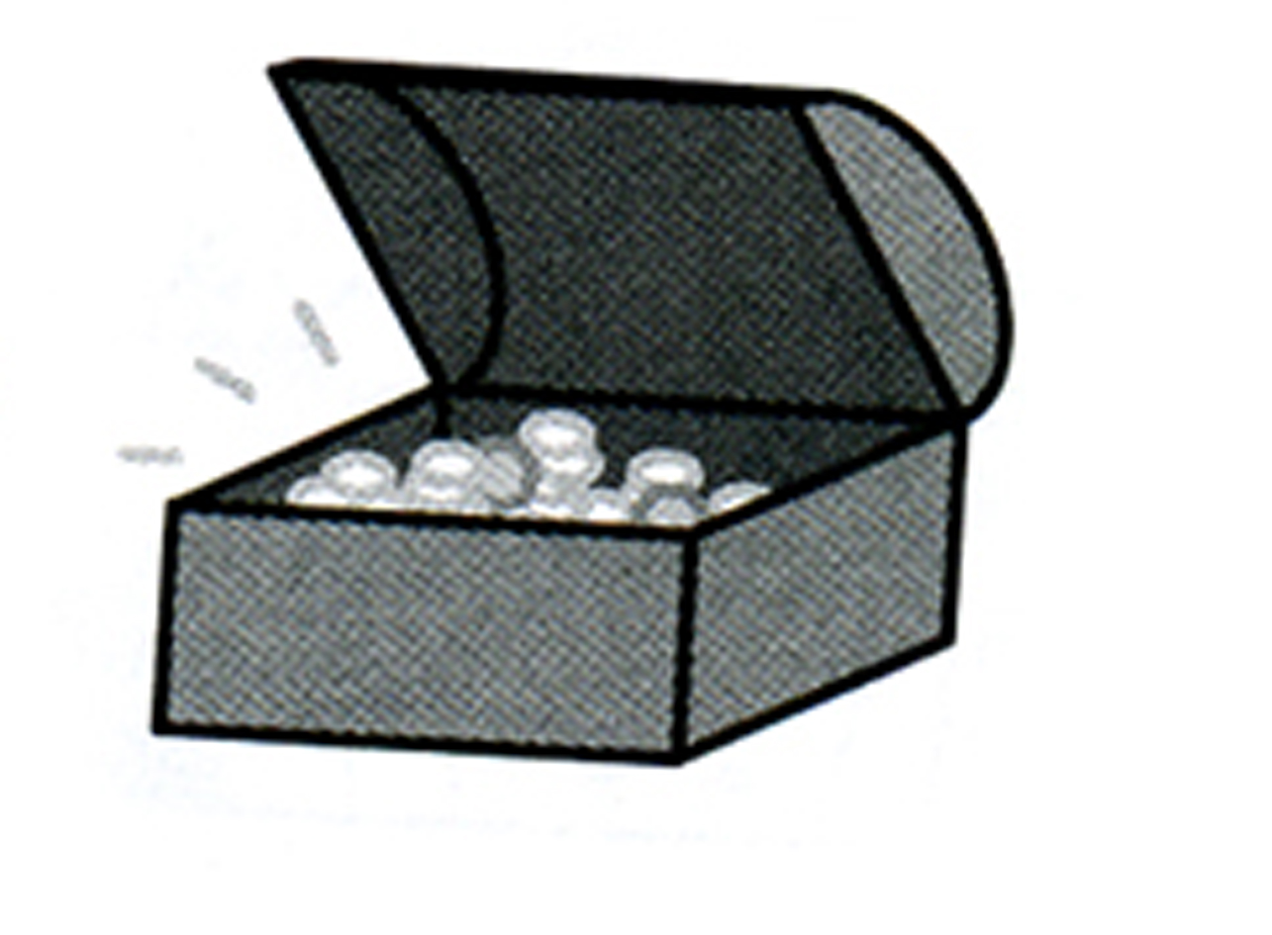
5 | 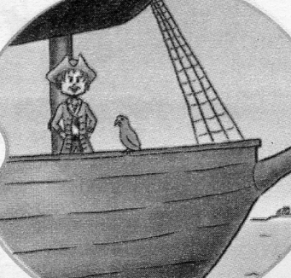 | 12 | 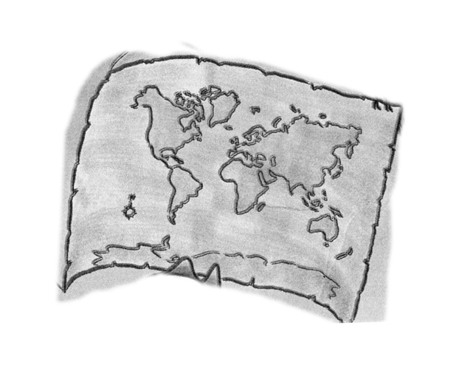
6 | 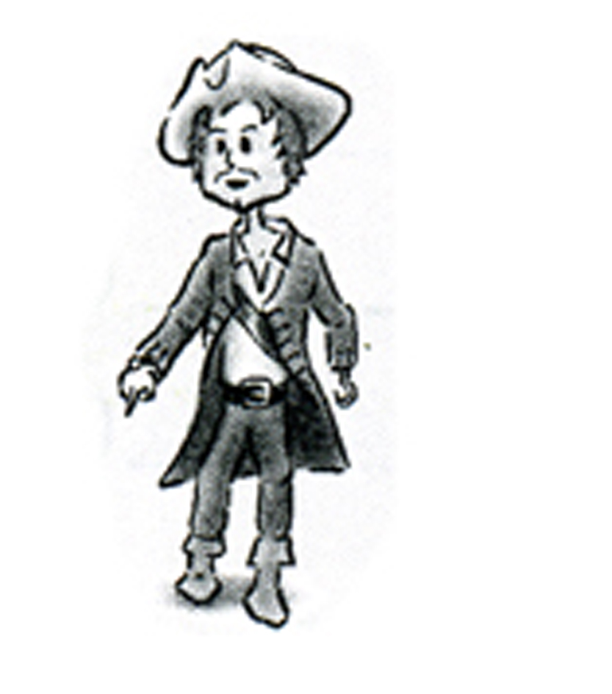 | 13 | 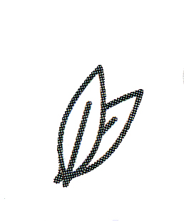
7 | 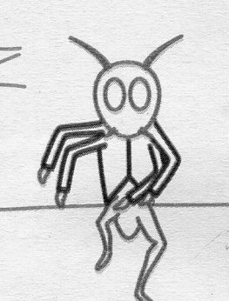 | 14 | 