**ΚΑΤΑΦΑΣΗ**[πρέπει]

I must you must he must she must it must we must you must they must

**ΕΡΩΤΗΣΗ**

Must I ? must you ? must he ? must she ? must it ? must we ? must you ? must they ?

**ΑΡΝΗΣΗ**

I must not you must not he must not she must not

It must not we must not

you must not they must not ============ I mustn’t you mustn’t he mustn’t she mustn’t it mustn’t we mustn’t you mustn’t they mustn’t

**ΚΑΤΑΦΑΣΗ** [έχω]

I have got you have got he **has** got she **has** got it **has** got we have got you have got they have got

**ΕΡΩΤΗΣΗ**

Have I got ? have you got ? **has** he got ? **has**  she got ? **has** it got ? have we got ? have you got ? have they got ?

**ΑΡΝΗΣΗ**

I have not got you have not got he **has** not got she **has** not got it **has** not got we have not got you have not got they have not got ============ I haven’t got you haven’t got he **hasn’t** got she **hasn’t** got it **hasn’t**  got we haven’t got you haven’t got they haven’t got

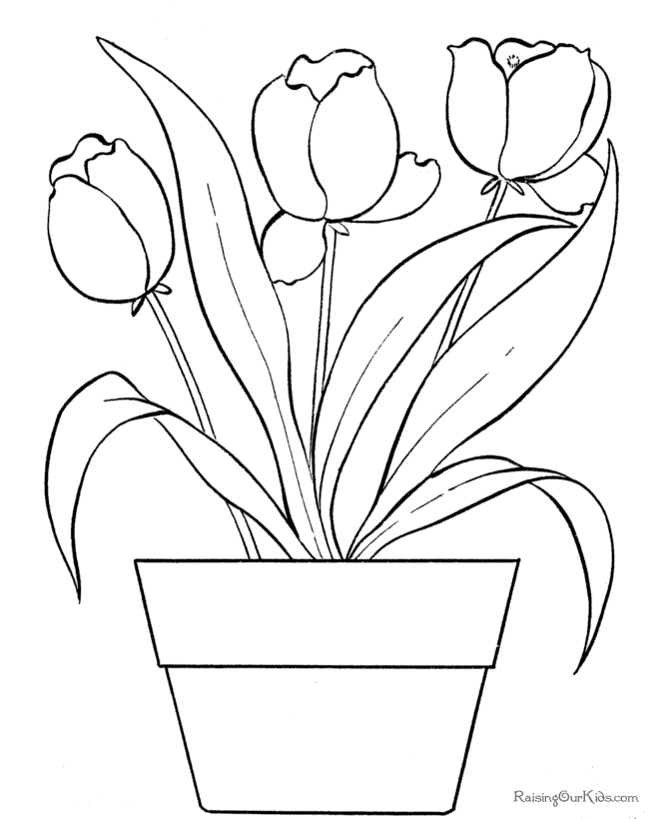

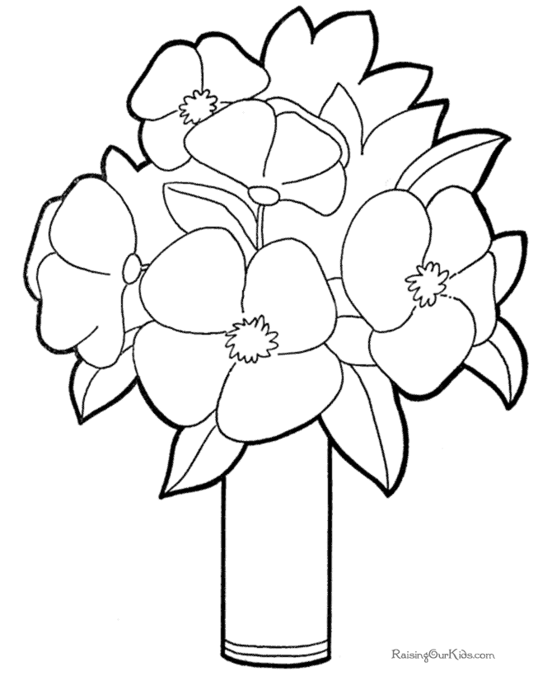

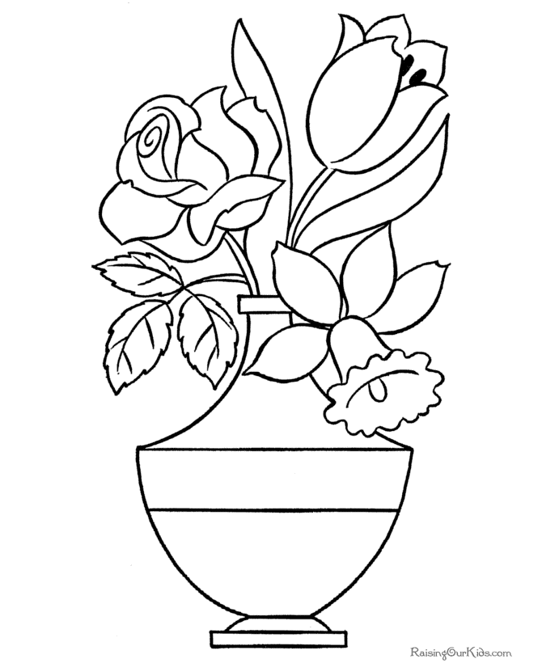

**ΕΝΕΣΤΩΤΑΣ ΔΙΑΡΚΕΙΑΣ**

**ΚΑΤΑΦΑΣΗ**

I am working

You are working

He **is** working

She **is**  working

It **is** working

We are working

You are working

They are working

**ΕΡΩΤΗΣΗ**

Am I working ?

Are you working ?

**Is** he working ?

**Is**  she working ?

**Is**  it working ?

Are we working ?

Are you working ?

Are they working ?

**ΑΡΝΗΣΗ**

I am not working

You are not working

He **is** not working

She **is**  not working

It **is**  not working

We are not working

You are not working

They are not working

**PRESENT CONTINUOUS**



